WORKING PAPER NUMBER: WP22_05

Nonmarginal budgetary impacts and economic evaluation: is mortgaging a solution?

Daniel Howdon
Academic Unit of Health Economics, University of Leeds
Academic Unit of Health Economics, Leeds Institute of Health Sciences, University of Leeds, Worsley Building, Clarendon Way, Leeds, LS2 9LJ. E-mail: d.howdon@leeds.ac.uk

This working paper should cited as: Howdon, D. Nonmarginal budgetary impacts and economic evaluation: is mortgaging a solution?. Leeds: University of Leeds, Academic Unit of Health Economics; 2022. Available from: https://medicinehealth.leeds.ac.uk/downloads/download/170/auhe_resources

DISCLAIMER
The series enables staff and student researchers based at or affiliated with the AUHE to make recent work and work in progress available to a wider audience. The work and ideas reported here may not always represent the final position and as such may sometimes need to be treated as work in progress. The material and views expressed in the series are solely those of the authors and should not be quoted without their permission.

Additional information

Funding
This work was unfunded.
Ethical approval
Not required
Conflict of interest
None to declare.
Acknowledgements
This paper arose out of discussions with James Lomas around early and final versions of Lomas (2019). I am also grateful for comments from Dave Parkin & other participants at the HESG Winter 2022 conference in Leeds, as well as Daliya Kaskirbayeva for internal AUHE peer review. All errors in this paper are my own.

Abstract

Recent years have seen an increase in the number of health technologies whose budgetary impact, if accepted by the relevant decision-making authority, would be deemed to be “nonmarginal”. This means that decision-making regarding the acceptance or otherwise of such technologies would require adjustments to the relevant threshold employed in order to consistently fulfil the objectives – such as that of population health maximisation – set down in the remit of such decision-making authorities, since adoption of the new health technology would displace existing technologies not just at the margin of the healthcare service’s spending, but also health technologies that are more cost-effective than those displaced at the margin.

One solution proposed for this has been that of a mortgage-type arrangement which would seek to smooth such nonmarginal budget impacts over future time periods. It has been argued that this would potentially permit a payment option that would over time be preferable for both a decision-maker seeking to maximise health over the relevant time horizon and for the manufacturer of the health technology.

This paper seeks to examine the process by which such a potential mortgage-type arrangement would operate and how this interacts with the technical context in which decisions are made, how it interacts with the normative basis for decision-making, and the type of decision rule that should be adopted in these cases.

Key words: mortgaging, capital expenditure, cost-effectiveness thresholds, non-marginal budgetary impacts.

Introduction

The last decade has seen an increase in the cases where a new health technology’s incremental cost-effectiveness ratio (ICER) has appeared to render it as cost-effective under a conventional comparison to a threshold value, but whose potential budgetary impact has led to it being regarded as ultimately unaffordable. In England, several proposed treatments for hepatitis C were deemed cost-effective by the National Institute for Health and Care Excellent (NICE) but, seemingly paradoxically, were deemed to be unaffordable by NHS England (National Institute for Health and Care Excellence, 2015a, 2015b, 2015c). Attempts have been made to demystify this apparent paradox (Bilinski et al., 2017; Lomas, Claxton, et al., 2018), create conceptual frameworks for such decision-making (Howdon et al., 2019), provide empirical estimates of appropriate thresholds to be adopted in such cases (Lomas, Martin, et al., 2018), and examine the ethical and political implications arising (Charlton et al., 2017; Rumbold et al., 2019).

This paper briefly outlines the specific problem of interventions deemed to be cost-effective but unaffordable, provides a broad overview of relevant literature on the topic, and outlines an example based on proposals to “smooth” or “mortgage” (Lomas, Claxton, et al., 2018; Lomas, 2019) the costs of high budgetary impact interventions over time. Various implications of high budgetary impact interventions in a world where financial smoothing can take place are discussed under different assumptions regarding the legitimacy of the budget and the type of spending that is displaced by funding such a new intervention.

While a lengthy discussion of the precise mechanisms behind public financing are beyond the scope of this paper, the discussion of some key questions that arise when the possibility of smoothing is admitted necessitates first establishing the role of finance in public policy. A neat exposition of some key points is provided in Keynes (1942), chastising an interlocutor that “we build houses with bricks and mortar, not with money”, and emphasising the differences between the bringing into use of “resources in general” and the merely technical nature of problems “of where the money [to employ those resources] is to come from”. Keynes’ key insight on this point was to emphasise the central importance of what societies want to do and whether they have the resources to do it, rather than the financial mechanisms by which such results may be brought about.

Base case assumptions & conceptual model
First assume that we have a decision-maker tasked with maximising the discounted present value of health, facing a decision whether or not to approve some new healthcare intervention. Such decision-making, based on principles of cost-effectiveness analysis, generally rests, in one formulation, on a comparison of a calculated ICER for a new treatment under consideration to some benchmark threshold, usually generically denoted as λ ,. If λ is optimally set as a supply-side threshold (Paulden, 2018), usually denoted as k, it should represent the opportunity cost of new health spending at the margin: an adjustment to the health service’s budget that would vary overall outcomes by one quality adjusted life year (QALY). This means that use of such a threshold as a guide to decision-making for new healthcare interventions that affect the remaining budget at the margin would ensure that spending on new interventions is only made when the health generated from new treatment exceeds the health displaced by reduced spending on existing treatment.

Assume, however, the new healthcare intervention under consideration has a “non-marginal” impact on overall spending, such that the use of λ = k would be inappropriate as a means of guiding decision-making in this case. While in principle this large budgetary impact may be recurring in all future years, assume (as appears to be the case in published literature on this (Lomas, 2019; Lomas, Claxton, et al., 2018)) that this potential budgetary impact is one-off, in occurring in the current year and no future years. This situation can be summarised using a stylised version of the indirect health production function, showing the relationship between health spending and QALY outcomes, in Figure 1. At the margin, the optimal supply-side threshold is given by the reciprocal of the slope of the indirect health production, 1/k. As the budgetary impact of a new intervention increases, however, we move away from this margin and the inappropriateness of such a value for an optimal supply-side becomes increasingly important, as the displaced health becomes that produced in an increasingly cost-effective way (as reflected by the reduction in the reciprocal of the slope of the indirect health production function as we move to the left). A decision-maker wishing to make decisions that contribute to the maximisation of health would therefore want to reduce the threshold to be adopted as the budgetary impact of a new healthcare intervention increases: this means that rather than k being a constant, it becomes a function of the overall budgetary impact, k=f(C).

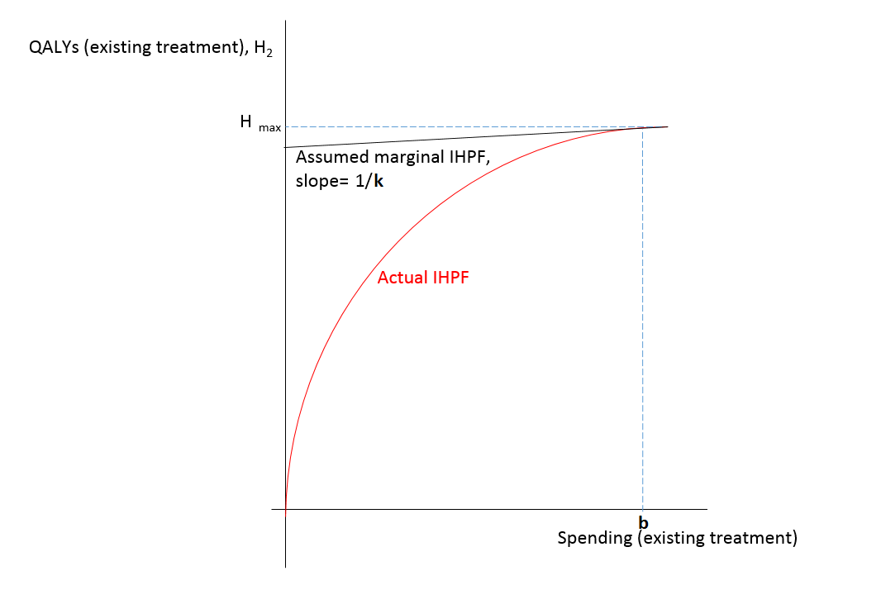

Further assume that we have a decision-maker facing a fixed budget B₁… B_{T} in each year 1… T. These budgets are optimally set in the respect that they, given available technology, represent society’s preferences (howsoever defined) for spending on healthcare in each year 1… T. While an explicit social welfare function with clear prescriptions for social choice may not be definable, organisations such as NICE can be seen as the agents of a socially-legitimate authority making budgetary allocations and decisions made according to their processes as “a partial social expression of some unknown underlying latent welfare function” (Claxton et al., 2010), and budgets can thus be seen as, in this sense, optimal.

It is worth developing a little further on the meaning of, and the interpretation of, the budget is in this situation. Lomas (2019) makes no assumption regarding the optimality or otherwise of the budget, stating that “[t]he resources available to the decision maker are exogenous, assumed to be determined by some social process” and that “from the perspective of the decision maker, k is therefore exogenously determined in any given period as a result of the social process by which resource allocation occurs”. While it is further argued that “[the relevance of this paper] extends to analysis that adopts a broader societal perspective”, the budget and derived threshold in this baseline case are deemed to be essentially arbitrary (although connected to each other). Under this stronger assumption, however, of being determined by a socially legitimate process, budgets represent not just the “administrative nuisance” as they may be seen according to a welfarist perspective, but instead are taken as “expressing an indication of social value” (Claxton et al., 2010).

In such a world where the budget is fully spent (consistent with maximising the discounted present value of health) and no net borrowing or saving across years takes place, the following accounting identity must hold in each year 1…T :

E_{t}= B_{t} (1)

where E_{t} is the total healthcare expenditure in year t. While decisions taken at time t=1 may impact on costs incurred and health gained at each year 1..T, the budget in each time period must equal expenditure. While relevant costs and health may be discounted at differential rates, as a simplifying assumption without loss of generality, let both be discounted at some equal health-relevant discount rate r_{h}.

If no net borrowing takes place in any given year, no questions arise regarding the divergence between the budget under either of these sets of assumptions. Under the stronger assumption of a socially-legitimate budget, it does not matter whether the budget (being equal to expenditure) is the amount that society wishes to allocate in mere financial terms (the available budget) or the amount it wishes to explicitly spend on available resources in that given year (the total expenditure). Ever under the weaker assumption of an arbitrary budget, while there may be fewer normative implications, the question of whether the budget represents a desired financial allocation or a desire for expenditure remains.

We now introduce the possibility of net borrowing in any given year, and assume (though this will be later elaborated upon) that any new expenditure resulting from the approval of this new programme falls on the current spending budget. Lomas, Claxton, et al. (2018) propose that in circumstances where a high budgetary impact exists, “manufacturers could smooth [these high budgetary impacts] by offering a “mortgage-like” repayment at a real rate of return that reflects their real return to capital (analogous to private finance initiative financing of upfront costs in the NHS)”. This would seem to permit financing at rates greater than both that of long-term (2.0%) and short-term (1.0%) government bonds (Dimson et al., 2021) and the currently-adopted 3.5% discount rate applied by NICE & the Treasury Green Book, given that the UK’s long term (1900-2020) real return to equities stands at around 5.4%. Lomas (2019) describes this process more generically as one in which the health system might “come to an agreement with the manufacturer about how the payment for the intervention is to be made over time”, and the motivating example assumes an interest rate of 0%, with a one-off budgetary impact of £772m smoothed over three years with payments aggregating to £772m.

In such a situation where expenditure can diverge from the budget through net borrowing, the following accounting identity must hold in each year 1…T:

E_{t}= B_{t} + N_{t} (2)

where N_{t} is net borrowing in year t.

Discussion

Since it is now no longer the case that E_{t}=B_{t} as an accounting identity, it is at this point that a number of important questions arise, outlined below:
- Does the budget represent a legitimately-expressed demand for spending on healthcare resources in that year (i.e. E_{t}), or does it merely represent a legitimately-expressed budgetary allocation in pure financial terms (i.e. B_{t})?
- What does this mean for the appropriate thresholds to be adopted in time periods of net borrowing and saving? What does this imply for the appropriate discount rate in each time period?
- Is there a useful distinction to be made between capital and current spending?

This paper proceeds by taking these questions one by one.

- Does the budget represent a legitimately-expressed demand for spending on healthcare resources in that year (i.e. E_{t}), or does it merely represent a legitimately-expressed budgetary allocation in pure financial terms (i.e. B_{t})?

If the budget merely represents a legitimately-expressed budgetary allocation to the healthcare in pure financial terms, then the potential for mortgaging is unarguable and relatively uncomplicated. This would imply that through some social process, it is decided that a given financial allocation is to be made to the healthcare sector, and this financial allocation can be used in whatever way is deemed to meet its goal of maximising the present value of health. In such a situation, it does not matter that E_{t} differs from B_{t} by N_{t}, because it is B_{t} that carries social legitimacy: the decision-maker is entitled to borrow against budgetary allocations in any given time period using financial instruments (by setting N_{t}≠0 in any given time period) to maximise the present value of health. Lomas (2019) states that the paper “adopts the perspective of the exogenously constrained decision-making agent, rather than the resource allocating principal”. This appears to adopt the approach that the budget involves a financial allocation rather than a desire for spending: were this not the case, setting N_{t}≠0 in any time period would indeed constitute decision-making within the purview of the resource allocation principal.

If, alternatively, the budget represents a legitimately-expressed demand for spending on healthcare resources in that year, then the normative legitimacy of mortgaging would appear to be questionable. Because E_{t} carries social legitimacy, any value of N_{t}≠0 in any given time period means that the decision-maker is acting beyond their remit in failing to spend the desired amount in the given time period. This would appear to rule out any role for mortgaging in these situations: there is no functional difference in terms of expenditure between the decision-maker, for instance, increasing B_{t} = E_{t} in any given time period, and increasing E_{t}>B_{t} by setting N_{t}≠0 in any time period.

- What does this mean for the appropriate thresholds to be adopted in time periods of net borrowing and saving? What does this imply for the appropriate discount rate in each time period?

Recall that the health-maximising threshold to be adopted for decision-making affecting spending at the margin, k, depends upon, all else constant, the resource use in that time period. It is however important to be clear at what value this margin is calculated: under conditions of no intertemporal borrowing, E_{t} = B_{t} and this can be equivalently stated as being derived from expenditure or budgetary allocation. When these two values can diverge, however, it is important to be clear that it is at the margin of expenditure that this value must be calculated: as illustrated in Figure 1, a supply-side threshold is calculated from the reciprocal of the slope of the indirect health production function at the margin of total health spending. This means that where intertemporal reallocations occur, they also impact upon k, the threshold to be adopted at the margin. It is perhaps instructive to consider the worked examples given in Lomas (2019) in this regard, reproduced below in Table 1 and Figure 2:

 | Scenario 1 |  | Scenario 2 |  | Scenario 3
Time (t, years) | $$∆C_{t}$$ | $$HOC(∆C_{t})$$ | $$∆C_{t}$$ | $$HOC(∆C_{t})$$ | $$∆C_{t}$$ | $$HOC(∆C_{t})$$
1 | $$£772mn$$ | $$£772mn/£12,452$$ | $$→0$$ | $${→0}/{£12,936}$$ | $$£386mn$$ | $${£386mn}/{£12,}518$$
2 | $$0$$ | $$0$$ | $$→0$$ | $${→0}/{£12,936}$$ | $$£193mn$$ | $${£193mn}/{£12,}551$$
3 | $$0$$ | $$0$$ | $$→0$$ | $${→0}/{£12,936}$$ | $$£193mn$$ | $${£193mn}/{£12,}551$$
… | $$0$$ | $$0$$ | $$→0$$ | $${→0}/{£12,936}$$ | $$0$$ | $$0$$
T | $$0$$ | $$0$$ | $$→0$$ | $${→0}/{£12,936}$$ | $$0$$ | $$0$$
Net present value | $$£772mn$$ | $$\frac{£772mn}{£12,452}=61,997$$ | $$£772mn$$ | $$\frac{£772mn}{£12,936}=59,677$$ | $$£772mn$$ | $$\frac{£386mn}{£12,518}+2*\frac{£193mn}{£12,551}=61,589$$
Table 1: Three scenarios [Source: Lomas (2019)]

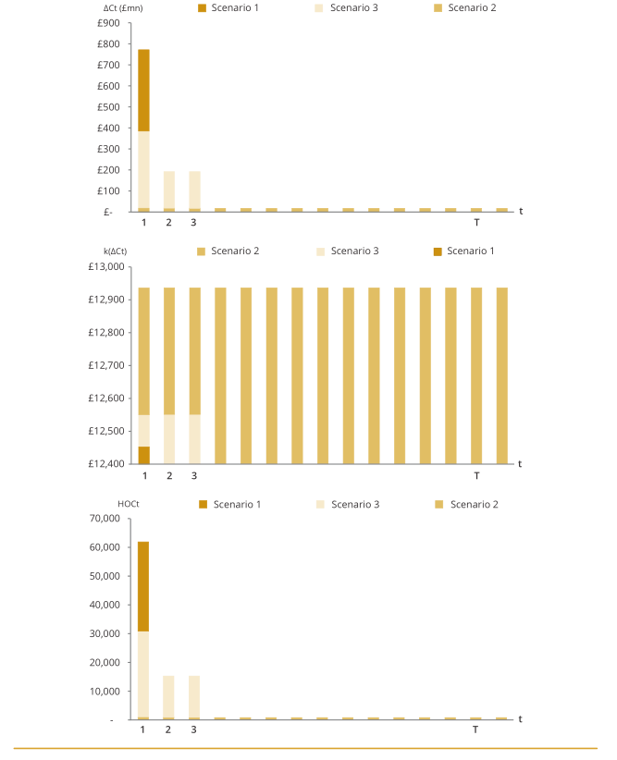
Figure 2: Three scenarios [Source: Lomas (2019)]

First consider scenarios 1 and 3. These reflect an equivalently big impact in resource use from the new treatment in year 1 but the cost and spending implications thereof are to some extent smoothed by mortgaging. E_{t} is no longer equal to the budget B_{t} for all time periods 1… T, but is made up in each time period of E_{t} = B_{t} + N_{t}.
In Scenario 1, total healthcare spending in year 1 remains as planned according to the fixed budget B₁. £772mn of spending is displaced in year 1 in favour of spending on this new intervention. (B₁-£772mn) is spent as before in year 1, and B₂ is spent as planned in year 2. E_{t} = B_{t} and by accounting identity N_{t} = 0 in each time period.

In Scenario 3, N_{t} is not equal to 0 in time periods 1 to 3. While the notional budget B₁ remains the same as planned, total healthcare spending, E_{t}, seemingly expands to £386mn in excess of the budget in year 1, i.e. to (E₁=B₁+£772mn-£386mn=B₁+£386mn). £386mn of spending from B₁ is displaced in year 1 in favour of spending on this new intervention. A total of (B₁-£386mn) is spent as before in year 1. Spending contracts in years 2 and 3 to (E_{t}=B_{t}-£193mn) and reverts to planned status quo ante E_{t}=B_{t} for years 4 onwards. This appears to be indistinguishable in practical terms from a situation where the budget in year 1 is expanded by £386mn and contracted by £193m in years 2 and 3 (with E_{t}=B_{t} in each time period). In such a situation, forgone health that could have arisen from this extra £386mn of the budget in year 1 would have in fact been generated less efficiently in year 1 than the marginal value of k had the budget not been expanded.

Assume for convenience, and without loss of generality, that B_{t} is constant for all time periods. This programme of net borrowing/saving implies a discrete break, all else constant, in the k to be used: 1) for the section of the existing budget displaced the value of k should be chosen to reflect that portions of the budget in year 1 less than B₁ (in the paper as written) represent more cost-effective spending than prevails at the margin; 2) for the section of spending beyond B₁ (i.e. the section representing positive net borrowing) a different k should be used that reflects that such spending displaces less cost-effective spending than prevails at the margin. This is illustrated in Figure 3:

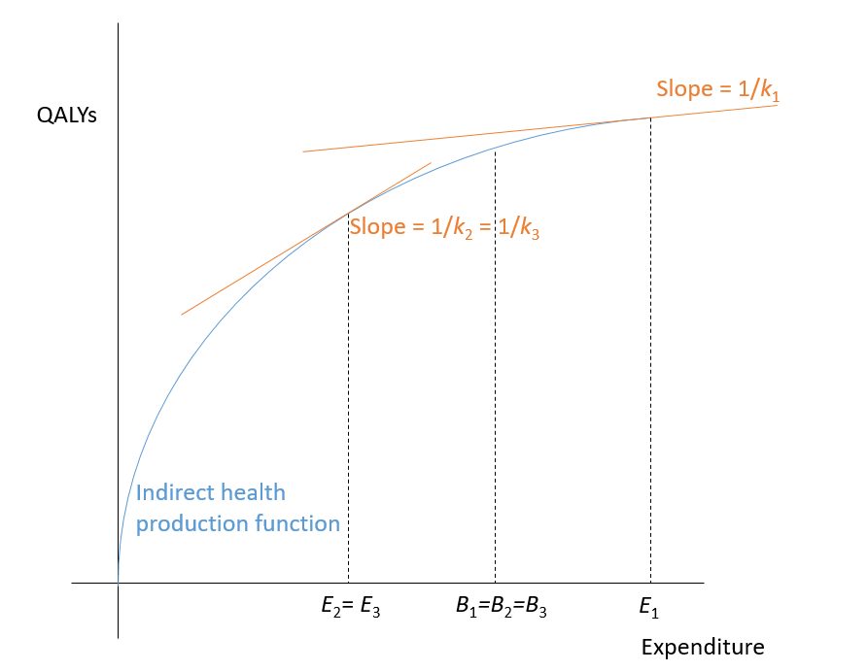 Figure 3: The implied optimal supply-side threshold, k_{t}, for each time period varies with the level of expenditure, E_{t} in that time period. This illustrates Scenario 3 in Lomas (2019).

This can be alternatively formulated as in Claxton et al. (2011) as being implemented through an adjustment to the discount rate for each time period g_{k}=k_{t+1}/k_{t}-1, reflecting the rate of growth of the reciprocal of the slope of the indirect health production at the point where expenditure is exhausted.

- Is there a useful distinction to be made between capital and current spending?

A further question arises as to whether it is sensible to judge the worthwhileness or otherwise of high budgetary impact health spending within this framework. Consider again the programme under consideration in Lomas (2019), with possible financing options outlined in Table 1 & Figure 2. This programme has a resource use of £772mn in year one, and zero costs in all future years: while the time profile of health benefits is not given, it seems reasonable to conclude that the resulting benefits from this initial one-off piece of spending are spread over future time periods. This appears to be an archetypal example of capital, rather than current spending: one that would conventionally be assessed as an investment decision where a large one-off commitment yields future benefits that can be characterised. It is unclear, for instance, how this decision differs from one regarding the building of a new hospital in order to achieve future benefits that extend beyond the first year of its financing. In this context, it seems somewhat odd to approach the decision to be made within a framework designed primarily for current, rather than capital, expenditure. Indeed, Scenario 2 in Lomas (2019) considers a mortgaging agreement over a sufficiently long time period that the budgetary impact in any given year may be considered to be marginal, and that k becomes the appropriate threshold to be used in the limit as this time period extends sufficiently. In the limit, similarly & as a corollary, spending for this project does not appear on the current spending budget. The existence of such problems represents the general justification for the use of separate capital and current budgets and respective explicit related decision rules for capital and current spending.

It is useful to return to Keynes (1942) at this point. The much-cited mantra of “[a]nything we can actually do we can afford” from this paper rests on the conviction that the role of finance represents only a technical problem to be solved given social preferences for social programmes and available resources. Keynes questions – in an example that generalises – “if there are bricks and mortar and steel and concrete and labour and architects, why not assemble all this good material into houses?”. It would seem curious that financial arrangements could be held to impact upon the desirability of funding a new programme: the question of whether something is socially desirable is anterior to that of any potential financing arrangement employed to bring it into being.

What would an appropriate decision rule be to establish the social desirability of such spending? Lomas (2019) presents decision-making in Scenario 2 apparently in the framework of current spending, but describes in situation in which no spending in the limit falls on the actual budget for current spending. This is effectively already a capital spending decision rule, tacitly assuming a separate budget for capital spending, or at least acknowledging the irrelevance of this project for impacts on current spending budgets. While new interventions with non-marginal budgetary impacts have meaningful implications where such impacts occur repeatedly over time, one-off budgetary impacts should not be seen as displacing current health but judged as capital investments yielding future health benefits. In a world where the future health benefits of such an intervention accrue in a predictable and uniform way in each future year, the decision rule would seem to simplify down to making the investment if and only if the future rate of return exceeded the relevant discount rate. Given that public financing of capital investments with upfront costs is routine and well-established, it is unclear why the manufacturer’s “real return to capital” (Lomas, Claxton, et al., 2018) should be relevant here, nor why there should be any need to “come to an agreement with the manufacturer about how the payment for the intervention is to be made over time” (Lomas, 2019).

Conclusions

This paper argues that previous characterisations of one-off non-marginal budgetary impacts would benefit from: 1) clarity as to whether the social process by which decisions are made regarding the health service are regarding financial allocations or desired levels of spending, 2) precision regarding the impact of large actual impacts on spending on the appropriate k to be used, and 3) a distinction regarding capital and current spending.

In summary:
- If what is allocated by the social process determining the health budget is a demand for expenditure in that year, any decision to smooth the impact on the budget for current spending across financial years is questionable in that it involves decision-making that would cause expenditure to deviate from this level. If, conversely, decision-making in each year merely makes a financial allocation, the decision-maker is entitled to take the net present value of B_{t} for all time periods and make financial decisions that result in maximising the present value of health.
- If potential expenditure on the new programme falls on the budget for current spending, smoothing spending over a finite time period affects the relevant portion of the current indirect health production given decisions regarding spending on currently employed programmes and the potential for the expansion and contraction of these programmes. This in turn affects the relevant value of k at the margin in each time period.
- Smoothing spending over a time period such that the relevant threshold to be used tends towards k at the margin essentially disguises what is a capital investment decision. Existing methods for determining whether capital investments are desirable are well-known and can be used in this context.

Bibliography

Bilinski, A., Neumann, P., Cohen, J., Thorat, T., McDaniel, K., & Salomon, J. A. (2017). When cost-effective interventions are unaffordable: Integrating cost-effectiveness and budget impact in priority setting for global health programs. PLoS Medicine, 14(10), e1002397. https://doi.org/10.1371/journal.pmed.1002397
Charlton, V., Littlejohns, P., Kieslich, K., Mitchell, P., Rumbold, B., Weale, A., Wilson, J., & Rid, A. (2017). Cost effective but unaffordable: An emerging challenge for health systems. BMJ, 356, j1402. https://doi.org/10.1136/bmj.j1402
Claxton, K., Palmer, S., Sculpher, M., & Walker, S. (2010). Appropriate perspectives for health care decisions.
Claxton, K., Paulden, M., Gravelle, H., Brouwer, W., & Culyer, A. J. (2011). Discounting and decision making in the economic evaluation of health-care technologies. Health Economics, 20(1), 2–15. https://doi.org/10.1002/hec.1612
Culyer, A. J. (2016). Cost-effectiveness thresholds in health care: A bookshelf guide to their meaning and use. Health Economics, Policy, and Law, 11(4), 415–432. https://doi.org/10.1017/S1744133116000049
Dimson, E., Marsh, P., & Staunton, M. (2021). Credit Suisse Global Investment Returns Yearbook 2021—Summary Edition. Credit Suisse.
Howdon, D., Lomas, J., & Paulden, M. (2019). Implications of Nonmarginal Budgetary Impacts in Health Technology Assessment: A Conceptual Model. Value in Health. https://doi.org/10.1016/j.jval.2019.04.001
Keynes, J. M. (1942). How Much Does Finance Matter? The Collected Writings of John Maynard Keynes; Royal Economic Society. https://doi.org/10.1017/UPO9781139524216.007
Lomas, J. (2019). Incorporating affordability concerns within cost-effectiveness analysis for health technology assessment. Value in Health. http://eprints.whiterose.ac.uk/146216/
Lomas, J., Claxton, K., Martin, S., & Soares, M. (2018). Resolving the “Cost-Effective but Unaffordable” Paradox: Estimating the Health Opportunity Costs of Nonmarginal Budget Impacts. Value in Health: The Journal of the International Society for Pharmacoeconomics and Outcomes Research, 21(3), 266–275. https://doi.org/10.1016/j.jval.2017.10.006
Lomas, J., Martin, S., & Claxton, K. P. (2018). Estimating the marginal productivity of the English National Health Service from 2003/04 to 2012/13.
National Institute for Health and Care Excellence. (2015a). Daclatasvir for treating chronic hepatitis C. https://www.nice.org.uk/guidance/ta364
National Institute for Health and Care Excellence. (2015b). Ledipasvir–sofosbuvir for treating chronic hepatitis C. https://www.nice.org.uk/guidance/ta363
National Institute for Health and Care Excellence. (2015c). Ombitasvir–paritaprevir–ritonavir with or without dasabuvir for treating chronic hepatitis C. https://www.nice.org.uk/guidance/ta365
Paulden, M. (2018). Strategic Behaviour and the Cost-Effectiveness Threshold: A New Conceptual Model. https://www.ihe.ca/publications/theoretical-models-of-the-cost-effectiveness-threshold-value-assessment-and-health-care-system-sustainability
Rumbold, B., Charlton, V., Rid, A., Mitchell, P., Wilson, J., Littlejohns, P., Max, C., & Weale, A. (2019). Affordability and Non-Perfectionism in Moral Action. Ethical Theory and Moral Practice. https://doi.org/10.1007/s10677-019-10028-4
Stinnett, A. A., & Mullahy, J. (1998). Net health benefits: A new framework for the analysis of uncertainty in cost-effectiveness analysis. Medical Decision Making: An International Journal of the Society for Medical Decision Making, 18(2 Suppl), S68-80. https://doi.org/10.1177/0272989X98018002S09

Equivalently a “net benefit” rule (Stinnett & Mullahy, 1998) can be adopted.
See Culyer (2016) for an intuitive model of what is represented by the cost-effectiveness threshold and of related issues.
A full conceptual model drawing out more explicitly how this relates to decision-making and various implications of this for equity and pharmaceutical pricing is presented in Howdon et al. (2019).
Although theoretically this may not be the case and thus this may not hold as an accounting identity, assume the (hopefully) trivial principle of monotonicity in production – that increasing the budget can always lead to increasing the amount of health produced.
It is unclear as to whether – and why or why not – this would rule out the use of using the present value of the budgetary allocation of the NHS as available investment funds to be grown in whatever way the decision-maker saw fit.
Where C_{t} represents costs at time t, and HOC represents these as health opportunity costs in QALYs (i.e. dividing costs by the estimated relevant supply-side threshold).
Further, forgone health as a result of the reduced £193mn in the budget in year 2 would have in fact been generated more efficiently in year 2 than the marginal value of k had the budget not been reduced. In this case, no additional implications arise as cost displacement in years 2 and 3 is zero.
Emphasis in original.

