PARTNERSHIPS FOR EQUITY AND INCLUSION

ADOLESCENT GIRLS MISSING FROM THE RADAR OF DEVELOPMENT:

PILOT PROJECT FROM FEDERAL CAPITAL TERRITORY, NIGERIA

Felicia Iyore Onibon; Angela Onome Oyedele; Rachael Atiba; Ekundayo Ocholi; Mabel Evwierhoma; Emem Olutoke; Rafatu Abdulhamid; Adetayo Erinle

March 2022

This report was produced as part of the activities of the Partnership for Equity and Inclusion, a collaboration of international research networks aiming to support equitable practice in public service institutions. Findings aim to inform policymakers and practitioners in public services as well as advocacy groups that seek to improve public service access, outcomes and representation for socially excluded populations.

About the research team:
Change Managers International Team comprises development-oriented individuals with several years of experience in the Non- Governmental Organization sector. They are Mrs Felicia Iyore Onibon, the President/CEO, Change Managers International Network and National Coordinator, 100 Women Lobby Group. She is a PhD student in Gender and Development Studies; she has over the years worked to link research to policy action and legislative advocacy. Mrs Angela Onome Oyedele, a Psychologist who also holds a Master’s Degree in Development Studies and Mrs Rachael Atiba, a Political Scientist with a Master’s Degree in Political Science. The team also includes academic staff from the University of Abuja who are also members of the academic faculty of the Centre for Gender Security Studies and Youth Advancement. They are, Prof Ekundayo Ocholi [immediate past Director of the Centre], Professor of Counselling Psychology, Professor Mabel Evwierhoma, current Director of the Centre, a Theatre Arts Professor and a Lawyer, Dr Emem Olutoke, a Theatre for Development expert and a lecturer at the Centre for Gender Security Studies and Youth Advancement. Dr Rafatu Abdulhamid, a Lecturer of Islamic Studies, University of Abuja, Nigeria. In addition, Architect Adetayo Erinle, the CEO of Tabitha Cumi Foundation an NGO known to have worked to promote the development of girls, adolescent girls and less privileged women in rural communities in the Federal Capital Territory.

Contents

EXECUTIVE SUMMARY 4
BACKGROUND 6
Adolescent girls in Nigeria 6
Inclusion interventions 8
Research Questions 9
METHODS 10
Sample Size and Sampling Technique 10
Data Analysis 10
FINDINGS: 12
Policy factors 12
Organisation-level factors 14
Community-level factors and Intersectional disadvantage 15
RECOMMENDATIONS 18
Policy recommendations 18
Community recommendations 19
CONCLUSION 19
References 21
APPENDICES 22
1. TOPIC GUIDES 22
2. FIELDWORK PICTURES 23
3. ANALYSIS ACROSS SAMPLE 28

EXECUTIVE SUMMARY

The growing inequalities within nations especially on issues of welfare and the livelihood of girls and women are a major focus of the UN Sustainable Development Goals. Change Managers International Network (CMIN) in collaboration with the University of Abuja and Tabitha Cumi Foundation (TCF) embarked on a pilot research project as a part of the Partnership for Equity and Inclusion collaboration, in order to identify drivers of social exclusion that maintain or creates inequalities and negatively influence the education, health and livelihood of adolescent girls in Nigeria.
Methods
The participatory method was adopted throughout the research where adolescent girls from 12 rural communities in the Federal Capital Territory, Abuja, were trained on participatory research method and the importance of this method in influencing communal values, norms and leadership processes that affect their overall development.
The research team received training in participatory methods from Professor Rachel Julian and Dr Ghazala Mir, using a Train the Trainer approach, through both online video tapes and zoom sessions. Twelve young women were then engaged by the team and trained in the methods as an opportunity to become a pivotal force in exploring and reducing the marginalization of women and girls in their communities. Interviews and focus group discussions involved a further 60 girls from the six area councils. These approaches supported the objectives of the Partnership for Equity and Inclusion Network to build capacity, resources and skills of the adolescent girls and their networks, including parents, relatives and community members. .
Results
Adolescent girls in the rural areas in which the study was conducted experienced poverty and lack of educational, healthcare and work opportunities as well as lack of inclusion in decision-making, all of whichconstrained their life opportunities and were not addressed in policy or practice. There is an urgent need for change in the political climate and for government at federal, state, and local levels to develop intervention policies for the inclusion of adolescent girls who are out-of-school or at risk of dropping out of education.
Recommendations
More inclusive policies and resources are needed to provide access to free education for adolescent girls in the study sites. Government should ensure access to good quality basic amenities in these areas, such as health and judicial processes alongside education and work opportunities, and these should be developed with the involvement of village heads, female leaders and girls themselves. Support and empowerment is also needed for girls who cannot return to school but wish to engage in trade. Community leaders should ensure an improved level of participation for girls in areas of decision-making that affect their lives.

BACKGROUND
The population of Nigeria, a Sub Saharan country in Africa, has risen to about 220 million with an estimated 49.5 % of women and girls. A larger percentage of Nigerians are unable to afford the high cost of living in the urban centres, thus most reside in the rural areas and have to cope with poor access to education, health and economic empowerment. Adolescent girls in the rural areas are also constantly victims of sexual and gender-based violence without access to justice and no voice to challenge oppressive structures (WHO, 2018)
The response of the Nigerian government in line with International conventions has been to enact legislations to protect the rights and lives of her citizens particularly children including the adolescent girls who are the focus of this study. The Child Rights Act passed into law in 2003 provides for the right of the child to the following; to health and health services, to parental care, protection and maintenance, to dignity of a child, to prohibition from marriage, to free, compulsory and universal basic education among others (Federal Ministry of Women Affairs 2004).
According to the Nigerian Child Rights Act of 2003, a child is any person below the age of 18 years. The federal nature of Nigeria has been a major impediment to the implementation of this act throughout Nigeria as only 24 out of the 36 states have adopted the Act (Federal Ministry of Women Affairs, Abuja, 2004). Other legal provisions that protect adolescent girl exist at the national level, such as the Trafficking in Persons (Prohibition) Law Enforcement and Administration Act 2003 and the Violence Against Persons (Prohibition) Act, 2015. Various states in Nigeria have also put in place legislative measures to secure the rights of children such as the Ebonyi State Law on Abolition of Harmful Traditional Practices Against Children and Women, 2001, Edo State Female Genital Mutilation (Prohibition) Law 2002, Bauchi State Hawking by Children (Prohibition) Act of 1985 and Cross River State Girl Child Marriages and Female Circumcision (Prohibition) Law 2000 (Country Report on Violence Against Children, Federal Ministry of Women Affairs, Abuja, 2004).

Adolescent girls in Nigeria
Nigeria is a country with diverse cultures and ethnicities and , as a developing country, it is faced with significant economic and social challenges. Its diversity encompasses norms that constrain women and girls from achieving their full potential in terms of participating fully in education, jobs and employment as well as in decision-making and governance (Klugman, 2018, p. 7)).
Nigeria has a young population with median age of about 18 years. Nigeria ranks low in various indices of human development and social norms can constrain women and girls from achieving their full potential, through participating fully in education, jobs and employment and involvement in decision making and governance. On the 2017 Women, Peace and Security Index, for example, Nigeria ranks 128 of 153 countries on dimensions of women’s inclusion, justice and security and performs especially poorly on indicators of women’s education, bias in favour of sons over daughters, and organized violence (Klugman, 2018, p. 7).
Many women and girls in Nigeria live in poverty and face major impediments to accessing social services and employment opportunities, especially those who live in poor households. While some progress has been made in closing gender gaps, the 2015 National Human Development Report notes that women continue to have access to fewer economic, political and social resources than men (UNDP, 2016).
A girl born in Nigeria, if she survives her childhood years, has a 40% chance of being married by age 15 and likely to become a mother before the age of 17 (UNDP, 2016).
Poor infrastructure and poverty make it difficult for girls to remain and complete their schooling up to the secondary level.::
“Close to 80 percent of poor households are in the North, which makes it challenging for them to cover the direct and indirect costs of schooling. All these factors have contributed towards limiting the number of girls that have access to secondary school. If nothing is done, 1.3 million girls out of the 1.85 million who began primary school in 2017/2018 in the northern states will drop out before reaching the last year of junior secondary school.”
(World Bank, 2020)
Adolescent girls in Nigeria are also subject to early marriage. Save the Children (2021) reported that 44% of girls were married before their 18th birthday and 17% were married before age 15. Men marry later than women and this difference in age, coupled with lack of educational and economic opportunities for women, reduces women’s agency and increases their vulnerability to physical abuse and domestic violence. Women were also shown to have very little to say in household decision making and rates of gender-based violence were as high as 52% of women experiencing domestic violence. Bello (2007) highlighted that over half of the girls in North West Nigeria are married by age 15, and over 80 percent are married by age 18. Girls in rural areas are significantly more likely to be married early compared to urban girls. The vulnerability of married adolescent girls is the basis for key recommendations put forward by the study that intervention programmes should be aimed at preventing early marriages and supporting married adolescent girls (Bello 2007; Save the Children 2021).

Inclusion interventions
The World Bank through the AGILE project, has invested in Nigeria to boost girls’ education (Discourse on Development 2020). The Coca-Cola company and several partners launched the Educating Nigerian Girls in New Enterprises (ENGINE) programme (DFID 2014). This programme brought together public and private sector partners to support the most marginalized girls in school and out of schools in poor communities. The aim of the programme was to build the girls’ confidence, increase their skills in financial management, leadership and business and influence gender norms in the community to empower women and girls. In one example,
The ENGINE programme sought to reach marginalized girls: those who were married, pregnant or had a child before the age of 18, divorced or widowed girls, unmarried, orphaned or come from a single-parent household; having a disability; living in a household with disabled family member or unable to pay school fees. The programme also intended to expand opportunities for girls aged 16-19, in school and out of school by building their confidence, increasing their financial management skills and working to influence gender norms around women and girls in the community. By 2017, the programme had reached 21,000 girls.
A 2008 Report compiled by the Nigeria NGO Coalition on CEDAW for the Forty First session of the Committee on the Elimination of all forms of Discrimination Against Women (Women Aid Collective 2008 p. 26) identified challenges and gaps in the implementation of existing laws that seek to protect the right of Girls and Women. These include the lack of faithful implementation of the established policy framework due to the wide gap between policy prescription and practice, non-existing resources budgets towards accomplishing goals and objectives of policies, low awareness of state laws that seek to protect the rights of women and low budgetary allocation to women ministries, making them redundant and distant from their primary constituency.
Bello (2007), who studied the experience of Married Adolescent Girls in Northern Nigeria, noted that most programmes being organized for young people targeted unmarried adolescent girls. Her study revealed that most adolescent girls in the North are married.
A situational analysis of adolescent health and development in Nigeria ( World Health Organization 2018) reported that legal and policy frameworks exist for the promotion of Adolescent Health and development in Nigeria such as the Nigerian constitution, Child Rights Act, National Health Act, National Policy on Adolescent Health and Development, National Youth Policy, the Ministry of Youth and sport Development but very little impact has been made in relation to adolescent girls’ welfare as there is no budget for programmes targeting adolescent girls at national and subnational levels. Like most government interventions in Nigeria, weak coordination of activities and programmes is another impediment.

Research Questions
The research aims to answer the following research questions.
- What is the level of education of adolescent girls in 12 communities selected in FCT Nigeria?
- What are the forms of marginalization being faced by adolescent girls in the communities selected?
- What are the socio-cultural factors that bring about and maintain the marginalization of Adolescent girls in the 12 communities?

METHODS
Participatory research design was used for this study. The selection process involved six Area Councils in the Federal Capital Territory, Abuja: AMAC, Kuje, Gwagwalada, Kwali, Abaji and Bwari. Two communities were identified for this research in each Area Council. Six girls were selected and trained on participatory research and afterwards, they participated in formulating the research questions with which communities were later engaged. This was important for the research as a means of familiarizing the 6 girls with participatory research methods, also as a means of educating the girls on the purpose of the Partnership for Equity and Inclusion research project and the expected impact. Data was collected by these Peer Researchers along with the research team, using Focus Group Discussion (FGD) with adolescent girls between the ages of 9-18 and Key Informant Interviews with traditional rulers and community members. Communication took place in English, Pidgin, Hausa, Gagara and Gbagi. Consent forms were made available to participants. Pictures of the process were taken by field assistants, interview recordings and videos were also taken to aid analysis.

Sample Size and Sampling Technique
The sample size for the research from each Area Council involved 66 girls and 12 Key Informants as follows:
Abaji: 11 Girls and 2 Community Leaders
AMAC: 13 Girls and 2 Traditional rulers were interviewed
Bwari: 11 Girls and 1 community leader
Gwagwalada: 11 girls and 2 Community/Traditional Leaders, such as tribal chiefs
Kuje: 10 girls and 1 community leader
Kwali: 10 girls and 4 community stakeholders
Purposive sampling was used to identify girls from six area councils, aged 12-18, who were excluded from development opportunities and from diverse ethnic groups.

Data Analysis
Interview data was transcribed verbatim and analysed thematically while paying attention to how frequently some of the themes were identified. This approach supported analysis of common and unique experiences within the sample [see Appendix 3]. Key themes identified from interviews and focus group discussions were: Inequality, Access, Health, Economic Empowerment, Gender Based Violence, Voice, Justice and Policy. The number of girls interviewed in each community and their ages was also documented during analysis.

FINDINGS
Key policy and social issues affecting the disadvantaged groups involved in the study related to the political climate, non-recognition in data and allocation of resources.

Policy factors
The Child Rights Act of 2003 prohibits exploitative labour of children but child labour and exploitation were noticeable in the communities visited. Despite the existence of the Child Rights Act there was no implementation of the policy and no provision by the Government to prevent exploitation, This appeared to be a major reason that the adolescent girls interviewed were excluded from the radar of national development activity. In Abaji the two communities Rimba 1 and Rimba 2 are agrarian communities with a quarry area located within the communities. Due to work activities available in the quarry and financial limitations experienced by adolescent girls, including the inability of parents to care for their children, some of the girls were involved in the trade of selling sand to the construction companies for the meagre sum of 1500 naira (about $3.6) for a tipper of sand. Commonly, girls took on this work willingly because they were aware of family difficulties.
In Bwari adolescent girls interviewed said they were never forced to work as they do these of their freewill and for upkeep of their families. In Kuje the girls said that due to the inability of their parents to support their education beyond secondary school, they resolved to trade as a means of saving for their education and up keep. One girl in Kuje said that her mother sometimes asked her to contribute to cooking expenses and could threaten not to feed her when she was unable to do so.
In the communities interviewed, very little attention appeared to have been paid to adolescent girls’ education and it was common to find girls who were not educated beyond primary school level. Participants attributed this to a strong preference for male child education over that of female children as it was believed that boys are of more value to family income. For this reason, girls were often left at home to assist their mothers instead. Participants pointed out that adolescent girl education was usually perceived as a burden to the family and a loss as she would be married off eventually. Participants recognised the value of education, however, and that, in the context of a patriarchal society, girls would not be empowered to speak up, challenge or make demands on the existing systems within communities without education,.:
“without being educated, you cannot be seen or known in the community…when a female is educated, she can express herself and she is well recognized in the community. It is important for the development of the communities… when I want to marry, my husband will respect me, and I will be able to express myself and be respected.”
Gwgwalada AG1, aged 16
Girls were thus aware of the importance of education and the effect of lacking this on the adolescent girls' growth and development.
Lack of policy support for the financial pressures and high birth rates in rural families could also contribute to the inability of parents or families to meet the needs of their children and especially adolescent girls:
Because we have a large-family of an average of 11 children, there is usually an arrangement to send some to school while others learn a trade especially girls. In cases where a girl is sent to school it is usually difficult to pay school fees and some drop out of school. It has increased suffering as fathers are usually torn between providing for all the children with so much pressure from their wives, this creates more problem for the family as unhealthy competition arises. Fathers also have to work harder in their farms to meet up with their obligations to the family.
Adolescent girl aged 17, Kuje
Poor living conditions in turn made girls vulnerable to social factors that could lead to unwanted pregnancies. Pointing out the negative effects of this context, a community leader said that early marriage could be a reason for increased gender based violence as underage couples are not yet mature enough for marriage.

Organisation level factors
Another factor around poor policy implementation that affected adolescent girls was the lack of public secondary schools in some of the communities and the dilapidated structures of schools that did exist in others. This meant that even when parents were interested in supporting their adolescent girls to go beyond primary education they could be discouraged by the extra transport costs of sending the girls to school since there were no free school buses to convey them. We found that some parents rented accommodation for their daughters but this raised other issues of concern such as financial pressures that could lead to promiscuity and unwanted pregnancies
‘sometimes they have to meet boys for money when their rent expires and when they run out of food and pocket money while living alone’.
Bwari AG1, aged 15
Similar issues were found in Gwagwalada where some girls relied on boys to take care of their personal expenses.
The development of adolescent girls was further jeopardised by the absence of quality health care or health education, which could affect their self-esteem and expose them to sexual manipulation. Particpants in Abaji informed the team that, unlike their urban counterparts, they had never seen sanitary towels and were obliged during their menstrual cycle to make use of cotton clothes. This could have negative implications on their health and make them susceptible to infections:
“Girls in my community are suffering from toilet infections.”
Adolescent girl, Kuje Gafere
The majority of adolescent girls in Abaji and Kwali claimed they resorted to the use of local herbs for health treatments, due to the lack of funds. A Chief informed interviewers that there were two primary health centres in the Idu-koro and Karimo communities of AMAC but the structure and capacity was limiteddespite these being semi-urban-communities. When women had serious health emergencies, they would have to go all the way to Dei-Dei, about 10 km away to be treated. The two communities researched in Kuje make use of one primary health care centre but most people relied on a local chemist.
“We do not have health centre in my community. Like when someone is pregnant and in labour, we have to take the person to Dafara community, health care and treatment is not free. One will have to pay first before [being] attended to by the nurses there.“
Adolescent girl, aged 16 Kuje Gafere

All participants from the 12 communities in the six Area Councils under study agreed that adolescent girls from age 12-19 should participate in social and family-level decision making. Respondents also showed understanding of the importance of this as there were various concrete reasons given for this such as the necessity for the adolescent girl to be able to make inputs, be validated and make choices in matters that concern them.:
“everyone has different desires and the needs of the adolescent girls will be fully captured when young girls have a place in decision making.”
Adolescent girl, AMAC

Community-level factors and Intersectional disadvantage
Involvement in decision-making at the personal level was also emphasised by participants. Most adolescent girls said that marriages were usually arranged and hoped that with education they would be able to decide on their own who to marry. Families were very involved in arranging marriages, however, girls played very little roles in forced marriages and the victims of this practice were usually expected to adapt to their new situation without family support:
“It happened to my sister as she married before 18 years. First of all, the man denied the pregnancy and was always beating her. So, she decided to return to our house but my mother still forced my sister back to the man’s house. So, the man was always beating her until she finally gave birth to the baby. And when the man saw that the baby looked like him, he stopped beating her.”
AG2 aged 14, Kuje
Findings showed that girls were not allowed to contribute to decision making in the family and the community at large even on issues that concerned their betrothal, marriages, education and choice of trade. Girls in Gwagwalada pointed out how important it was for them to be able to decide on who they marry. Similarly, girls in Gafere and Dafara communities in Kuje believed that their being involved in decisions made concerning their education or trade would enable them commit fully to these. Being involved in decision-making was also seen as relevant to community leadership:
“It is important for us to be able to decide on who to marry.”
Adolescent Girls Focus Group, Gwagwalada.
“They ought to participate in decision making so that they can be elected as leaders in their society”
Adolescent Girls Focus Group, Kwali
Participants thus recognised the links between community and political dynamics - the ability of an adolescent girl to participate in decision making at the family and community level had implications for future participation in political and leadership roles, particularly in areas that affected their lives. This community level dynamic thus links to the skewed conditions in Nigerian politics where women are not adequately represented.
Community leaders were responsible for decision making in developmental matters that affected the communities visited and adolescent girls could also benefit from these decisions. However, no female community leader could be accessed by the researchers to respond to issues that concerned the welfare of the adolescent girls as most community leaders were males, apart from female leaders of markets. This indicates that within the communities visited, mostly men took decisions and engaged with government at all levels even on issues that affected the adolescent girls directly. There were no structures through which these leaders engaged with adolescent girls, married or unmarried, to discuss their priorities and this had of Clear implications for how well the welfare of the adolescent girls was considered in community and political processes. It is worth noting that Nigerian political processes did not require the representation of women and reinforced these community level dynamics.
Cultural norms and expectations could also have negative implications on education for adolescent girls. A community leader in Abaji, a noted that there was fear amongst families and community members that girls who able to achieve a university education had a higher tendency to bring a “strange man” from outside the community to marry. This concern could be a major reason for most of the girls not being educated beyond secondary school.
Again community level restrictions were, therefore, tied in with structural barriers in wider society that made it more difficult for girls access education and for communities to feel that this was possible in a safe environment that valued their cultural norms. The combined impact of this context meant that girls were either unable to access secondary education, increasing the chances of marriage at a young age, or else were vulnerable to exploitation because of their precarious financial situation.

RECOMMENDATIONS
More opportunities for development that improves the self-esteem of girls and positions them for inclusion in decision making at the family, community and governmental levels is needed. As highlighted in the Introduction to this report, gender issues have garnered much attention in recent times and preventing the marginalization of adolescent girls is an essential part of this development. There is potential for scaling these recommendations up across the country and indeed the African region, where women are recognised by the international community as a pivotal force to much needed development.

Policy recommendations
- More inclusive education and healthcare policies are needed from policy makers that implement the UN Sustainable Development Goals and ‘leave no one behind’.
- Government intervention is needed to improve the economic conditions of the communities to which the girls in our study belonged, for example, opportunities in the major community occupations of trade and farming such as support for modern ways of farming, in order to lift families out of poverty.
- The government should make education free for girls up to secondary level.
- The implementation of polices on education and infrastructural development should address the access of adolescent girls to schools, especially in rural communities where schools are located outside these communities.
- Termination of extreme poverty in these communities is needed to bring better opportunities for adolescent girls and to increase parents’ willingness to support their education.
- Basic amenities to increase the living standards of adolescent girls are needed, such as good roads, schools close to their communities, school transport and access to water and sanitation, including clean toilet facilities and sanitary towels.
- Award systems and scholarships that encourage adolescent girls in some communities to pursue education could motivate adolescent girls who may lack interest in education.
- Policy support is needed for girls to take decisions on matters that affect them directly or indirectly such as in deciding readiness for marriage, choice of trade and on academic pursuit.
There is high potential for scaling up recommendations particularly with special attention to the safety of girls in Nigerian schools.
Organizational recommendations
- Better access to education provision, particularly in relation to literacy, numeracy and business skills, would support girls’ capacity to become agents of change in their communities.
- Attention to pregnancy among adolescent girls and development of initiatives in collaboration with girls and their parents could mitigate the currently negative consequences of such pregnancies and help ensure that adolescent girls complete their education.
- Health, education and development organisations need to work closely with women and children in communitiesin excluded communities. Collaboration with those who have expertise in this area, and dialogue with diverse stakeholders, including adolescent girls and policymakers would build trust in communities and mutually beneficial partnerships.
- Health, education and development organisations should ensure that the principles of equity and inclusion are highly respected and that the voices and development of adolescent girls is prioritised and respected in governance.

Community recommendations
Community priorities and norms are central to the process of development and can not be ignored. Access to adolescent girls involved in this study could not be achieved without the permission of their community leader, even with evidence of governmental approval for the study. Recommendations for communities themselves put forward by study participants were:
- Community leadership should include more women and representation for the adolescent girl in village councils.

CONCLUSION
Sustainable actions that will improve the livelihood of the girls and their communities are needed.
It is important to note that participatory methods of research were a new phenomenon in all the communities with which we engaged. This innovation is mainly because of the high participation of the adolescent girls themselves. The confidence it roused in them was very significant. As a result of the research some of the girls became interested in going back to school or become more serious about learning a trade so they could build on the relevance that they experienced in the few months of engaging in this study. This method of engaging adolescent girls exposes them to new knowledge and skills that support their development and impact in their communities. The findings support participatory engagement methods in projects involving girls, such as a current World Bank project with Adolescent Girls in Secondary Schools in seven States in Nigeria on which some research team members are currently working. . One of the aims of the World Bank project is to attract more girls from specific communities into Secondary Schools. Participatory research methods would support girls to develop their voice in this process and their confidence to discuss issues relevant to going back to school.
A second recommendation from girls interviewed was that parents should be sensitized to the value of education for adolescent girls. This could be through using success stories or by showcasing girls of the same age group and women that have become a force to reckon with in the society due to education and participation in decision making.

References
Bello, Annabel S. Erullar Mairo. (2007) The Experience of Married Adolescent Girls in Northern Nigeria
Department for International Development (DFID) (2014) The Coca-Cola company and the UK government strengthen girls’ education and economic opportunities in Nigeria - GOV.UK (www.gov.uk) Accessed 24/3/22
Discourse on Development (2020) World Bank approves $500 million to access education for Nigerian girls Accessed 24/3/22
Federal Ministry of Women Affairs (2004) Country Report on Violence Against Children, Federal Government of Nigeria, Abuja.
Klugman J, Parsons J and Melnikova T (2018) Working to Empower Girls in Nigeria The Georgetown Institute for Women, Peace and Security
Save the Children (2021) State of the Nigerian Girl: An incisive diagnosis of child marriage in Nigeria. Save the Children International; Save the Children Nigeria
UNDP (2016) National Human Development Report for Nigeria United Nations
Women’s Aid Collective (2008) “CEDAW And Accountability to Gender Equality in Nigeria.” A shadow Report (Pg. 26)
World Health Organization.(2018) “Situation Analysis of Adolescent Health and Development in Nigeria.”

APPENDICES

TOPIC GUIDES
The following questions were used to engage with Adolescent girls between 9-18 years and community leaders in a Focused Group Discussion to investigate the state of the health, education and livelihood of Adolescent girls in the selected communities to answer the three research questions. The questions were in two sections, General participant questions and questions for adolescent girls as shown below.
General
- Do you think Adolescent girls’ education is a priority in your community?
- Why is Adolescent girls’ education important for development?
- Should Adolescent girls from the age of 12-19 participate in decision making?
- Why do you think Adolescent girls from age 12-19 should participate in decision making?
- How does financial limitation affect the progress of Adolescent girls?
- How does unwanted pregnancy affect the social and economic development of Adolescent girls?
- Why can`t Adolescent girls discipline themselves to avoid social vices that exposes them to unwanted pregnancies?
- Do you think the high poverty level has increased child labour?
- How has high birth rate affected parents in caring for the Adolescent girl?
- How does the underprivileged Adolescent girl access and maintain quality health care in your community?
- Do you think early marriage has increased GBV and health challenges among young women in your community?
- Suggest ways to inform parents on the importance of Adolescent girls’ educations
- How has limited education for Adolescent girls increased underdevelopment and social vices in your community?
- Is there anything you would like to tell us about your community we have not already talked about?

Adolescent girls
- Do you think Adolescent girls’ education is a priority in your community?
- Why is Adolescent girls’ education important for development?
- Do you think Adolescent girls should participate in decision making?
- Why do you think Adolescent girls should participate in decision making?
- Do you have a financial obligation to your family?
- Are you under pressure to fulfil financial obligations to your family?
- How does unwanted pregnancy affect the social and economic development of Adolescent girls?
- Why can`t Adolescent girls discipline themselves to avoid social vices that exposes them to unwanted pregnancies?
- Do you think the high poverty level has increased child (Adolescent) labour?
- How has high birth rate affected parents in caring for the Adolescent girl?
- How does the underprivileged Adolescent girl access and maintain quality health care in your community?
- Do you think early marriage has increased GBV and health challenges among young women in your community?
- Suggest ways to inform parents on the importance of Adolescent girl educations
- How has limited education for girls increased underdevelopment and social vices in your community?
- Is there anything you would like to tell us about your community we have not already talked about?

FIELDWORK PICTURES
Abaji team interacting with girls, community members and Traditional rulers during a visit to the community to collect data.
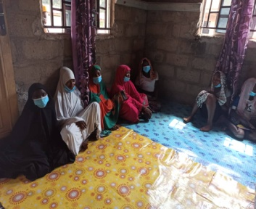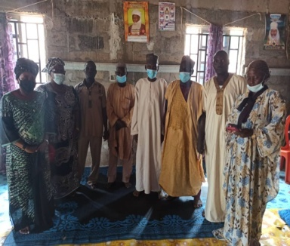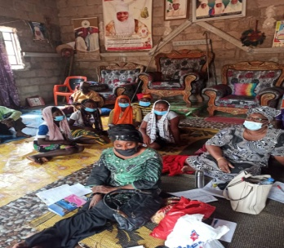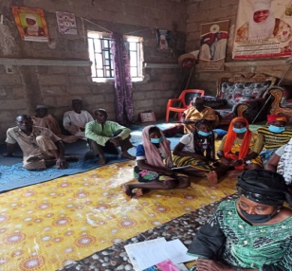

AMAC team interacting with Girls, community members and Traditional rulers during a visit to the community to collect data.
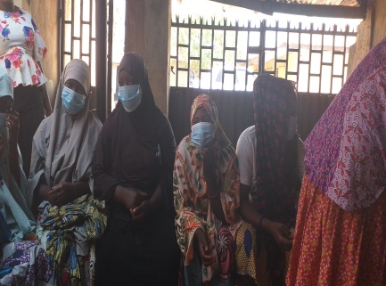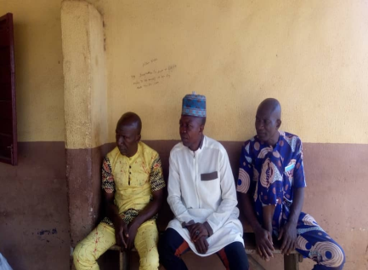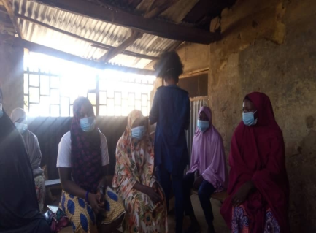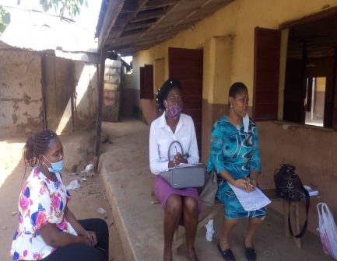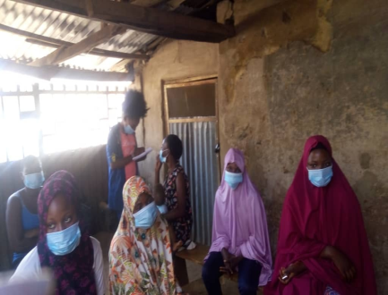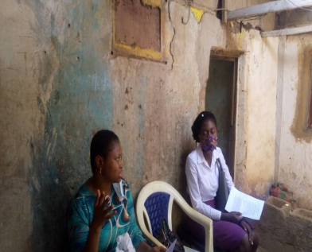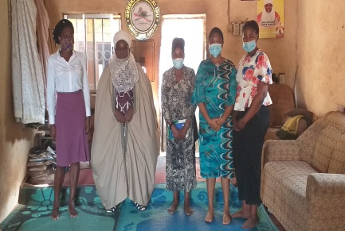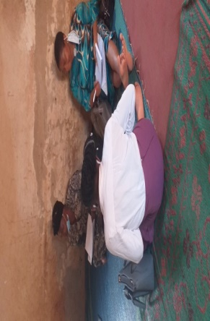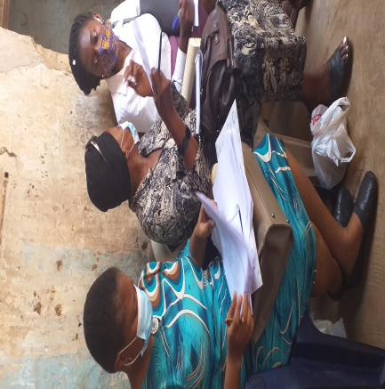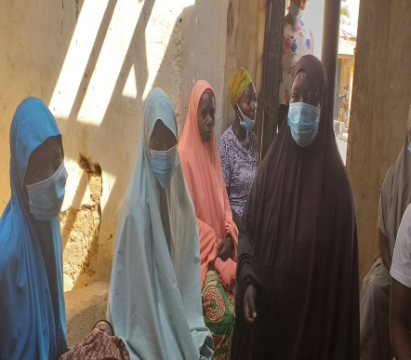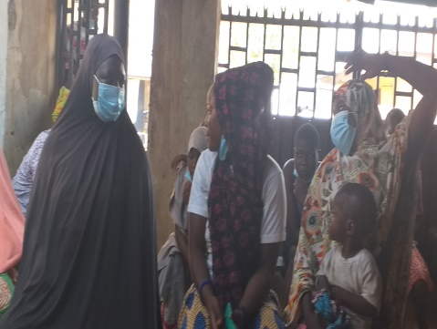
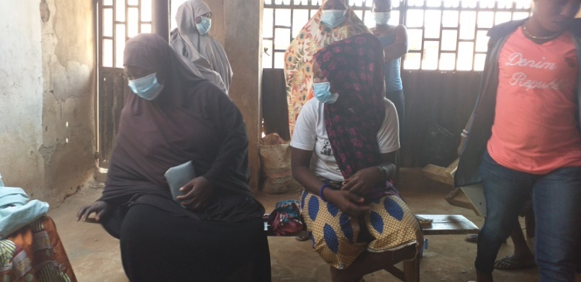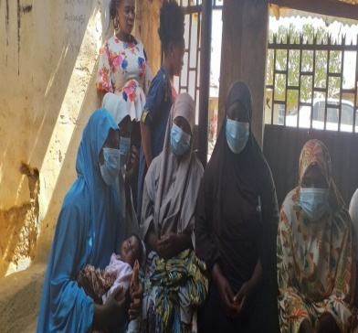

Bwari team interacting with Girls, community members and Traditional rulers during a visit to the community to collect data.
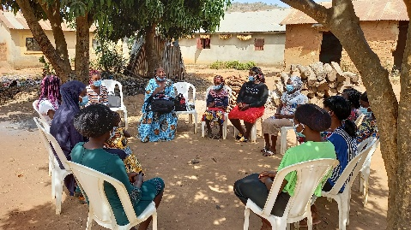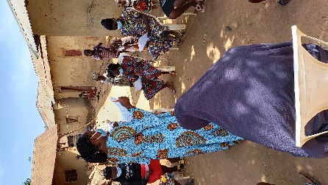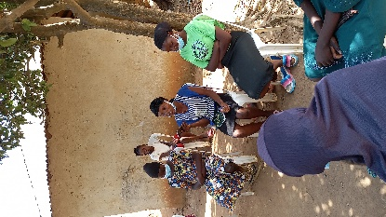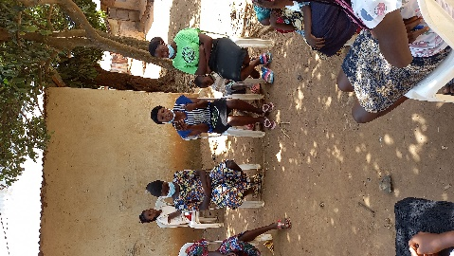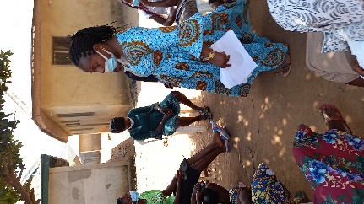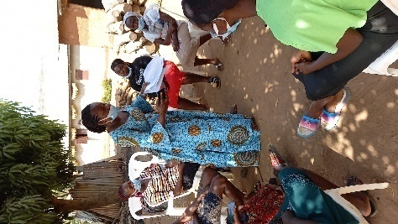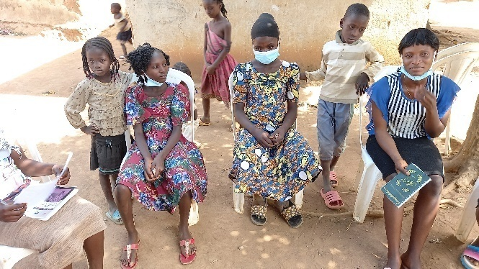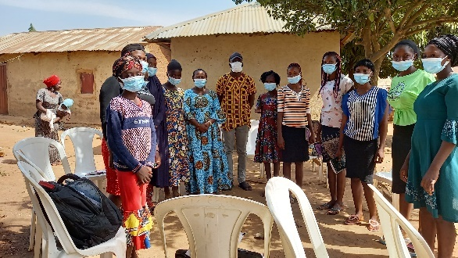

Gwagwalada team interacting with Girls, community members and Traditional rulers during a visit to the community to collect data
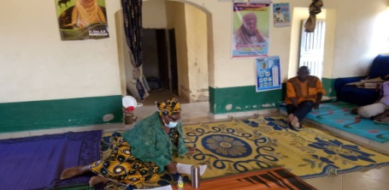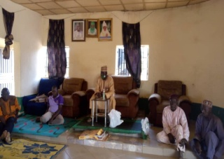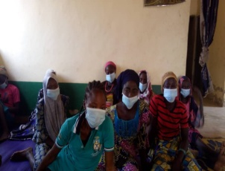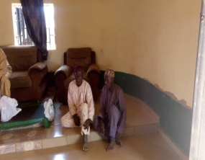

Kuje team interacting with Girls, community members and Traditional rulers during a visit to the community to collect data.
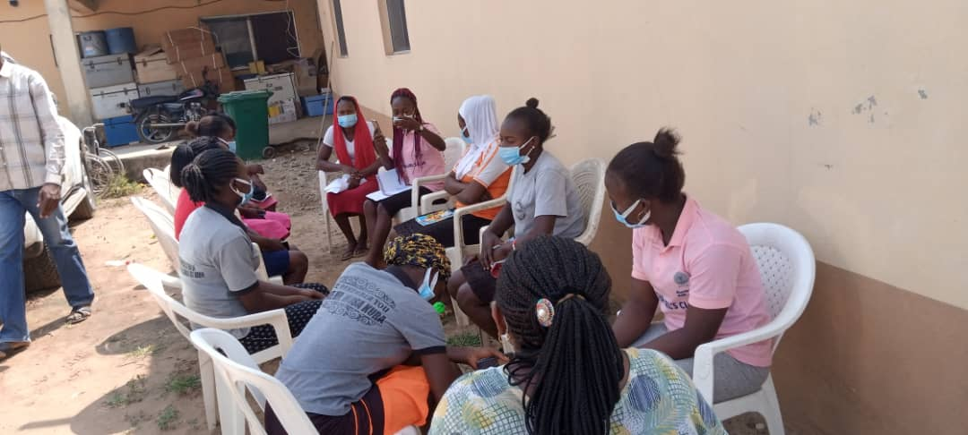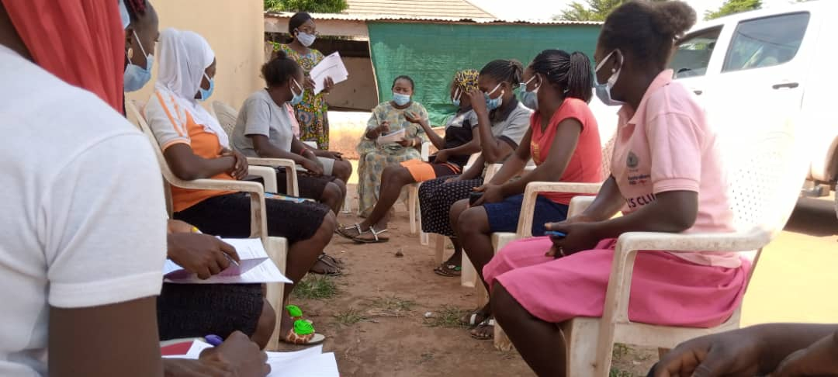

Kwali team interacting with Girls, community members and Traditional rulers during a visit to the community to collect data.
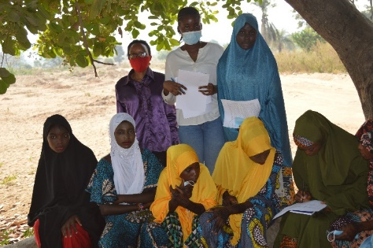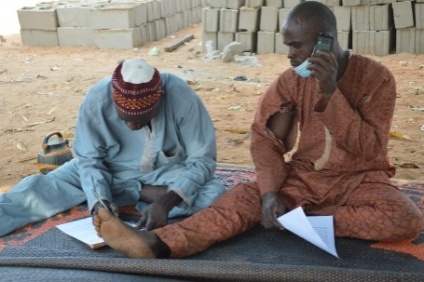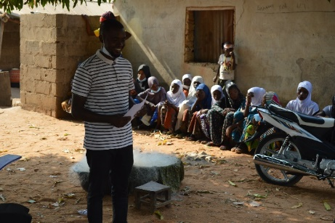
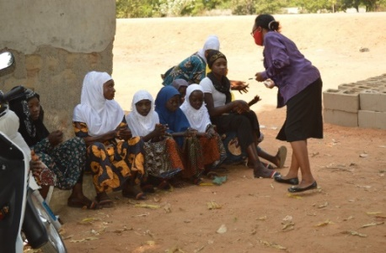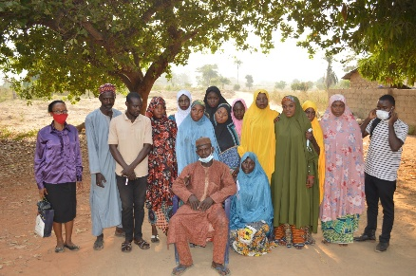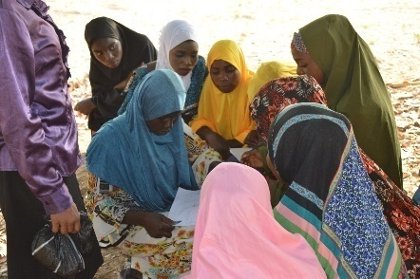

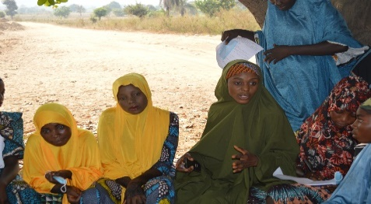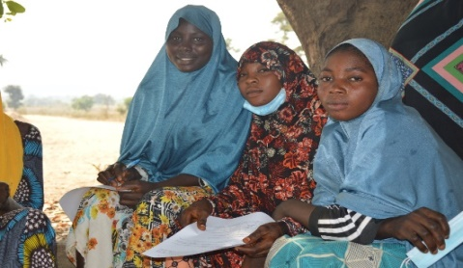

ANALYSIS ACROSS SAMPLE
QUESTIONS | ABAJI | BWARI | KUJE | KWALI | AMAC | GWAGWALADA
1 – education as priority | 100% | 100% | 100% | 100% | 100% | 50%
2 – why a priority | For development enhancement and infrastructure development | For development | Can excel at work, as it guarantees good life | For better positioning | For development | Same as Abaji
3 – involvement in decision-making | Yes | Yes | Yes | Yes | Yes | Yes
4 – reasons for involvement | To make decisions in family | Deserve to be held important  Differences in opinion and be respected | For exposure  Express displeasure  Right of Adolescent girl | To be elected as leaders | Different desires | To be able to choose life partners.  Members of community.  Making a contribution.
5 – impact of finance | Drops out of school | Child labour | School drop out | Drop out of school | Level of education is affected | Fall out of school.  Child labour subjection.
6 – unwanted pregnancy | Self-esteem is diminished.  Fallout of school.  Slow down productivity as cant interact with peers | LOW -SELFESTEEM | Subjected to poor living condition | Lack self control | Dreams are broken | Self esteem is diminished. Fall out of school.
7 – unwanted pregnancy causes | Financial constraints | Financial constraints | Poor educational background  Lack of willpower | Lack of self control | Social media influences | Temptation.  Boys over riding
8 – impact of poverty | Yes | Hawk to support family  To improve living | Yes | Yes | Yes | Yes
9 – parental care | Preference of boys | High cost of living | Parents unable to care for children | Parents make girls to marry early | Leaving girls to fend for themselves | Preference for boys
10 - healthcare | They fend for themselves through difficult means | No money | Adhering to teachings in school.  Some pay others said its free. | Use local herbs for treatment | Taken care of by the boys | Supported by family members fend for themselves
11 – early marriage | Yes, no much rape cases but no gender base violence | Increased immaturity and dispute | Yes- 20%  No- 805 | 50/50 | Yes | 50/50
12 – parental interventions | Sensitization replicate continuously | Encouragement.  Parents to work hard to provide. | Using success stories for parents using inter-me diaries | Sensitization | Awareness sensitization | Sensitization.  Collaboration with government and NGOs
13 – impact of limited education | Not being in school and gainfully employed | Ignorant and misinformed.  Lack of awareness and proper encouragement | Lack of parental care  Steal and get pregnant | No form of progress in community |  | Lack basic social amenities
14 – other issues |  | No water  No Bridge

