INEQUALITIES AMONG YOUNG PEOPLE IN INFORMAL SETTLEMENTS DURING THE COVID 19 PANDEMIC: A CASE STUDY OF KIBERA, NAIROBI

This briefing brings together evidence from a pilot study on how to address inequalities experienced by the youth in an informal settlement during the Covid-19 pandemic.

The research was carried out by HAKI Africa and is one of a series of pilot studies exploring how public services could be more inclusive of disadvantaged social groups in low and middle income country contexts. The studies are supported by an international partnership of academic, policy and non-government organisations collaborating to produce new knowledge and solutions to exclusion and disadvantage. More details of the PEI collaboration and a full report for this project can be found here

KEY RECOMMENDATIONS
Following the findings of this project, the following recommendations were developed.

Macro Level Recommendations
The Ministry of Health and the County Governments should improve access to universal health coverage by building and maintaining health facilities in informal settlements and providing medicines in existing dispensaries.

The Independent Policing Oversight Authority should investigate and punish corruption, harassment and extrajudicial killings perpetrated by police officers.

County Governments should adopt and implement policies that ensure proper waste management, water drainage and sanitation in informal settlements.

The National Government should sustain its youth employment program commonly referred to as Kazi Mtaani beyond the pandemic in order to enable youth to meet their livelihoods. The County Governments should join the national Government by providing economic stimulus programs for the youth in informal settlements.

The Ministry of Water should work with County Governments to increase access to water in Kibera by constructing piped water infrastructure.
The Ministry of Housing should construct affordable housing in the informal settlement.

Local Universities should collaborate with international academia to undertake further research on the required strategies to sustain equality in the informal settlements. Local Universities should also give special consideration for youths from informal settlements in their work-study programs.

The courts should convict politicians for paying young people to fight, purchasing and supplying weapons to them, and giving them free alcohol.

Meso- and Micro-Level Recommendations
The youth and the community within informal settlements should be supported to undertake community and resource mobilisation with the aim of enhancing services to their local areas.

Young people should be fully engaged in public participation processes related to national and county government development plans. This includes attending the open public meetings which occur in some of the wards in Kibera.

Youth in Kibera should be supported to develop leadership skills and to take advantage of all available opportunities including informal, non-formal and formal schooling.

FINDINGS
Using a participatory approach, this project revealed the following findings.
While unemployment is an overall challenge in Kenya, young people in Kibera face an extra burden of being racially stereotyped and profiled by employers as violent and lazy. Economic disadvantage results in a need for child labour to finance family costs means that young people become household bread winners at an early age. They often seek for a means of making money as quickly as possible, with negative consequences for their education and motivation to stay away from crime.

Most youth in Kibera lost their jobs during COVID-19 since they worked in the informal sector which was hardest hit by the effects of the pandemic. For some young people, prostitution was considered as the only option in order to get food on the table under the Covid-19 constraints.

“The government and civil society organizations should help the youths to kick start income generating activities.”
Johnson

Health facilities cannot be easily accessed due to distance, and they have inadequate or no medication. Maternity wards in most of the health facilities in Kibera are neither fully equipped nor well maintained. People are required to pay before being seen and Government-funded healthcare do not cover all diseases.

Most youth in Kibera who have no education at all migrated into the settlement when they were already older. Other youth attended the low-fee private schools, which are believed to offer lower quality education than government schools. The Ministry of Education embraced online teaching during the lockdown, thereby disadvantaging young people in Kibera due to the lack of energy, devices like smart phones and money to purchase data bundles.

Congestion in Kibera is caused by the numerous houses in the small area and the number of people living in single-room houses. Under these circumstances, social distancing was seen as the luxury of the rich. Houses were so close to each other and those living in them could not socially distance from either during their waking or even sleeping hours. Housing congestion was reported to be increasing and linked to sexual and gender-based violence.

Sanitation is still considered a luxury rather than a necessity and some young people have to pay in order to use a toilet. When they cannot afford to do this, they use alternative approaches, such as the “flying toilet” where inhabitants use polythene bags and dispose of them on their roofs. This exposes them to health hazards and infections such as tuberculosis, and diarrhoea.

Access to water is a problem in the settlement. So, young people rely on water kiosks, which provide water at a fee. While people can harvest water from rain during the rainy seasons, this water is hardly fit for drinking. Most young people could not practice hand washing effectively -the most common way of fighting Covid-19- due to insufficient water.

“I wish we could be treated like other Kenyans since we also pay taxes, just like them. I hope the government can come up with income generating programmes that target youths in our communities, housing strategies to ensure good living conditions in the slums, deliver water and sewerage services in our communities and establish employment agencies to address the acute unemployment rate...the government should implement strategies that eliminate discrimination against people living in the slums such as Kibera.”
Peris

The project also identified a cyclical relationship between unemployment and crime, which were both factors caused by and resulting from inequalities. Most youth who are not employed find themselves trapped in drug abuse and other crimes. At the same time, once convicted, young people cannot be employed in particular jobs, especially in government posts.

“We as youth, together with NGOs, should also come up with mentorship programs, that will help the youth not to engage in drugs and other illegal activities.”
Johnson
Police brutality and harassment has inculcated fear among youth who run away from any police officer in sight. The failure to hold the police and politicians accountable for their acts of violence has contributed to normalizing the use of violence in Kibera.

“The government should also hold the political leaders to account when they mobilize support and facilitate gangs to commit violence.”
Francis

“Police brutality is the biggest form of inequality I have seen as a young man living in Kibera, this needs to stop.” Butrose

Corruption in Kibera is linked to accessing basic needs such as housing. This corruption also feeds inequalities because only those with money can are assured of the services they seek.

Some laws and policies such as the high cost of licensing in order to establish small businesses further discriminate against the poor. Some youth reported not paying licenses in order for them to be able to kick start their businesses.

Some Government, NGO and community-based interventions are alleviating inequalities in Kibera. There is a need to maintain such efforts in order to achieve sustainable change.

“I still wonder what will happen to me after this Kazi Mtaani program ends...It may also be good for the Government to extend this Kazi Mtaani program as long as it can just to keep youths busy and avoid crime in the society.”
Austine

“I now believe that it is each and everyone's responsibility to steer our communities into safer paths as a result of the lessons learned during the COVID-19 outbreak.” Paul

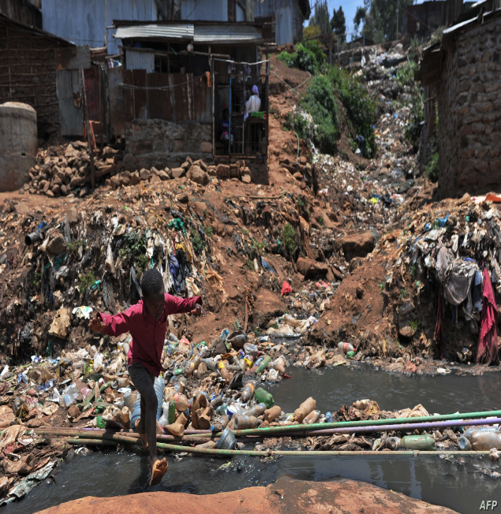
A child wades across the open sewage system in Kibera to leave the settlement.

For further details please contact:
Mr. Yassah Kimei
PI, Program Lead-HAKI Africa
Email: yassahmusa@gmail.com
Tel: +254 721 312922
Website: www.hakiafrica.or.ke

The Kazi Mtaani Programme is an initiative designed to cushion the most vulnerable youth in the informal settlements from the effects of COVID-19 pandemic.

