PARTNERSHIPS FOR EQUITY AND INCLUSION

Inequalities among Young People in Informal Settlements during the COVID-19 Pandemic: A Case Study of Kibra, Nairobi

Sellah King’oro, Yassah Kimei and Davis Oenga

March 2022

This report has been produced as part of the activities of the Partnership for Equity and Inclusion, a collaboration of international research networks aiming to support equitable practice in public service institutions. The findings of this report seek to inform decision-making of policymakers and practitioners in public services as well as advocacy groups that work towards improving public service access, outcomes and representation for socially excluded populations.
Research team member organizations:
- Government of Kenya
- Nairobi City County
- HAKI Africa
- Kituo cha Haki Kibera
- The Kenya National Cohesion and Integration Commission
- The University of Nairobi
- The Kibera Community Leadership Forum
Authors
- Dr. Sellah King’oro, PI-Head of Department-National Cohesion and Integration Commission, PhD
- Mr. Yassah Kimei, Co-PI, Program Lead-HAKI Africa, BA
- Mr. Davis Oenga, Co-PI, M&E Technical Lead-Kituo Cha Haki Kibera, MA

Copyrights Reserved @ University of Leeds, HAKI Africa and Kituo cha Haki Kibera www.hakiafrica.or.ke

About Haki Africa and Kituo cha Haki Kibera
HAKI Africa is a national human rights organization based in Nairobi and Mombasa working to improve livelihoods and to enhance the progressive realization of human rights in Kenya. Initiated in 2012, The Organization promotes partnership between state and non-state actors in order to constantly improve the wellbeing of individual and communities and ensure respect to human rights and rule of law
HAKI is a Kiswahili word meaning Justice or Human rights. Haki Africa therefore envisions that, human rights and dignity shall be granted to all. It seeks to promote transparency and accountability across all levels of Governance. Currently, the organization works in informal settlements across 15 Counties of Kenya.
Kituo Cha Haki Kibera is a youth led community based grass root organization that agitates and fights for the rights of the less fortunate; including youth and women of Kibera Sub-county. The aim of the organization is to empower the community on their rights and address the economic and social challenges they face through legal empowerment by community based paralegals and evidence based research. The organization is based in Kibra and addresses human rights violations the community face, including extra judicial killings, enforced disappearances, rape and defilement as well as other sexual and gender based violence cases.
Table of Contents
EXECUTIVE SUMMARY v
ABBREVIATIONS AND ACRONYMS viii
Introduction 1
Rationale 1
Goal 3
Objectives 3
Structure of the Report 3
INEQUALITY IN KIBRA: A LOOK INTO THE MIRROR 3
Introduction 3
Poverty 4
Health 5
Education 5
Population Density 6
Housing 6
Water and Sanitation 7
Waste Disposal 8
Energy 8
Income 9
Gender inequalities 10
Political participation inequality 10
METHODOLOGY FOR THE PILOT PROJECT 11
Introduction 11
Participatory Research Participants 11
FINDINGS 12
Demographic Characteristics of the Research Participants 12
Age and Gender Distribution 12
Duration of Stay in Kibra 12
Distribution 12
Educational Level 12
Occupation 12
Sources of Livelihood 13
Inequality Explained through Stories, Poems and Photos 13
Francis 14
Andrew 15
Margaret 16
Johnson 17
Austine 18
Grace 19
Peris 19
Angela 20
Butrose 21
Vivian 21
Nicky 22
Paul Odongo 25
DISCUSSION 26
Inequalities Facing Youths in Informal Settlement 26
Youth unemployment 26
Access to Health 26
Access to Education 27
Housing Congestion 27
Sanitation 28
Water 28
Factors Emanating from or Aggravating Inequalities in Kibra 29
Crime 29
Sexual and Gender Based Violence 29
Police harassment 29
Impunity 30
Corruption 30
Biased Laws and Policies 30
Non-Responsiveness of Government 31
Child Labor 31
Government and NGO Interventions 31
CONCLUSION AND RECOMMENDATIONS 32
Conclusion 32
Policy Recommendations 32
National Government 32
County Government 33
Universities 33
Community and Youths 33
Donors and Partners 34
REFERENCES 40

EXECUTIVE SUMMARY
Background
Kenya’s cities and towns are centres of industry, education, and culture, hosting 34 percent of the national population and generating over 65 percent of the national GDP. Due to a combination of demographic, economic, and political realities, many Kenyan cities are facing daunting challenges. Perhaps the most important one is rapid urbanisation, outstripping by far the capacity of the government and local authorities to guide the physical growth of urban areas and provide essential urban services for their citizens.
It is in this context that the University of Leeds in collaboration with HAKI Africa, Kituo cha Haki Kibera and the Kenyan National Cohesion and Integration Commission implemented a pilot research project identifying the inequalities among the youths in Kibra Slum during the COVID-19 pandemic. The pilot study brought together key stakeholders: individuals, community, and government institutions which are all expected to benefit through coproduced take-home lessons useful for making interventions in respective areas.
Methods
The study relied on both secondary and primary data sources. Secondary data was taken from sources that included published books and papers, government documents, UN and World Bank reports. Primary data collection employed a unique study approach called Participatory Research Methods. Research participants constituted youth aged between 18 and 35 years who resided in Kibra. Stratified sampling was employed to ensure representation from all the five wards from Kibra namely Lindi, Sarang’ombe, Makina, Laini Saba and Woodley. Six youths from each of the mentioned wards were recruited by the study team to share their stories in thematic approach. Six youths could not participate in the research until its conclusion as they had to move back to their villages among other reasons. The 24 youths participating in the research shared their experiences and views through film making, song and poem writing, and photography among other approaches.
Findings
sSecondary data showed that in Nairobi, 60 percent of the population lives in slums that occupy only 5 percent of the total land area of the city. The growth of these slums is unprecedented, with the number of slum dwellers expected to double within the next 15 years. Secondary data showed that a paltry 22 percent of slum households in Nairobi have water connections, while 75 percent access water through water vendors who overcharge, making slum dwellers pay more for their water than people living in middle- or high-income areas. The provision of sanitary services is also inadequate and the use of open spaces and “flying toilets” is common. In places like Kibra, poor environmental sanitation leads to waterborne and vectorial diseases such as diarrhoea and malaria.
From the stories, photos, poems and songs shared by the research participants, the study revealed that, while unemployment is an overall challenge in Kenya, young people in Kibera face an extra burden of being profiled by employers as violent and lazy. Most youths in Kibera lost their jobs during COVID-19 since they worked in the informal sector which was hardest hit by the effects of the pandemic.
On the other hand, health facilities cannot be easily accessed due to distance, and these have inadequate or no medication. Maternity wards in most of the health facilities in Kibra are neither fully equipped nor well maintained. The people are required to pay before being attended to and the Government National Hospital Insurance Fund (NHIF) does not cover all diseases.
Most youths in Kibra attend the low-fee private schools, which are said to offer better quality of education than government schools. Most of the youths in Kibra who have no education at all migrated into Kibra when they were already older. The Ministry of Education embraced online teaching during the lockdown, thereby disadvantaging young people in Kibra due to the lack of energy, devices like smart phones and money to purchase data bundles, putting them at a disadvantage compared to their counterparts from middle class and high income areas, who would be sitting the same examinations during the final year of both Primary and Secondary schooling.
Overcrowding in Kibra results from the many houses in the small area, but also because of the many people living in single-roomed houses. Under these circumstances, social distancing was seen as the luxury of the rich. In Kibra houses are so close to each other and the people living in these houses cannot afford to give each other the suggested two meters distance whether during their waking or even sleeping hours, putting them at high risk of contracting COVID-19.
Sanitation is still considered a luxury rather than a necessity. Many places in Kibra have to pay in order to use a toilet. When people cannot afford this, they use alternative means e.g. a ‘flying toilet’ approach where inhabitants use polythene bags and dispose of them on their roofs. This exposes them to health hazards and infections such as tuberculosis, diarrhoea, among others. Access to water is a problem in the settlement. So, the youths rely on water kiosks which provide water at a fee. While people can harvest water from rain during the rainy seasons, this water is hardly fit for drinking. During our interactions with community members and the youth, we noted that most of the youth could not practice hand washing (the most common way of fighting Covid-19) effectively due to insufficient water.
The project also identified several factors that were feeding off the existing inequalities but at the same time fuelling them. There is a cyclical relationship between unemployment and crime. Most youths who are not employed find themselves trapped in drug abuse and other crimes. At the same time, once convicted, youths cannot be employed in some jobs especially in government. Housing congestion was reported to be exacerbating as well as concealing sexual and gender-based incidents. On the other hand, some youths decided to sell their bodies in order to get food on the table under the COVID-19 constraints. Police harassment has inculcated fear among youths who in turn run away from any police officer in sight. The failure to hold the police and politicians accountable for their acts of violence has contributed to normalizing the use of violence in Kibra. Corruption occurs when people want to access basic needs like housing. This corruption also feeds inequalities because only those with money can be assured of the services they seek. Some Government, NGO and community-based interventions are alleviating inequalities in Kibra. There is a need to maintain such efforts in order to achieve sustainable change.
The research findings made several contributions. First, they generated knowledge on marginalization in the area of education, health, gender, housing and other inequalities in the informal settlement during the COVID-19 pandemic. They also opened dialogue between the Kibra community and key government and non-state stakeholders. The study gave useful information for initiating and scaling up similar studies by the Commission, other government agencies and scholars by using the unique methodologies and the policy proposals developed.

ABBREVIATIONS AND ACRONYMS

AMREF African Medical Research Foundations
CBO Community Based Organization
COVID-19COVID-19 Coronavirus Disease 2019
HAKI Africa Humanity Activism Knowledge and Integrity Africa
KNBS Kenya National Bureau of Statistics
KYEOP Kenya Youth Employment Opportunities Project
MDA Ministries and Department Agencies
MoH Ministry of Health
MSF Médecins Sans Frontières
NACOSTI National Commission for Science, Technology and Innovation
NGO Non-Governmental Organization
NHIF National Hospital Insurance Fund
SID Society for International Development
UN United Nations
K-Haki Kituo cha Haki Kibera
UTIs Urinary Tract Infections

EQUALITY AND INCLUSION IN INFORMAL SETTLEMENTS

Introduction
The world has recorded a dramatic increase in the world’s urban population. In 1950, the global urban population was less than 30%. This increased to 45% in 1995 and 55% in 2019. The increased pressure in urban population has contributed to the mushrooming of informal settlements. According to the World Bank Report (2020), 54% of the urban population in Sub-Saharan Africa lives in informal settlements in 2018.In Kenya alone, the World Bank estimates that 60% of urban families inhabit the informal settlements.
UN-Habitat (2015) has cited factors that contribute to the creation of informal settlements. These include weak governance demonstrated in the areas of policy, planning, land and urban management, unaffordable housing for the urban poor, displacement caused by natural disasters and conflict, marginalization, and economic challenges among others.
UN Habitat (2015) observes that Kisumu has seven informal settlements namely Nyalenda A and B, Manyatta A and B, Obunga, Bandani, Manyatta-Arab, and Kaloleni. On the other hand, Nairobi hosts over 40 informal settlements including Kibera, Mathare, Kayole, Kawangware, Dandora, Korogocho, Baba Dogo, Fuata Nyayo, Kangemi, Huruma and Mukuru Kwa Njenga among others.
Onyango & Tostensen (2015) define informal settlements as ‘dense settlements comprising communities housed in self-constructed shelters under conditions of informal or traditional land tenure. These informal settlements are a visual manifestation of urban inequality both socially and economically. They exemplify the exclusion of poor urban households from the society’s formal economy.
The World Bank (1990) classifies Kenya as a lower middle-income country and one of East Africa‘s fastest growing economies. According to Society for International Development-SID & KNBS (2013) however, Kenya remains one of the most unequal societies when compared to Uganda and Tanzania. Inequality therefore remains a key challenge to Kenya but is even more pressing in informal settlements where the level of inequality is higher.

Rationale
This pilot study takes a human rights perspective, focusing on the rights embedded in Article 42 1(b) of the Kenyan Constitution (GOK 2010) on Economic and Social Rights, notably the right to education. This provision is in line with the classical liberal theory of equal opportunity (Levin, 1981), including equal educational opportunity for every learner to enable them exert their abilities and excel. The vulnerable and marginalised groups face socio-cultural and economic, as well as institutional obstacles which limit their progress in almost all spheres of life. As such, the study employs the lens of justice and fairness (Rawls 1971) which is in line with the Partnership for Equity and Inclusion (PEI) 4Rs framework of Redistribution, Recognition, Representation and Reconciliation. Individuals are equal and free, thus educational structures ought to be planned and operationalised to eliminate obstacles of any form for cohesion and harmonious living.
The poor and marginalised households are the most affected by the containment measures of COVID-19 (Ngwacho, 2020; Baker, 2020). The COVID-19 challenges are not only manifested in education but are very closely linked to household poverty and living environment. The impact of COVID-19 is more severe for disadvantaged Nubian children from the informal settlement of Kibra, causing interrupted learning, compromised nutrition, childcare problems, and consequent economic cost to families who cannot work and are uncertain about their future life. These are multiple forms of disadvantage which the Partnership for Equality and Inclusion (PEI) was keen on investigating. The issues, in particular education were examined at the level of the community, agencies working with communities and at the macro policy level. The latter unearthed government plans and implementation in the provision of education to the marginalised communities in informal settlements.
The COVID-19 pandemic—which began in December 2019—has affected the entire globe, with governments taking various containment measures. Some of these measures include lockdowns, curfews, boarder closures, domestic travel restrictions, school closures and limits on public gatherings. Across the globe, near or total closures of schools, universities, and colleges have become a norm, and by end of April 2020 about 1.6 billion (91%) students were affected (UNESCO, 2020) with many governments being unable to predict when physical social interactive learning will resume. In Kenya, the long period of pandemic containment has triggered different ways of human engagement and provision of services, which has affected almost all sectors of the economy. In the education sector, there is a shift from physical provision of education to remote learning through radio, television, and internet. However, use of remote online learning has created a gap between the learning environment of the upper echelons of society and those of the marginalised and vulnerable groups.
Kenya, like other countries, has witnessed an unprecedented increase in urban population over the past fifty years. This has posed a great challenge to urban economies which have been unable to cope with the increasing demand for essential services such as housing, health and education. As a result, more urban dwellers in Kenya live in poverty and reside in overcrowded slums that lack basic amenities to sustain a minimum level of living.
In Nairobi, an estimated 1.5 million people live in informal settlements, roughly 60% of the city’s official census population of 2.5 million (Census 1999). These 1.5 million people are confined to an area of less than 5% of total municipal residential land. Segregation policies in the colonial era, a post-independence policy of slum clearance and a more recent lack of equitable and defined land and urban development policies have shaped Nairobi slums, like Kibra, into their present state.

Goal
The Goal of this Pilot Project was to document the inequalities faced by youths living in informal settlement of Kibra during the COVID-19 period and provide evidence for decision-making at policy and community level.
The Project was funded by the University of Leeds and implemented by HAKI Africa in Kenya in collaboration with Kituo Cha Haki Kibera (K-HAKI) and other stakeholders

Objectives
With particular focus on the informal settlement of Kibra in Nairobi City County, Kenya, the project intended to:
- Explore and document the inequalities youths face while living in informal settlements
- Highlight the implications of COVID-19 pandemic among youths living in the informal settlements
- Identify the factors derived from or aggravating inequalities in informal settlements
- Proffer interventions in combating the different inequalities faced by youths living in informal settlements

Structure of the Report
This report has five sections. The first one introduces the subject matter of the report by providing a background, rationale and objectives. The second part reviews published and unpublished literature on the subject. The third shares the methods used by the study to collect, analyze and present data. The fourth presents the findings of the study through stories, poems and song. And the final section gives a conclusion and proffers recommendations for policy uptake.

INEQUALITY IN KIBRA: A LOOK INTO THE MIRROR

The UN Chronicle (2003) identifies several indicators of an informal settlement as shown in the Table below. These indicators demonstrate the inequalities facing all settlements across the world.

Character | Indicator | Definition
Access to water | Inadequate drinking water supply | A settlement has an inadequate drinking water supply if less than 50% of households have an improved water supply household connection
Access to  sanitation | Inadequate sanitation | A settlement has inadequate sanitation if less than 50% of households have improved sanitation
Structural quality of housing | Location | Proportion of households residing on or near a hazardous site, under garbage mountains, high-industrial pollution areas and unprotected high –risk zones (e.g. railroads, airports, energy transmission lines)
 | Permanency of  structure | Proportion of households living in temporary and/or dilapidated structures.
Overcrowding | Congested housing | Proportion of households with more than two persons per room. The alternative is to set a minimum standard for floor area per person (e.g. 5 square meters).
Security of tenure | Forced evictions and ambushes | Proportion of households with formal title deeds to both land and residence. And in addition to enforceable agreements or any document as a proof of tenure arrangement.
Source: UN Chronicle Online Edition: Slums and Housing in Africa 2003

Poverty
The UN Sustainable Development Goals gave a primary focus to poverty alleviation by embedding this in Goal 1. The deepest form of inequality setting Kibra apart from other urban areas in Nairobi is its levels of poverty.
Most of the slum dwellers are poor due to low incomes, irregular employment, lack of secure land tenure or collateral, lack of assets, inaccessibility to resources and poor environmental conditions. Some of these conditions formed the basis of developing a human development index. The World Bank contended that even if urban incomes are generally higher then rural incomes, slum dwellers suffer from unique aspects of poverty including forcible evictions, poor sanitation, overcrowding, pollution and natural disasters among others.
In 2011, Desgroppes and Taupin contended that three villages in Kibera (Raila, Soweto East and Kianda) had 72% to 83% of the households living under poverty level as shown in the Map below. The lowest poverty levels were recorded in Silanga and Laini Saba villages where 34% to 39% of their households were living below the poverty line.
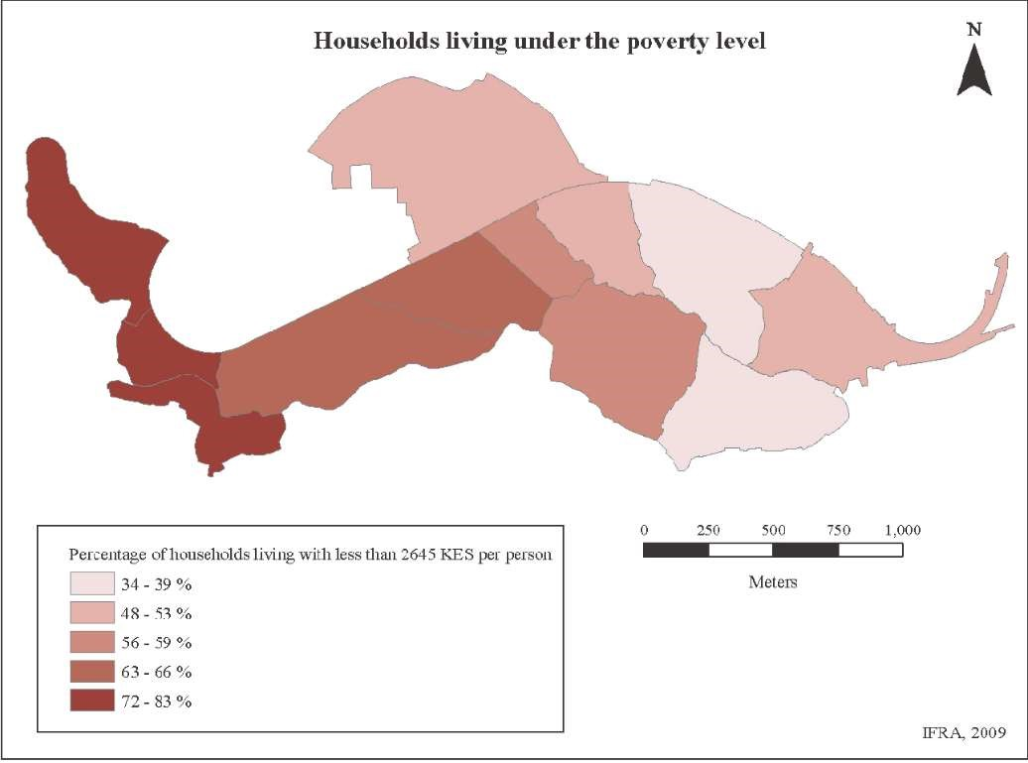
Source: Desgroppes, A., Taupin, S. (2011).Kibera: The Biggest Slum in Africa
From this background, it is evident that Kibra, among other informal settlements in Nairobi house the majority of the poor and must therefore be given a keen focus during development planning. As such, they must be fully integrated into strategies for urban management.

Health
While Kenya’s average life expectancy is about 66 years, Kibra’s is less than half of that. The average is brought down by a high child mortality rate and various illnesses that affect the young, like malaria or severe Urinary Tract Infections (UTIs) from shared toilets.
Informal settlements house a skewed burden of communicable and non-communicable diseases, undernourishment and injuries arising from lack of clean water, adequate sanitation, overcrowding and poor income among others. Vindicate this by asserting that inhabitants of informal settlements in Nairobi experience poorer health than the inhabitants in other areas. For example, the HIV prevalence in Kibera was reported to be 12.6%, more than double the country average prevalence which stood at 6.2%. In terms of service provision, public health amenities are limited. So, most Kibra residents rely on health facilities established by NGOs, e.g. African Medical Research Foundations (AMREF), Shining Hopes for Communities (SHOFCO) Médecins Sans Frontières (MSF) and faith-based organizations (Corburn, J. & Riley, L. 2016). This shows that inhabitants of informal settlements have to pay a little more than other citizens who can easily access public healthcare opportunities.

Education
There is disillusionment of many of Kenya’s urban poor who, like the majority of rural urban migrants, moved to the city with the hope of finding jobs and improving their economic wellbeing as well as achieving new optimized opportunities. This hope has been elusive due to unrealized education objectives, massive drop-outs or push-outs, unconducive learning environment due to area violence, dirt and filth, and lack of family support. The government is the main provider of education in Kenya.
The 2019 national census indicates that Kibera has 161,207 people attending school whether at pre-primary or tertiary level. Over 81% of the students are in informal schools with only 27% attending government schools (GoK, 2019). Kibra suffers low literacy levels compared to other parts of the country partially due to the lack of government investment in education facilities the area. Malenya describes this well;
‘The manner in which educational policy has been designed and resources distributed over time exhibits a tendency towards marginalizing children in urban informal settlements in terms of access to quality education compared to their counterparts elsewhere.’

Population Density
There are approximately 2.5 million slum dwellers in about 200 settlements in Nairobi, with Kibera housing 1 million inhabitants. These informal settlements occupy 5.84% of the land used for residential purposes in Nairobi, but they house 55 per cent of the city’s population. This implies that 40% of residents use two-thirds of the land, while 60% live in slums in less than 6% of the land. The unequal allocation of land is a key political issue of Kenya, which has its roots in colonial policies of dispossession and racial segregation. This geography of spatial injustice is also seen in the increased population pressure in Kibera.
Table 1: Population Density Changes in Nairobi’s informal Settlements (2000-2020)

Area/ha | Inhabitants/ha |  |  | Net Increased Inhabitant/ha  2000-2020
 | 2000 | 2010 | 2020
287.13 | 439.43 | 671.88 | 985.70 | 546.27
Source: Ren et. al., (2020)
While the population density in the entire Nairobi grew by 1.05 times (from 1999 to 2019), Ren et. al, found out that the population of informal settlements grew by 1.25 between 2000 and 2020.

Housing
Although 90% the land in Kibra is reportedly owned by the government, the residents in this community live in 12 x 12 ft houses better known as shacks owned by absentee landlords. These shacks often house eight or more family members, many of whom sleep on the floor According to the 2019 Census, 23.5% of the walls are mud or cow dung, 23.1% are iron sheets, 0.4% cardboard, timber and uncovered adobe and still 0.1% nylon or cartons. The percentage of housing with mud walls in Kibera Sub-county is similar with that of rural Mirangine Sub-county in Nyandarua County (GoK, 2019). A 2013 survey by KNBS concurs with this by showing that Embakasi Central constituency has 90% share of brick/stone walls, about five times more than Kibra Constituency.
Table 2: Percentage Distribution of Conventional Households by Dominant Wall
Material of Main Dwelling Unit
No. of  Convention al  Households | Mud/Co w dung | Stone with Mud | Covered Adobe | Uncovered Adobe | Plywood/ Cardboar d | Offcuts/ Reused wood/Wo  od planks | Iron sheets | Concrete/ Concrete blocks/ Precast  Wall | Stone with Lime/  Cement
61,651 | 23.5 | 12.9 | 2.2 | 0.4 | 0.4 | 0.4 | 23.1 | 18.7 | 16.0
Source: GoK, (2019) 2019 Kenya Housing and Population Census Vol IV: Distribution of Population by Socio-Economic Characteristics Nairobi: KNBS

Water and Sanitation
Water
The major problem in informal settlements is the unavailability, inadequacy and unreliability of water supply systems. According to the 2019 Housing and Population Census, only 11% of the population in Kibra subcounty have piped water in their dwellings as opposed to 34.8% in Kasarani and 38.2 in Nyeri Central sub counties.The table below indicates that most of the inhabitants access water through standpipes and water vendors.
Table 3: Percentage Distribution of Conventional Households by Main Source of Drinking Water

No. of  Conventional  Households |  | Protected Spring | Unprotected Spring | Protected well | Borehole/  Tube Well | Piped into Dwelling | Piped to  Yard/Plot | Bottled Water |  | Rain  Harvested Water | Water Vend  or | Public Tap/Stan dipped
 | 61,651 | 1.4 | 0.1 | 0.3 | 1.3 | 11 | 20.6 |  | 3.8 | 0.1 | 16.1 | 45.1

Source: GoK, (2019) 2019 Kenya Housing and Population Census Vol IV: Distribution of Population by Socio-Economic Characteristics Nairobi: KNBS
As shown, the Nairobi City County provides stand pipes in some areas within Kibera. These are then metered and franchised to kiosks operated either by private individuals or, in some instances, by community-based organizations. Water vendors, who deliver water by hand carts, normally retail at a higher tariff as compared to the county. This implies that Kibra inhabitants have to pay over four times more per unit of water consumed because they buy it from a water kiosk or a standpipe comparative to their well to do country mates who have installed city county water meters. IDRC (2016) terms this the ‘poverty penalty’ meaning that inhabitants of informal settlements pay more for poor services than the inhabitants in wealthier neighborhoods. Fear gripped the inhabitants of Kibra given their inability to practice frequent hand washing to wade off the Covid-19 virus as they could not access sufficient water for this purpose.
Toilets
Graham (1995) argues that sanitation is grossly inadequate in most informal settlements. The 2019 Census shows that only 37% of the population in Kibra use the main sewer relative to 77% of the population in Makadara Sub-county.
Table 4: Percentage Distribution of Conventional Households by Main Mode of Human Waste Disposal
No.  Conventional  Households | of | Main Sewer | Septic Tank | Cess Pool | VIP  Latrine | Pit Latrine  Covered | Pit Latrine Uncovered | Bucket Latrine | Open/B ush | Bioseptic  Tank/  Biodigester
61,651 |  | 37 | 5.4 | 0.3 | 11.8 | 38.8 | 4.7 | 0.9 | 0.3 | 0.8

Source: GoK, (2019) 2019 Kenya Housing and Population Census Vol IV: Distribution of Population by Socio-Economic Characteristics Nairobi: KNBS
45.5% per cent of the households in Kibra have no direct access to a toilet. They share a pit latrine with others. In a study by Onyango, P and Tostensen, A. (2015), it was observed that pit latrines in Kibera are not only poorly maintained but are over-used by an average of 500 people to each toilet. Pit latrines are a major method of excreta disposal given the weak water-borne sewerage system in the settlement. Its inadequacy is derived from the low supply of water, temporary nature of structures, dense physical layouts and insufficient capacity of inhabitants to invest in the required expensive physical infrastructure including pipes, pumping stations, and sedimentation ponds among others. Most of the people have to pay to use a toilet.
This poor sanitation exposes Kibera residents to health hazards such as infections, risk of sexual abuse as both males and females share the facilities.

Waste Disposal
Many settlements have no provision for baths or showers.
The Nairobi City County has hardly provided garbage collection to Kibera. A recent census showed that the County Government collects waste for only 6.5% of the households in Kibera as compared to 33.8% in Laikipia East Sub-County (GoK, 2019).
Due to limited and irregular provision of waste disposal services by the County Government, Community Associations including CBOs, youth groups and FBOs, and private companies have made garbage collection a business in Kibera (Nthambi M., 2014).Consequently, most villages in Kibra are littered with refuse and are contaminated with rotting waste.

Energy
94.2% of the residents in Kibra Sub-county use electricity for their lighting needs, lower that their fellow citizens in Westlands Sub-county (97.1%) and Aberdare National Park Sub-county (100%)
Table 5: Percentage Distribution of Conventional Households by Main Type of Lighting Fuel

No. of Conventional Households | Mains Electricity | Paraffin Pressure  Lamp | Paraffin Lantern | Paraffin Tin Lamp |  | Solar Torch/Spotl ight | Solar Charged | Candle
61,651 | 94.2 | 0.1 | 1.2 | 2.1 |  | 0.3 | 0.1 | 1.7

Source: GoK, (2019) 2019 Kenya Housing and Population Census Vol IV: Distribution of Population by Socio-Economic Characteristics Nairobi: KNBS
Cheseto (2013) observed that most people in Kibra who were connected to electricity live along the main road network leaving out a large portion of the population due to poor accessibility and the temporary nature of housing. This has necessitated many households to tap power directly from electric posts or from neighbors. Attempts to disconnect these illegal connections have sometimes culminated in physical confrontations. Unfortunately, some of the people live under the power lines thereby putting their lives in danger.
The Table below illustrates that due to high poverty levels, most households in Kibra use paraffin and charcoal that they believe to be cheaper and affordable. In some cases, firewood is used.
Table 6: Percentage Distribution of Conventional Households by Main Type of Cooking Fuel

No. of Electricity Paraffin Gas Biogas Firewood Charcoal
Conventional
Households
61,651

4.7

40.2

43.7

1.0

0.4

10.0

Source: GoK, (2019) 2019 Kenya Housing and Population Census Vol IV: Distribution of Population by Socio-Economic Characteristics Nairobi: KNBS

There are implications of using paraffin, charcoal and firewood for respiratory health. In addition, the risk of fires and environmental degradation are imminent.

Income
Determination of income is difficult in informal settlements as has been experienced by many surveys in Nairobi and in other urban centers worldwide. Most of the residents are engaged in informal sector activities which do not always generate a regular income. When asked to state income and expenditure, respondents in these areas almost always give higher figures for household expenditure than for their declared income.
Majority of the inhabitants are workers in the rich peoples’ homes far off. Some lucky ones may find work nearby. Others are casual labourers in factories in industrial area. They walk to work daily. Curiously the undesirable exercise to and from work and the physical nature of the work they do, keeps them in shape and healthy. In any case, most cannot afford public transport. The 2013 KNBS survey illustrates that only 49.1% of the Kibra residents work for pay as compared to the neighboring Lang’ata whose 52.7% work for pay.

Gender inequalities
In Kibra, there are 116 women for every 100 men. Yet, these women are worse off than their male residents in the informal settlement and females in other parts of Nairobi in terms of access to employment, health facilities, secure housing and education completion. There are several factors that predispose women to even greater risk. These include; sharing of toilets, lack of street lighting and transportation, high poverty with limited educational and economic opportunities. It is recorded that 85% of women in Kibra report experiencing some form of violence in their lifetime and about 18% of the teenage girls have either given birth or are pregnant with their first child Kiriti & Clement (2003) also argue that the share of income earned by women is much lower than men's share.

Political participation inequality
Political inequality results in socio-economic inequality that in turn produces powerlessness for the disadvantaged group. This powerlessness can be eliminated if political processes embrace competitive politics that provide opportunities for all people, including the disadvantaged to organize and influence public policy.
Politics in Kibra and in Kenya at large are mobilized along ethnic lines. That is why the residential patterns of the villages can also be manifested in ethnic orientation as illustrated below.
All communities of Kenya live in Kibra. The map below illustrates that some majority communities dominate certain villages in the settlement. For instance, the Kikuyu dominate Laini Saba, Soweto East and Silanga villages. The Nubians mostly inhabit Lindi, Kambimuru and Makina villages. The Luhya dominate Mashimoni while the Luo dominate Kisumu Ndogo, Gatwekera and Raila. The Kisii are in Soweto West and Kianda villages.
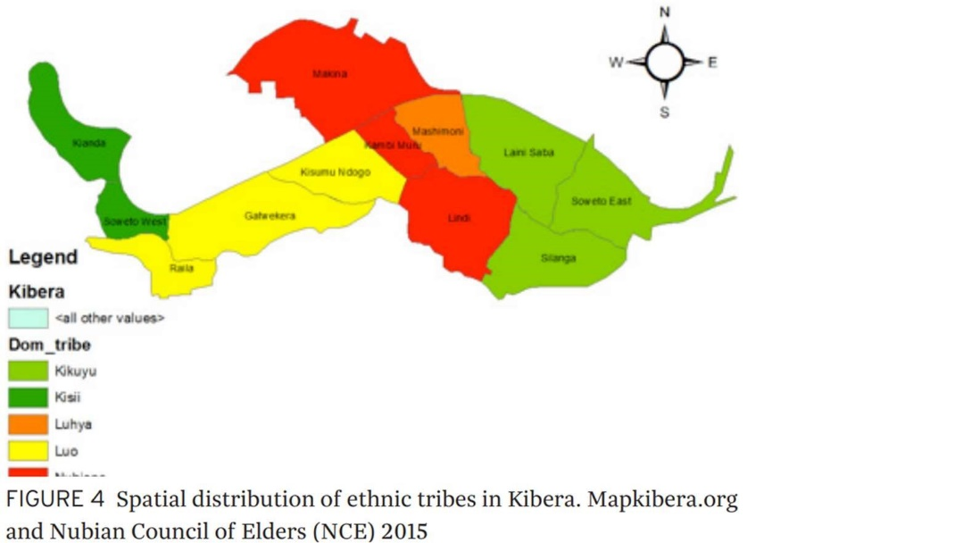

Owiti(2014) observes that political inequality is driven by ethno-regional patronage, crony capitalism and political exclusion; elite capture of the dominant state and public policy; and zero-sum politics, historical grievances and political violence.

METHODOLOGY FOR THE PILOT PROJECT
The study employed a unique study approach called Participatory Research Method. This method comprises a range of methodological approaches and techniques, all with the objective of transferring power from the researcher to research participants, who are often community members or community-based organisations. The youths participating in this research themselves analysed and reflected on the generated information, in order to arrive at the findings and conclusions of the research. Some shared their experiences and views through film-making, song and poem writing, and photography among others.
Participatory research can involve action as well as inquiry. People can not only discuss their problems, they can also think about possible solutions to them and actions which need to be taken. The aim was to influence decision-making processes and impact peoples’ lives locally and nationally. The challenge is that the views of the most marginalized people are by definition largely absent in public forums, which further excludes them and in turn amplifies the perspectives of the more dominant groups. Bringing these people and perspectives into policy processes is an arduous task.

Participatory Research Participants
Research participants constituted youth aged between 18 and 35 years who reside in Kibra. Youths were randomly selected to share their stories with pertaining access to public services such as education, health or water among others.
Stratified sampling was employed to ensure representation all the five wards from Kibera namely Lindi, Saran’gombe, Makini, Laini Saba and Woodley. Six youths from each of the mentioned wards were recruited by the study team to share their stories in thematic approach as earlier explained. The total was seventeen (17) Girls and Thirteen (13) Boys with representation of youth living with disability. All Youth that were selected were trained in participatory research for them to understand the scope of the research and how to collect and analyse data for the study.
Out of the 30 Youths selected, only 24 were able to complete and submit their stories. Six youths could not participate in the entire research process for the following reasons; Migrating out of Nairobi for failing to sustain their livelihoods due to Covid-19 effects, falling ill, and other compelling issues of competing responsibilities. The stories collected were uploaded to a password protected ‘Microsoft Teams’ folder. All youths signed consent forms with the aim of endorsing their willingness to participate in the project and agreeing to the use of the information they provided.
The study had three mentors who listened to the stories and captured the information for further analysis.
Ethical approval was obtained from Kenya’s National Commission for Science, Technology and Innovation (NACOSTI) and the University of Leeds. The study did not provide any incentives to the study participants. However, all youths were facilitated to attend meetings with transport and refreshments. Thematic analysis was used to undertake a narrative analysis drawing on the themes identified from the stories collected during the data collection phase.

FINDINGS

Demographic Characteristics of the Research Participants

Age and Gender Distribution
Majority of the research participants (80%) were young adults within an age range of 19 to 25 years. The remaining 20% were aged between 26 and 35 years.

Duration of Stay in Kibera
Most of the research participants (60%) were born in the Kibera implying that they have lived there all their lives. Others had lived there for more than 15 years (22%) and 10 years (18%).

Distribution
The ethnic distribution of research participants was diverse. A large number of them belonged to the Luo community (39.8%), Luhya (28.5%) and Kamba (10.3%) communities. The Nubian, Kikuyu and Kisii communities constituted 6.8%, 4.5% and 3.0%, respectively.

Educational Level
All the research participants had completed secondary school, 30% had joined vocational training, 35% had joined University and 35% had joined other tertiary institutions. Unfortunately, this is not a perfect reflection of education status in Kibera. The Kenya Housing and Population Census (GoK, 2019) records that 43% of the girls and 29% of the boys in Kibera have not attended school at all.

Occupation
Majority of the research participants (60%) were still students or in training or had just completed certain levels of education. Those who were out of school were engaged in the informal sector including doing business or trading. This exhibits the real situation in Kibra where even degree holders fall back to working in the informal sector after earning their qualifications.

Sources of Livelihood
Most of the research participants (55%)were dependants because they were unemployed or were still schooling during the period of the study. 29.4% of the research participants reported to have some livelihood sources including having casual work and volunteering with local institutions, particularly community based organizations (CBOs).

Inequality Explained through Stories, Poems and Photos
Oscar
I am Oscar. I was born and live at Soweto East in Highrise Ward. I loved football from a young age because every time I came from school, I would join the older boys to play football. This would help me forget that I had not had an adequate meal at lunch. Upon arriving at home late with my clothes very dirty, my parent would punish me and make me promise not to play football the following day. Unfortunately, I could not resist. I kept going back to the football field again and again until my parents set me free to play after school. Today, I am a football coach with the opportunity to coach young boys and girls of ages fewer than 9, under 11 and under 13.
I had a job at Ligi Ndogo Soccer Academy situated along Ngong Road. Unfortunately, since the outbreak of the Corona virus pandemic, my job was suspended following the Ministry of Health (MoH) measures that banned the social events including sports.I decided to voluntarily coach the young boys and girls of Kibra instead of just staying home as I wait for the easing of the MoH measures. We started training at Undugu grounds. Unfortunately, Covid-19 threat became real when many other teams came to use the same pitch. So, together with the young boys and girls from Kibra, we moved to another pitch.
Sadly, the environment of this pitch also became threatening when a sewage pipe broke and spread the sewage waste on most part of the pitch. Needless to say, the Kibra community uses one corner of the pitch to dump their waste too. For one, some players play barefoot while training so they are forced to step on this waste too. Shoes or not, we all step on the waste and could carry the germs in the waste to other areas of the community. While playing, some of us fall on the ground and one can never rule out that the fall will land one in the dry or even wet waste. Additionally, the young people hold the ball during the game and some carry it home to store it until the next game. When they reach home, some of them do not wash their hands based on the lack or inadequate supply of water in the area. If they eat with unwashed hands, they may ingest the germs which may lead to sickness. I realized that this is a critical issue when the incidences of sickness among the young girls and boys increased tremendously. In fact, at one point in time, 15 out of the 23 players were all complaining of stomach upsets. I was really scared because we risked having a Cholera outbreak. Consequently, parents stopped their children from training. So, currently, I have no team to train because there is no other pitch we can move to. While stopping the children to train looks like a good solution to an immediate problem, the result of being idle at home is that the young people get distracted and even engage in crime and other acts of violence.
I wanted to do something about it. So, I talked to the sub-county administrator and our member of county assembly to help alleviate this problem. However, I have neither received any positive feedback nor action. The fact is that the Government can avoid all these implications if they take things seriously and act on our request before things get worse. Finally, I wish to plead with the Government and Civil Society Organizations to intervene in this matter because one of the kids could be the Michael Olunga of tomorrow. Let us not kill the hope of tomorrow. Let us not impose crime on our society by pushing the young people into this constricted space. Let the Government provide all public services in Kibera, particularly waste management, as they do in Muthaiga.

Francis
My name is Francis. For the almost thirty years I have lived on this earth, I have witnessed many incidents of insecurity in my neighbourhood, and I have read about insecurity in many parts of the country. I do not know whether our leaders have sat down and asked themselves why insecurity seems to only get worse in this country.
I was born in a Soweto East. But, the name of our ward (Highrise) seemed to have been borrowed from the tall buildings that stood with defiance looking down at the shanties in Soweto village. Life as a young person in school was much easier for me because I depended on my parents for everything. I went in a private school near my home as the closest public school was in the next ward. This should not be confused with the likes of Brae burn since it belonged to a neighbour. I was luckier than my classmate Maria who had to look for money to feed her sickly and old grandma. Since she had to provide for food and pay her own school fees in the day secondary school, Maria found herself in the local gang which was led by young boys who had moved into Kibra. If these boys were here when we started school, the chief would not have allowed them to miss out on education. Her role as a young girl was very simple, to carry the gun from one gang member to another. This is because nobody including the police could suspect such a young innocent girl to be carrying a lethal weapon. In the process of being part of the male dominated gang, Maria was raped countless times, and this made her to grow even colder.
Although I was not in what could be labelled as a criminal gang like Maria, I joined a small group of young men who made me feel that I belong to the street I lived and protected me from other boys whenever fights began. To fit in, I had to put on dreadlocks, put on a tattoo and wear casual clothing. Unfortunately, the police impounded me several times based on the reasoning that I come from Soweto, I have dreadlocks and a tattoo. It is sad the police have profiled citizens by the location of their residence and their clothing. Thankfully, in all instances, the police found out that it was a matter of mistaken identity.
Having finished my degree at the University of Nairobi, I thought that I would get a good job immediately. This did not happen as per my expectations. Instead, I first volunteered and now got employed in a community-based organization. But my friend Eric did not get a job. So, when our Member of Parliament asked for youths who wanted jobs, he joined the team. I also did because I wanted a better job, probably at national level. When we went to the meeting place, we met other young people who had been sent by the Honourable to tell us what our work will entail, and the remuneration attached to it. We were asked to attend a political rally and heckle the opponent of our ‘employer.’ This was not a hard task. So, we went, and we got our money. As elections approached, the tasks became tougher and included a lot of violence. I pulled out but any young people did not because it was there only source of the money that sustained their livelihoods. In order to commit some of the heinous acts without feeling guilty, most of the youth started abusing drugs. Unfortunately, these young people were injured, some died in the process and others were arrested in the process. This was done without regard to the leaders who manipulated them to mete this violence in the first place. The resulting impunity causes political leaders to come back every electoral cycle to hire young people and manipulate them to commit acts of violence.
Since March of 2020, we have lost many young people for flimsy reasons. Most of us lost our jobs during the pandemic and therefore became idle. As the saying goes, ‘an idle mind is the devil’s workshop.’ The Covid-19 containment measures like curfews also became a source of death for young people who would be found outside for either good or bad reasons. The police have been recorded to have beaten and injured people in Kibera and beyond. My question is why and what did the young generation do to the government?
I wish to call the government to create more jobs for the youths to avoid losing our young generation since they are the ones building the nation at large. The government should also hold the political leaders to account when they mobilize support and facilitate gangs to commit violence.

Andrew
My name is Andrew, a community leader in Langata, Soweto East. A home is the most important place where every person should feel safe. In my life, I have always lived with the fear of losing my home. I have heard many reasons why our home has been taken before and I have also heard why other people’s homes in Kibra have been taken. When I was much younger, our house was demolished because the government said we lived too near to the railway line. The irony is there was no place to live far away from the railway line. We were chased and were never shown where we should go. As recent as 2018, the Zone-B, of our area was demolished again after a short notice period. The Ministry of Housing promised to compensate the residents but until now (2021), some people are still waiting for the promised compensation.
For those who were lucky enough to receive the compensation, the tenants were given lower than the landlords. While the residents received 58,000 Kenya shillings, the landlords received ten thousand Kenya shillings more. This did not take into consideration the fact that tenants and not landlords supply the materials for building or improving the houses they live in.
The demolition of the houses affected the residents because they had to find alternative accommodation that proved to be more costly. And with the coming of Covid-19, the situation only got worse. Most of the residents experienced salary cuts and others lost their jobs. This translated into difficulties in paying the rent in their newly acquired rental homes and they could hardly manage to feed their families.
In my area, there is a commonly used slogan, ‘no money no justice’. This slogan emanated from the favouritism always offered to the rich. Indeed, the rich receive more favours from the local authorities. For example, they are easily given places to construct what they want as compared to those who do not have money. It even gets to a point where they corrupt the administration and take the land that belongs to the less fortunate.
Due to the congestion of buildings in Kibra, the drainage systems pass very near or sometimes right through our houses. This has caused a lot of harm. When they are functional, the smell is awry and when they block or break, they cause a lot of harm in terms of diseases. The sad thing is that, it takes months to rectify blocked or broken drainage systems in Kibra but a faulty sewage in the Highrise Estate must be repaired the same day, unless it is a weekend. It makes me wonder whether some people are more special than others.
On the other hand, the construction of roads has created positive and negative impact in my area. The positive side is that they make Kibra more accessible while the negative side is that people are displaced affecting their social structure. So, road construction and other government development projects have contributed to evictions in the informal settlement. The construction of the road forced me to move as my place was said to be on the path of the development. I used to make a living out of selling Mandazi’s every morning where I was residing before the displacement. But now, I have no space for the business at my current residence.
Also, we live in small houses that are single rooms. This has encouraged a lot of problems and vices for those with big families. In terms of sanitation, it is very hard to maintain the highest levels because the same room that is used for cooking is also used for sleeping, bathing etc. Due to the tiny spaces, young girls have found themselves being defiled among other sexually related violence by their own kin like uncles, brothers etc. Even when the girl reports to the mother, they tend to keep this information on the low because they know that their relative will be imprisoned for a long time.
I pay 3,500 Kenya shillings as monthly rent for my single room. This amount is exorbitant. This is worse give the fact that landlords only appear to pick the rent and do not try to undertake maintenance and repairs of the house even following several complaints. When you complain, they tell you that if you don't want to stay in the house, just leave. Since it is difficult to find a place in the informal settlement, one is forced to stay.

Margaret
My name is Margaret. I was born in Kibera back in 1996 and raised here up to now. I have three siblings; two brothers and one sister. We were raised in a single matope(mud) house with polythene paper windows. Getting three meals a day was foreign to us.I started my interest in the entertainment industry way back as a child when I listened fervently and memorized the music playing on our neighbours’ radio. As I engaged with real life, I expanded my skills to include general interaction with people. Today, I am a Master of Ceremony in events, a photographer, and an events planner too.
The entertainment industry has its ups and downs. I faced a real dilemma when entering the business because the law required me to raise 70,000 Kenya shillings in order to get a license as an events organizer. I had to start engaging in this business without a permit in order to raise the money to pay it. This means that my first few months in business made no difference for me as I was working solely for the government. Plus, I risked being put in prison had the licensing officers found me. This law is therefore unfair for the disadvantaged who cannot afford that cash. Many young people are unable to get into genuine business because of such impediments.
The kind of life lived by the people in Kibra is a strenuous one. This is more for the women who like my mother, have to wake up early and find something for their children to eat every day. We lived a life of hand to mouth. This meant that my mother had to do heavy work every day and she was forced to skip meals in order to save the little she had for her children. Given that she was exposed to the cold every morning and she carried heavy materials, my mother devolved a chronic illness. My brother and I, being the oldest kids were forced to help our father raise money for hospitals and other basic needs. I am happy to help my family from the little income I make as an events planner. But, sometimes I wonder to myself, if we were rich and not in the slums, maybe my mother could be in perfect health and I could do well financially from my small business.
I also realized that the disadvantaged do not receive similar treatment when it comes to health. We were advised to take a National Hospital Insurance Fund (NHIF) card for our mum which was a great idea. Unfortunately, the card doesn't cover for special clinic. Since mum was scheduled for a two-day clinic per week, my small business became the main source of money for the treatment. I would also have to provide money for transport since the hospital was located far from our home. When the global pandemic hit us, the total lockdown crippled my business completely. People were forbidden to do any social events. So, sleeping with an empty stomach became the norm again for me and my entire family.
While under lockdown, I started a small voluntary service to build the skills of the many youths who were also locked down as they could not attend school. I founded a Community Based Organization that helped young people to grow in theatre and performance skills. The young people established groups of different classes and they could teach each other the lessons and revise some examination papers before or after theatre practice. Now the theatre has more than 70 youths and kids looking up to me to nurture their talents and possibly earn a living from it. For sure life is not fair to us who live in the slums.

Johnson
My name is Johnson and I am 23 years old living in Gatwekera village in Kibra. Being raised in the slums is not easy especially for a boy. One goes through a lot of challenges in order to survive and make it out of that life. One day I fell critically ill and my mother did all she could to provide medication for me. Despite her effort, my health was deteriorating and it seemed like I was on the brink of death. At that time, my mother told me the real reason why we live in Gatwekera. Three months after I was born, my dad left us to marry another woman. Since he was the main bread winner, we had to vacate from home and we were forced to live in the streets. Sometimes we even went to sleep hungry as most of the time we slept outside in the cold. She worked at various hotels in Kakamega town so just to get food and other necessities for me. Life did not improve. My mother decided to try her luck in Nairobi because she had heard that there are more opportunities there for any hardworking person.
On arrival, she went to Kibra where housing was more affordable. In Kibra, life was not the way she expected. It was very difficult to find something to do and when she found it, she had to work very hard since it was not work commonly known to be done by women. After a while, she got married to my step-father. She thought that this was a progressive change that would assure her happiness. Unfortunately, it wasn’t as easy as she thought. Sometimes, the two fought to extent of killing each other. At that time, I was old enough to understand what was going on, seeing them fight really affected me psychologically. I even could not face my friends since most of them were mocking me by referring to my parents as wrestlers. Some of them used to laugh at me. It was hard even making friends in the slums since no one wanted to be associated to a poor child, no one wanted to be friends to a boy who does not have decent dressing style. Imagine the poor calling you poor!
After schooling I had to face the realities of life. Looking for work was one of these challenges I had to face. This is compounded by the little education I have. Even the menial ‘jua kali’ jobs are difficult to get since most employers profile people from Kibera as being thieves and aggressive. And when I get an opportunity, it always turns out that it cannot provide for my rent, food and savings. So, I eat everything and never keep some for a rainy day. Things are worse now with the COVID-19.The small job I had is now gone and the little surplus I had is already spent. At one time, I was arrested past curfew time because I left the casual work I got from the day that was one kilometre away. I was harassed and beaten up. The police even demanded money from me, and forcefully took the 200 shillings I had earned from that day’s work. I could not go to work the next day since I was nursing my injuries and as a result, I lost the job.
The pandemic has escalated things for me. My landlord is always on my neck for the arrears that have accumulated during the period when I lost my job. I am afraid of being evicted since I have no idea where I will go once this happens. A friend has advised me to join them in selling drugs such as bhang so that I can earn money. I really need money to sustain my life but I am afraid of being caught.
The government and civil society organizations should help the youths to kick-start income generating activities. Other good government programmes to improve youth skills in self-reliance such as Kenya Youth Employment Opportunities Project (KYEOP) should be brought to the youth in the Slums. Currently, they do not reach the slums. In addition, we as youths together with NGOs should also come up with mentorship programmes that will help the youths not to engage in drugs and other illegal activities.

Austine
Hello, my name is Austine. I was born and raised here in Kibra for more than 20years. I am 28years old, married and blessed with 2 children. Living in Kibra has got a lot of challenges, but we are resilient and we handle every situation as it arises. Life before COVID-19Covid-19 was somehow tolerable to me because I was employed and I was getting my salary at the end of every month. I would use this to cater for my family and my needs.
But nowCOVID-19has destroyed my life. The moment COVID-19COVID-19 was reported in Kenya on 3rd March, things started falling apart. I lost my job that very month. Without knowing the pandemic was here to stay for the rest of the year and more. Yet, the income I used to earn in order to pay rent, buy food, pay school fees and many more was no more.
I sought other alternatives just to make sure I put something on the table. I had to start a small business of selling masks in order to get my daily bread. The business started well when everybody was cautious. But over time, the sales dwindled since people became more careless by reusing disposable masks. They wore masks for the police so that they are not arrested and not for their own health.
Fortunately, Kazi Mtaani programme came to Kibra and I was privileged to be engaged by the chief on this programme. It has played a big role for me because the amount I get from it pays my rent, purchases food and contributes to clear school fees bills. This Government programme has really helped me since during this pandemic.
Nevertheless, I still wonder what will happen to me after this Kazi Mtaani programme ends. I therefore request the Government to have a specific programme, similar to Kazi Mtaani that targets youth in informal settlements beyond the pandemic. It may also be good for the Government to extend this Kazi Mtaani programme as long as it can just to keep youths busy and avoid crime in the society.

Grace
My name is grace, and I am 28 years old. I am married with three children. I live in Makina in Kibera slums. I have a two-year old son who has an asthmatic condition and is allergic to almost all classes of antibiotics. Since the corona virus started spreading, life has changed for all of my family. My eldest daughter is 16 years old. I would like her to stay home and enjoy like other girls her age, but she cannot just sit and watch the misery we are going through. She has become our self-appointed errand person. She is always out looking for a casual job here and there. She runs to the grocery store or pharmacy to get the things we need. To decrease the risk of exposure to the rest of the family, my daughter uses the back door to enter and walk immediately into the bathroom to wash before interacting with the rest of us. She is restricting her movements in the house because the rest of us can’t risk the possibility of exposure she has taken on. With all these errands, my daughter could not afford to participate in the online classes that her school had arranged because we did not have a computer or phone that she could use.
My 23 year-old cousin was working in a restaurant. Three of her co-workers tested positive for COVID-19. Unfortunately, despite over a week of fever, fatigue and cough, she was not able to get tested back then because one test cost 10,000 Kenya shillings which is double of her monthly salary. In fact, some of her colleagues had to quit the job for their inability to afford COVID-19COVID-19 testing. She also told me that some of the people in other restaurants stopped working because they were required by the Government to test once per week to maintain the job. She felt better after a while of self-treatment. I wish I could have been there to help her, but I was afraid to help her because we were not sure whether she was covid positive or not. As parents we all are trying to balance the line between providing support, structure and stability for our kids while remaining calm and flexible given our changing circumstances. We need to help keep our children safe physically while understanding and trying to accommodate their needs as teenagers to connect with their peers and maintain their sense of autonomy.

Peris
My name is Peris and I am 20 years old. I have been living in Kibra, Gatwekera since birth. In my home and community at large, we feel left out and almost forgotten by the government when it comes to housing. For one, our houses do not have running water and electricity. The sewerage services serving our location are extremely poor. Unfortunately, most youths from Kibra cannot get good jobs, since we are marked as thieves especially when you note in your resume that you are from Kibra. Moreover, with the coming of COVID-19 announced in our country in March, 2020. This has escalated the inequalities further especially with the initiation of the lockdown. Mostly, people have experienced job losses which have directly affected our abilities of paying rent hence forced eviction amidst the pandemic. I specifically have been affected directly and I have been forced to live with my family of eight in one single room.
Since we lack substantial savings, the little we have is from hand to mouth and this has affected our dieting.I have a small boy in the house and he has been complaining of us eating vegetables all throughout. The real concern however is the lowering of immunity of the young boy for not taking a balanced diet.I have also been unable to pay for essential commodities especially the sanitary pads. In order to meet our nutritional requirement, we as a family had to plant some vegetables and trap wild birds for our nutritional needs. However, the demolitions in many parts of Kibra to pave way for the expansion of the super highway led to relocations, open sewerage, open water pipes and even loss of our small farm.
The open sewerage has increased the cases of waterborne diseases such as diarrhoea that has cost most of our children lives. COVID-19 has also paved way for police harassment which has resulted in injuries and death for some youths in Kibra, deterioration of our health and constant evictions. I wish we could be treated like other Kenyans since we also pay taxes, just like them. I hope the government can come up with income generating programmes that target youths in our communities, housing strategies to ensure good living conditions in the slums, deliver water and sewerage services in our communities and establish employment agencies to address the acute unemployment rate. Most importantly, the government should implement strategies that eliminate discrimination against people living in the slums such as Kibera.

Angela
My name is Angela. I am a mother of two; a boy and a girl. I live in Kibra’s Saran’gombe ward, Gatwekera village. I work with young girls and women. My house is a rescue centre for girls and women who have undergone gender and sexual based violence. I also provide housing for teenage mothers who have been chased from their homes. Currently, I have 26 girls whom I live with in my house as I mentor them through issues that affect them because I am a gender based violence survivor myself.
Where I live, I have neighbours with whom I share with basic facilities like washrooms. Some people have these basic amenities within their structures but some have to pay to access these amenities. Those who cannot afford resort to the use of what is commonly termed as flying toilets or use open drainages at night. This poses a lot of health risks.
There is this time when one of my girls came to use the toilet since I have always allowed them to do so if they cannot afford to pay for the facilities. I was not around at that time. My neighbours ganged up against her and took her out of the toilet midway. She was actually half naked. They also covered the toilet with soil so no one can access it anymore.
So now, we pay to use a toilet which is expensive for me considering I live with a lot of people. I am therefore planning on constructing my own toilet that can be used by any person who needs it, not just my girls. Any person who cannot afford to pay for it and needs to use it will use the one I am going to set up.

Butrose
I have called Kibera my home for 21 years now and police brutality and harassment from gangs is sort of “normal” in my society. My name is Butrose and this is my story.
Police harassment in my community is not a headline to hit the news, it is as normal as it gets. I have vivid experiences of a police vehicle passing near our base. It was a Saturday afternoon, the guys and I were chilling, talking about everything from ladies, to football, to politics, joking about bet kuungua pale sport pesa …simply having fun.
While it passed near where we were seated, one of the men in uniform slid down his window and said “tutawakujia nyinyi.”In total confusion of trying to comprehend what we might have done and bearing in mind how brutal police can be…all of us took to our heels, running for safety. Anytime we saw a police vehicle we used to run, not because we had or have anything to hide but simply because they threatened us that they ‘will come for us’ without any explanation about our wrongdoing.
First forward to the government directives to curb the spread of COVID-19. Police brutality has seen a record high during curfew hours. People are being beaten aimlessly under the pretext that they are late even if it is just five minutes past the curfew hour. The very police ask for bribes yet Covid has reduced the economy to nothing. Police brutality is the biggest form of inequality I have seen as a young man living in Kibra, this needs to stop.

Vivian
My name is Vivian. I am 25 years old and I live in Kibra Soweto. My neighbour was expectant with her third child. She used to tell us stories of how the experience was when she gave birth to her first born and second born son.
“Lazimadaktariakuslapkamahujakaavizuri…..
Hao ma midwives ni rohombaya……
Bafu na choozahuko si ni chafuaki….
Hapousipoangaliamtotopoaanabadilishwa ama hataanaibiwa
Hukohatawamamawanazaa Kwa floor kamahaomanurseswanaangalia”

Translation: The doctors slap you if you do not cooperate. The midwives are ill intentioned. The sanitation facilities are too dirty. If you do not guard your baby well, it can be exchanged or even taken away. Some women just give birth on the floor as the nurses look on without offering any help.

We had numerous conversations on where she would go for the birth of her third child considering her past experience. She decided to try out the new maternity hospital that had been recently opened near Olympic area.
Her contractions started late at night and she just realized she had gone into full labour after curfew hours had started. I remember she had received a pass from one of the maternity hospitals to present to the police in case she was forced to go to hospital during night curfew hours. Even with all this, the police harassed us and kept us for what seemed as a very long time especially because she was writhing with pain. We however talked our way out and my neighbour gave birth to a healthy baby boy. Upon her return, she acknowledged that the services there were good despite the fact that she had to pay a little more.

Nicky
I am Nicky from Kibra. My story on housing inequalities is better told through the photoshoot below.

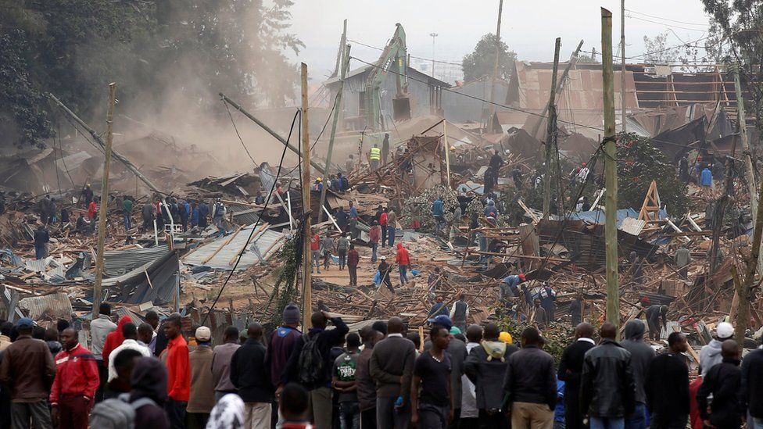
Figure 1: Houses being demolished as people are evicted in order to pave way for a Government project.

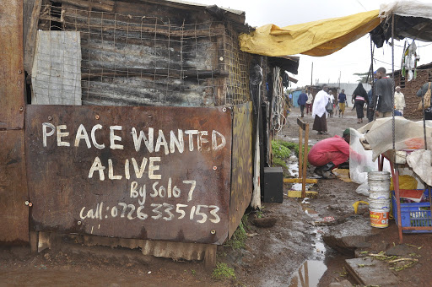
Figure 2:A renowned artist in Kibra uses walls to pass the message of peace.

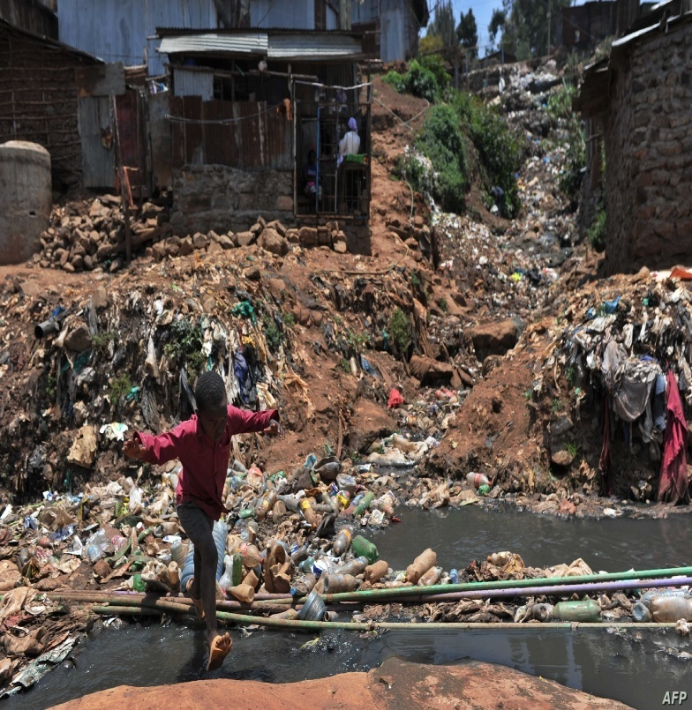
Figure 3: A young boy wading through an open sewerage system come dumping site to get out of Kibera
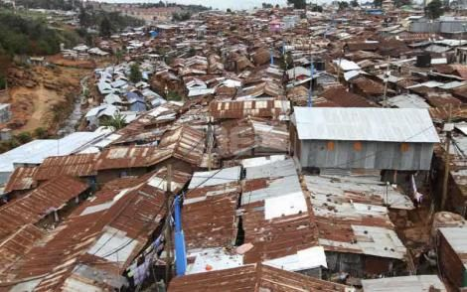
Figure 4: The congested housing within Kibra
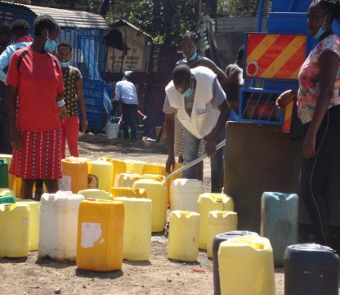
Figure 5: The lack of water in Kibra forces people to buy from this commercial truck.

Paul Odongo
Life has always been like a tree blossoming out in a desert
The scorching sun too harsh and the torrential rain brings floods
There's only safety when the roots are deep
Then again, deep roots take time, time that we did not have to prepare for this pandemic
The good question we asked had no good answers "COVID-19 itaishaje? Na itaishalini?"
The desert seemed endless

Our lives were disrupted
And we couldn't say it was for the better
Kazi zilisimama
As artists we could no longer recite our poems, sing our songs or dance to our tunes
That wasn't the only frustration, we could no longer get an income
This meant, no food on the table, unpaid bills, multiple debts and homelessness for some
Social issues that had long been ignored like domestic violence, crime, drug abuse, GBV and depression glared at the slums like an open wound
ripe and ready to burst
The scorching sun had done its worst.

As an individual my solutions were limited, but as a community, we joined together to push forward
We embraced the government guidelines, even some which were barely applicable in the slums like social distancing
We embraced digital platforms to source for income
NGOs played a huge role in providing for our basic needs, counselling, awareness and an occasional employment here and there
For a change, the tree had more than hope

Certain benefits were realized in the wake of COVID-19
we witnessed reduced cases of common diseases like cholera as a result of the frequent hand washing exercise
The awareness level of the government institutions, NGOs and the community about many social issues increased exponentially
Families got to understand each other better as a result of the lockdowns
Systems such as education which were disrupted are recovering
Certainly, this pandemic has created a roadmap to fixing not only the world but also our nation, our community, our families and ourselves as individuals
I now believe that it is each and everyone's responsibility to steer our communities into safer paths as a result of the lessons learned during the covid-19 outbreak
The tree of life can weather any storm, only if we are united.

DISCUSSION

Inequalities Facing Youths in Informal Settlement
The stories and other artistic expressions from the research participants pointed to several types of inequalities existing in Kibera. This section discusses these inequalities and the effect of COVID-19 on each of the identified issues. Most of the research participants reported lack or inadequate access to employment, piped water, latrines, housing, educational facilities, and waste management and health facilities.

Youth unemployment
Youth in Kibera face unemployment challenges. Although unemployment is a national challenge in Kenya, research participants said the unemployment rates in Kibera are worse than elsewhere due to the profiling done by some employers against people from Kibera.
Most of the youths in Kibera who have jobs work in the informal sector. Unfortunately, this sector was hard hit by the onset of Covid-19 and most reported to have lost their jobs or their personal businesses. Some of them, especially those working in the hotel industry, found it difficult to return when normalcy started to trickle in because they could not afford the cost of undertaking the Covid-19 tests regularly. The Ministry of Health directed that all people in the hospitality sector should have a clean bill of health before offering services to the public. Needless to say, most of the people in the informal sector were exposed to the risk of getting the virus. But they did not have any options because for them, their families could eat only when they worked.
Being off work, most of the research participants spent the little savings they had in the first few months of COVID19. In fact, some of them did not have any savings at all This is based on the fact that the salaries or wages they earn from their jobs can only cover their day to day needs and they cannot spare much for saving. As a result, COVID-19affected them not only by keeping them away from their jobs but also by introducing new expenses such as purchasing masks, sanitizers, water among other needs.

Access to Health
One of the glaring inequalities shared by the research participants was their skewed access to health facilities. Some of them mentioned that the nearest health facilities were very far from where they lived. This means that they took a lot of time and it cost them more to reach the facilities as opposed to people who live near the hospitals. Even where hospitals were easily accessed, medications were not sufficient. Some of the participants reported having to buy medication from private pharmacies to supplement part or cover the entire prescription.
Productive health was said to be of critical importance in the informal settlements and therefore requires serious attention. Maternity wards in most of the health facilities in Kibra are neither fully equipped nor well maintained. Some require a down payment before women are attended to. This puts at risk the health of the women without money at that very time. The youths mentioned that since March 2020 to the time of the study, Kenya had lived under lockdown with a curfew that ranged between 10 pm to 4 am every day. Some of the hospitals gave the antenatal visitors a pass to travel at night to the clinic in the event that a woman runs into labour. Unfortunately, these passes were not recognized by the police as office clearance in some cases. Some of them had to pay the police to be allowed to travel at night to the hospital.

Access to Education
All the research participants reported they had undertaken secondary education. Nevertheless, they had challenges in so doing. Most of them went to private schools owned by locals. These schools, otherwise known as low-fee private schools, are said to offer lower quality of education than government schools. This exhibits the inequality between low-fee private schools, ‘real’ private schools and public schools. In fact, some participants believe that more youths from Kibra would have gone to the University if they attended public schools.
Most of the youths in Kibra who have no education at all migrated into Kibra when they were already older. Most of them are from rural areas and believed that Nairobi has more opportunities to meet their livelihood. The chiefs were said to be following up with parents to ensure that their children of school going age are not only registered but are also attending school. Although this is a good for ensuring the government holds community members responsible for their children’s education support is also needed for parents, who may find these responsibilities difficult to meet. It is still a challenge to many parents’ especially single parents, who have to pay for tuition, uniforms shoes and books in order for a child to be allowed in school.
Following the outbreak of COVID-19, the government ordered the closure of all schools indefinitely. After a while, the Ministry of Education introduced online teaching particularly for candidates who were in Class 8 and Form 4 (Primary and Secondary school finalists). Being in the city, it might be expected that children in Kibra would easily access online classes through access to the internet, television radio, tablets or phones. Unfortunately, this was not the reality as many could not access these devices; lack of energy was also a challenge as those who did not have electricity faced more difficulties.
Notwithstanding the above catalogue of challenges, there have also been positive changes in Kibra, especially with respect to education. More children and youth are currently attending school, although the schools are non-formal and sub-standard in terms of quality teaching.

Housing Congestion
Most of the research participants illustrated how the houses in Kibra are located next to each other. This is affirmed by the percentage of the population living in Kibra vis-à-vis those living in the entire Nairobi city. Houses were reported to be still predominantly one-roomed, yet they host big families. This congestion has several negative implications. One research participant mentioned that sexual and gender-based violence is worse in such households due to the exposure of the household members to each other’s privacy.
As youth get older, they move from the one-roomed house managed by their parents into outside group living. Many children and youth are reported to be roaming the streets, because the community does not even have places for recreation and play. All these conditions make youth and children vulnerable to hazards, notwithstanding their resilience that several studies have shown. It is not surprising, therefore, that the prevalence of diseases, such as HIV and AIDS is being reported to be high among the age group 15– 24 among youths living in slums.
COVID-19 containment measures required that people stay as far from one another as possible. But for people in Kibra, social distancing was seen as the luxury of the rich. Their houses are so close to each other and the people living in the house cannot afford to give each other the suggested 2 meters whether during their wake or even sleep hours.

Sanitation
In Kibra, sanitation is still considered a luxury rather than a necessity. Research participants mentioned that although some have toilets in their dwellings, others cannot access them. Some youths in Kibra have to pay in order to use a toilet. Unfortunately, whenever they do not have sufficient resources, they use alternative means to cater for this need. One research participant introduces the flying toilet approach where inhabitants use polythene bags and dispose them on their roofs. This becomes a risk when the same inhabitants rely on rain harvesting to get drinking water. This poor sanitation environment exposes the children and youth to health hazards and infections such as tuberculosis, diarrhoea, among others.

Water
Access to water is a problem in the settlement. The youths rely on water kiosks which provide water at a fee. The photo exhibition of one of the research participants showed many 20 litre cans belonging to various families in the Kibra, as they bought water from a mobile water boozer. While people can harvest water from rain during the rainy seasons, this water is hardly fit for drinking.
COVID-19 aggravated the situation of water in Kibera. The most common fight against the pandemic was done through the frequent washing of hands. At the same time, the lockdown reduced the mobility of water boozers in the settlement. While hand washing was a national call that seemed easy to practice, it was difficult for the people in informal settlements.

Factors Emanating from or Aggravating Inequalities in Kibra

Crime
There is a cyclical relationship between unemployment and crime. Most youths who are not employed find themselves trapped in drug abuse and other crimes. At the same time, once convicted, youths cannot be employed in some jobs especially in government.
Research participants said that crime and violence were ‘normal’ occurrences in Kibra. According to the research participants, being unemployed and out of school, while doing nothing worthwhile, makes the youths more vulnerable to violence, both as victims and perpetrators. This situation makes youth in Kibra more vulnerable to criminal activities, which the present study identified as negative activities, ranging from stealing, mugging, robbery and even murder. Information from the participants confirmed that youths in Kibra are still drinking excessively, trafficking drugs and alcohol and participating in prostitution.
This situation was worsened byCOVID-19. On the one hand, isolationism and other stressors like losing jobs, being unable to provide for one’s family and the fear of the virus forced the youths to engage in crime in order to get food onto their table or in drugs to forget their troubles.

Sexual and Gender Based Violence
Sexual and gender-based violence is reported among youths living in Kibra. Research participants listed various reasons that worsened this kind of violence in the informal settlement. These include the fact that the inability to afford basic needs exposes the youth to participate in solicitation of sex. In addition, substance abuse causes many to engage in physical and verbal violence against girls and women. The congestion in households also predisposes girls, boys and women to sexual violence. Cases in Kibra continue to be high with limited access to justice due to courts working under restrictions and also threats that survivors receive from perpetrators. This forces many of the youths, women and children to not pursue cases and as a result to not get justice. The low economic standards of the community and the youths restricts them to have an advocate to represent them since it is very expensive to afford one.

Police harassment
Research participants mentioned that police work of maintaining law and order and enforcing the COVID-19 measures was accompanied with a lot of harassment. This led to many youths being injured, being maimed or losing their lives. For some of the participants, police harassment is not a new phenomenon in Kibra and Kenya as a country. It is manifested through verbal threats from the police to the youths claiming that they will be arrested for no apparent reason. This fear has been inculcated in the youth to the extent that they will run away from any police officer or police car in their sight. When the police see this, they think that the youth are running away because they have committed a crime.

Impunity
The profiling of youths in Kibra as violent continues to justify the use of force by the police. Even when extrajudicial killings are covered by international reputable organizations like Amnesty International did in 2017, no police officer is held to account for the identified crimes. The youth also mentioned that politicians manipulate them to perpetrate violence against political opponents but politicians are not held accountable for this act. The result is the sustenance of violence in the informal settlement since the person who shall suffer at the end is the youth in the slum and not the police nor the politician.

Corruption
On the one hand, corruption fuels inequalities in Kibra while it worsens the existing ones too. The research participants reported corruption of the police and the local administration under different contexts. The local administration is paid to allot land to private individuals to build houses in the settlement without following proper procedures. This cannot occur in any area outside the slum because private individuals either buy land according to the laws of Kenya or rent houses. This corruption also feeds inequalities because only those with money can be assured of stable housing. Some youth said they had been denied government jobs that were meant to cushion them during COVID-19 such as Kazi Mtaani meant for youth. Some complained that they had been asked for money to be given these jobs.

Biased Laws and Policies
Laws and policies in a country are meant to ensure that justice prevails. Unfortunately for Kibera, some laws and policies were mentioned to engender inequality instead.
Some laws and policies such as paying high costs of licensing in order to undertake small businesses further discriminates against the poor. Some youths reported not being able to pay for the licenses for them to be able to kick start their businesses.
One research participants mentioned that the NHIF card excludes the treatment her mother required for her chronic sickness. NHIF is intended to provide access to quality healthcare for all its members at a cheaper price. Therefore, excluding some diseases or type of treatment in itself brings inequality in the provision of health attention to the affected persons.
Another participant mentioned the unequal application of the compensation policy by the Ministry of Land which is required by law to compensate any evicted household. The money given to the landlords was different from the one given to the tenants even in this case where tenants are the ones who built and maintained these houses. Enforced evictions have severely affected many youth and left them stranded. Those hugely affected by their properties being destroyed are left unsupported to find ways to start new lives.

Non-Responsiveness of Government
Most research participants mentioned that they do share their plight with their local leaders, government officials but there has been no or minimal response. For instance, one participant followed up on recovering a football field from waste without success.

Child Labour
Child labour was reported to be rampant in Kibra. Young Maria had to take care of her grandmother and pay for her own livelihood as a young girl. Another participant recounted how her 16-year-old girl had to work and run errands for the family throughout the lockdown. Child labour starts off the young person from a point of disadvantage. Young people become household bread winners at an early age and therefore seek for means of making money fast.

Government and NGO Interventions
Research participants mentioned that some of the changes that are taking place in Kibra are based on programmes being driven by the Government of Kenya, NGOs, faith-based organizations, UN agencies and CBOs in the area.
Participants mentioned Kazi Mtaani programme which engaged youth in the informal settlement during the toughest time when most of them had lost their jobs and closed their businesses. This initiative is lauded for providing employment and for reducing engagement in crime among youth. Nonetheless, this type of employment still confines youth to the non-formal sector. This provides the youth enough only for survival and barely meets their full basic needs base.
On the other hand, Government projects have been seen to cement instead of alleviating inequalities. For example, the construction of the superhighway has left many youths and their families displaced from their houses following major demolitions and evictions. The photo display of one of the research participants showed people standing in front of many houses that were being demolished. This left many homeless and some had to seek alternative living quarters with others thereby increasing the congestion in the informal settlement.
The youth through their community-based organizations also contributed to enhancing skills and capacities of their fellow youths in Kibra during the pandemic. Some of them offered to coach others in football, theatre, and schoolwork among others at no fee.

CONCLUSION AND RECOMMENDATIONS

Conclusion
Participatory methods employed in this project enabled us to identify key areas of focus for HAKI Africa and Kituo cha Haki Kibera. The different stories collected give a snap reflection of the situation in Kibra. The study has revealed that there are several inequalities experienced by youths living in Kibra. It has also established that COVID-19 has worsened these inequalities. With this realization, the response of both government and non-state actors is urgently called upon to address the subsisting situation in Kibra.
Given the inequalities and challenges that youths are facing in the informal settlements. The findings of this pilot project could be used to craft policy alternatives on the diverse social aspects for those who live under these slum conditions.

Policy Recommendations

National Government
The national Government through its Ministries and Departments should do the following:

Policy Recommendation | Target MDA
Revaluate their interventions in handling COVID-19 measures in light of this report | Ministry of Health
Improve the community’s access to universal health coverage by building health facilities, providing medicines in existing dispensaries and maintaining them | Ministry of Water
Increase access to water by constructing piped infrastructure into Kibra | Ministry of Water
Construct affordable housing | Ministry of Housing
Create economic stimulus programmes with specific focus on the population living in the informal settlements in order to entrench income generating options | Ministry of Public Service, Gender and Youth Affairs
End police brutality | National Police Service
Investigate and punish corruption among the police | Independent Police Oversight Authority
Enhance Security and safety for the people living in Kibra | Ministry of Interior and Coordination of Local Government
Issue individual titles to people living in slums and pay compensation in a timely manner when people are evicted for government projects | Ministry of Land
Install street and security light | Ministry of Energy
Involve youth in government policy making and government project implementation | Ministry of Public Service, Gender and Youth Affairs
Collaborate with low-fee private schools to provide quality education | Ministry of Education

County Government
The County Government should do the following.
- Adopt and implement policies for proper waste management, water drainage, and sanitation
- Construct health facilities in areas with no access and employ sufficient staff
- Establish rehabilitation programmes for youths who are bowed under the burden of alcohol, drug and substance abuse among others.
- Generate alternative employment for its youth population
- Develop mechanisms that will help reduce the increased cases of sexual and gender based violence (GBV).

Universities
The local Universities should do the following.
- Enhance capacity of the youths living in slums through mentorship
- Give special consideration for youths from informal settlements in their work-study programmes
- Undertake further research on the implications of specific inequalities and generate the policy alternatives required to address them
- Collaborate with other research institutions to undertake more research

Community and Youths
Communities in informal settlements and the youths therein should do the following.
- Undertake community and resource mobilisation in order to bring services to their locales
- Fully engage in public participation when both national and county governments are making their development plans
- Sensitize their fellow youths to take advantage of all available opportunities including informal, non-formal and formal schooling

Donors and Partners
Development partners should invest in the following within informal settlements.
- Complement government in enhancing access to education, health, water, sanitation and waste management among others
- Invest in addressing inequalities to improve the livelihoods of people living in the informal settlement

The findings and recommendations of this report were discussed at a stakeholders’ meeting in Kibera attended by representatives of the following organisations as well as the meeting facilitators:

Organization |  |  |  |  |  | Name
CDF Kibera Constituency |  |  |  |  |  | Siyama Ismael
Chief Kibera |  |  |  |  |  | Nehemiah Amwocha
Child Services |  |  |  |  |  | Everline bowa
Local CBO/Foundation on Inequalities |  |  |  |  |  | Benard Owino
Local CBO/Foundation on Inequalities |  |  |  |  |  | Michael Oduor
 | University of Nairobi |  |  |  |  |  | Professor Winny Mitullah
Ministry of Interior Coordination |  |  |  |  |  | Tom Ogeto
Nairobi County Assembly |  |  |  |  |  | Hon. Magembe Makina ward
Nairobi Metropolitan Services |  |  |  |  |  | Roselyne Mkabana
 | Nairobi Water and Sewerage Company |  |  |  |  |  | Edwin Asani
National Gender and Equality Commission |  |  |  |  |  | Dr Sellah King’oro
SHOFCO |  |  |  |  |  | Peggy Adhiambo
Teacher Representative from School in Kibera |  |  |  |  |  | Mrs Mwaura
University of Nairobi |  |  |  |  |  | Judith Atieno
Wasanii Sanaa |  |  |  |  |  | Justine Ondiere
Youth From Kibera |  |  |  |  |  | Kombedho Michael
Youth From Kibera |  |  |  |  |  | Angela Hope
Youths Affair/Youth Fund |  |  |  |  |  | Teresia Kemunto

The discussion and decisions about future action taken at the meeting are set out in the table on the next page.

MINUTES OF PARTNERSHIP FOR EQUALITY AND INCLUSION (PEI) RESEARCH VALIDATION MEETING HELD AT KOYARO CENTREHOTEL, KIBERA ON THE 26TH OCTOBER, 2021 FROM 9:00 AM TO 3:00 PM

Meeting Agenda
- Research presentation on Partnership for Equality and Inclusion (PEI) pilot findings in Kibera
- Discussion of future actions from dissemination meeting

Meeting Discussion and Action Points

Area/Theme | Discussion | Action Points / Recommendation
Introduction/ welcome session -Vincent | The session was opened by an opening prayer from one of the attendants. Each participant introduced their names, position in the community, role and contribution to the community. | - The different sector of the community was involved in the findings and to share their contribution on how COVID-19 has affected different sectors of the economy in general especially in the 4 main sectors: health, education, security, water and sanitation.
Introduction to the research study findings -Project manager Yasah Musa | Introduction to the Partnership for equity and inclusion programme (PEI) brings evidence from a research project focusing on the equitable treatment of populations that experience exclusion from education, healthcare and from the local authority.  PEI framework focuses on four main areas: Recognition, Representation, responding and recommendation.  Inequality has been present throughout the years but with the outbreak of COVID-19 the situation in Kibera has worsened and there has been.  - Increase in early/teenage pregnancies, abortions and early marriages in Kibera  - Increase in the cases of Sexual and Gender-Based Violence (SGBV)  - An increase in mental health problems caused by loss of income-generating activities has increased cases of rape, domestic violence and child labour  - An increase in insecurity propagated by loss of jobs has increased robbery  - Police and residence brutality.  - However, there has also been family reunion and bonding as parents have more time with their parents. | - To curb the incidence of inequality in Kibera, there should be a multi-sectoral approach that involves key players in the community as a whole including individuals, Community-based organizations, local authorities, Non-Governmental organizations and Human rights organizations that advocates for the respect of Human rights, income-generating activities especially for the youths, health of the people, improved infrastructure, education and water and sanitation  - Establishment of the Kenya PEI Network Group that brings together organizations in Kenya that are involved in Equity and Partnership issues to enable them address these issues and come up with sustainable solutions to curb these challenges.
Discussion session by Yasah | Do you think there is equity in resource allocation in Kibera?  - Kibera still has a long way to go when it comes to resource allocation. Resources are not equally distributed since some areas are still struggling even with sanitation especially toilets and water is a big issue in Kibera  - There is also still very poor housing and open sewerage in Kibera  - Youths in Kibera still have low employment  - There is still challenges in Nutrition and police brutality | - There are strategies and policies put in place that ensures every place including Kibera share resources together  - There should be harmony between the police and youths  - The local government should channel resources in the key main areas especially in health, water and sanitation
Discussion session by Yassa | What are the issues of water and sanitation in Kibera?  - Availability of water depends on the locality you are in for example in areas such as Gatwekera and Undugu, Kisumu Ndogoareas, there is plenty of water available but living conditions are worse and very poor sanitation, lack of toilets and sewer lines pass just next to the door step, in areas such as Ayany and Olympic have nice housing and security but water is always a challenge. This forces the people living in the locality to buy water at a high price where a 20 litres of water goes for Kshs 50 making it very expensive to afford buying. | - Sewages should be developed in Kibera to allow ample flow of wastes  - The National Construction Authorities should ensure landlords adhere to the rules of construction when coming up with buildings and houses that people leave in  - The Nairobi Metropolitan Services (NMS) should dig more boreholes to ensure the availability of clean water all over Kibera this comes after the government announced that they will provide piped water to slum areas to help reduce the shortage of water supply in slums.  https://www.standardmedia.co.ke/business/business/article/2001407266/nms-borehole-water-to-be-piped-to-homes
Question and Answer session by Vincent | - Mental health issues in Kibera is still a huge issue especially during the COVID-19 pandemic  - There is still an increase of SGBV even when cases have been reported to the police and chief, there is no action taken by the local authorities | - Mental health continues to be an issue in Kenya as a whole and the outbreak of Covid-19 has exacerbated the situation. Mental health Taskforce the government to declare Mental Health a national disaster https://www.health.go.ke/mental-health-taskforce-urges-government-to-declare-mental-health-a-national-emergency-nairobi-tuesday-july-7-2020/  - There should be meaningful involvement of women in the fight against sexual and gender-based violence  - Promotion of the girl child development should trickle down from university to primary schools as cases of defilement and rape cases continues to be reported in Kenya frequently.  HAKI Africa in partnership with other civil societies held a press statement early this year to condemn these acts of Gender based Violence and urged the government to declare Sexual and Gender Based Violence a national disaster in Kenya.  https://www.youtube.com/watch?v=LqR_lpGS0ZM  https://newsaf.cgtn.com/news/2021-10-16/Lawyers-group-urges-Kenya-to-declare-femicide-GBV-a-national-disaster-14pNOoaUK7S/index.html  Mental Health and Gender Based violence has been rampant and cases are reported daily. This needs to be addressed and solutions put in place, both the government, private sector and civil societies should work together to see these being addressed.
Plenary session -  Prof. Winnie Mitullah | COVID-19 has affected the whole world including America, Asia, Europe and Africa. Every sector was hit by the pandemic and with it came economic insecurity and increased life stressors. Jobs were lost, health systems were overwhelmed, food shortage and increased mental health problems. Every country was trying their best to curb the effects of the COVID-19 that when the PEI research came in to investigate the various inequality of the pandemic, especially in the informal settlements. the focus on Kibera was on inclusion and is intended to see  - What are we doing that makes any difference and how are we building on it?  - What are we doing as a government for the youths?  - Are we building windows of opportunity for them?  - Where are we losing the youths especially during the transition process?  - Even though change is minimal, what are we doing to make the change happen?  What next  Everybody is addressing issues of equality and inclusion but this issue is still intensifying, what are we not doing right to curb the problem?  There is more need to scaling up research to policy | - Government can utilize various opportunities especially in research to target strategies, policies and build on incentives to improve on inclusion and equity of resources especially for the marginalized individuals in the informal sector so that everyone is included  - Human rights organisations should stand strong to ensure the rights of individuals regardless of the area they come from and ethnicity are respected.  - Government should partner with local entities, civil societies, and universities, private sectors for more research and possible solutions for these issues that continue to be reported in Kenya.  - Community-Based Organizations should target strategies that ensure there is rightful allocation of resources especially in the informal areas including Kibera that enables accountability and transparency.  - The government should come up with mechanisms to make sure our youths are involved in meaningful nation building and also job opportunities to reduce the increased cases of Extra Judicial killings and enforced disappearances. The government through NMS and Kazi Mtaani has done great job in cushioning the youths with small jobs and also by providing water supply during this pandemic. Although there is need to come up with long lasting solutions that will enable the society progress both socially and economically.  - UN Habitat should partner with Policy Makers, researchers, civil societies to address the issue of affordable housing which remains to be their top priority in improving living standards in Kibra and Kenya as a whole. Slum upgrading which was initiated by UN-Habitat in partnership with Kenyan government is taking more than the expected period where only two project have been completed with1400 household constructed and has benefited 1400 families only from the over half a million people living in Kibera for a period of over 15 years since the inception of the slum upgrading project in 2005.
Round up and closing | The meeting was closed by a word of prayer by Terry Anne of HAKI Africa. A Roundtable photo was taken by the Research team | All the stakeholders especially police department, children’s office, Nairobi Metropolitan Service, Member of County Assembly representative, civil societies and Kibra Environmental department promised to work closely with PEI group representatives to make sure what was highlighted in the reported are implemented. Many implementers and policy makers acknowledged the gaps that do exist and unwillingness to push for an inclusive society being a challenge for Equity and Inclusion. There is more need for follow up with the policy makers and implementers to make sure these issues are addressed well and strong measures should be put in place.  There is still more need for more research in Kibra and Nairobi that should be done especially on Mental health and also around GBV. Cases continue to be reported and thus more need of coming up with possible solutions to curb these cases.

AOB

- Youths should be encouraged and sensitized to register as voters. This can be followed up by ensuring everyone who comes for community meetings should present evidence of a voting card

- Let’s all be involved in sharing the burden of advocating for the rights of the vulnerable in the community especially, the girl child, boy child, youths, women and people living with physical disabilities

- We all are involved in one way or another to ensure the rights of individuals, let's all play our part in making the world a better place to be

- Active involvement of the media in Addressing Inequalities within the societies that youths and vulnerable population face

Minutes compiled by Davis Oenga and Yasah Musa. HAKI Africa PEI Research Team Lead

RESEARCH VALIDATION MEETING HELD AT AIC TRAINING CENTRE, KIBERA ON THE 23RD- 24thFEBRUARY2022
Date: 23rd - 24th February, 2022 Venue: AIC TRAINING CENTER, KIBERA
Meeting Agenda
Final Project Report Policy Overview: Valuation meetings on research presentation on Partnership for Equality and Inclusion (PEI) research findings dissemination meeting

The 2 Days meeting brought different stakeholders. Experts from different organization and government ministries that focuses on addressing inequalities to have a clear roadmap on how address inequalities and promote the welfare of youths living in informal settlement. This was as results of the findings from the PEI pilot project that was implement in Kenya by Haki Africa
The key discussions highlighted the need to address inequalities holistically and ensure youths are involved actively at every decision-making process on issues that affects them. The key stakeholders Attending the meeting were from
- Government of Kenya Ministries
- UN Agencies
- Development Partners-World bank and UNICEF
- Community Social Organization
- Implementing Partners
- Youths from Kibera
Meeting Discussion and Action Points

Area/Theme | Discussion | Action Points / Recommendation
Introduction/ welcome session by Vincent | The session was opened by an opening prayer from one of the attendants. Each participant introduced their name, position in the community, role and contribution to the community | The different sector of the Government community was involved in the findings and to share their contribution on how Equity and inclusion has affected different sectors of the economy in general especially in the 4 main sectors: health, education, security, water and sanitation
Introduction to the pilot project findings  Davis Oenga | Introduction to the Partnership for equity and inclusion program (PEI) brings evidence from a research project focusing on the equitable treatment of populations that experience exclusion from education, healthcare and from the local authority.  PEI framework focuses on four main areas: Recognition, Representation, responding and recommendation.  Later the session was broken into four groups each group was to tackle the four areas where Equality and inclusion has been a major problem as follows  Group one: Health  Group two: Education  Group three: Housing  Group four: Employment  Grouping of Groups to address the policy environment regarding inequalities in Kenya | - To curb the incidence of inequality in Kibera, there should be a multi-sectoral approach that involves key players in the community as a whole including individuals, Community-based organizations, local authorities, Non-Governmental organizations and Human rights organizations that advocates for the respect of Human rights, income-generating activities especially for the youths, health of the people, improved infrastructure, education and water and sanitation
Group one presentation  Dr Sellah King’oro | Do you think there is equity and inclusion in terms of health in Kibera?  Health is a fundamental right that our constitution guarantees in section 43(1) that every person has a right to attain highest standard of health including sexual health, despite this declaration health has not received much attention as pre-empted in the constitution. It has been undermined in the following ways:  - Structurally  - Institutionally  - Politically  - Economically  - Socially  EQUITY  - People leaving in Kibera cannot afford the high cost of health care  - Inadequacy of public health facilities  - In accessibility of the health facilities, the distance is too fur  - Out of pocket to meet healthcare expenses  - High cost of leaving hinders the access of high cost of health care  - Poor attitude towards people leaving within the informal settlement hinders the quality access of health care  - Inadequate human resource to guarantee the access to quality health care.  Inclusion  Public participation  Lack transparency and accountability  Weak governance structures  Public theft and pillaging of resources  Weak human resources (skills and capacity) | - There should be strategies and policies put in place that ensures everyone is included in health especially in Kibera share resources together.  - The local government should channel resources in the key main areas especially in health  - More health centres should be targeted in the community areas
Group two presentation  Yassa Musa | Equity and Inclusion in education in Kibera?  Challenges that arise in education  - Inadequate space  - Overpopulation of the available schools  - Poor water, sanitation and hygiene at the schools  - Shortages of skilled human resource including teachers. The available staffs are mainly PTA teachers  - Poor infrastructures at the schools. There are only 9 schools verses the entire population and there is also corruption in the schools in terms of securing admission opportunity due to limited space  - Inequality in bursary distribution  - corruption in allocation of bursaries  - unfairness in the vetting process of bursaries  - Unfair allocation of textbook distribution | - More funding allocation in the public schools in Kibera to ensure fulfilment of the CBC curriculum  - Face-lift of the public schools to enable improvement of water, sanitation and hygiene including construction of more modern facilities, better toilets and other amenities  - Fair distribution of bursaries and more aid to those children who are less fortunate
Group three presentation | Equity and Inclusion in Housing in Kibera  - Poor construction of housing  - no ramps and washrooms for people living with disability (PLWD)  - forceful eviction for the railway upgrade  - Slum upgrade has excluded other areas especially in Gatwekera hence no inclusion  - Marginalized individuals including PLWD were not included in planning process and only politicians and “loud” people got the houses during the slum upgrade  - Lack of amenities including sewage, water and play areas for children | - There should be meaningful involvement of PLWD in the planning process of housing upgrade  - Promotion of the slum upgrade scheme  - The government should come up with different housing rate to consider income hence striking the equity balance  - there should be construction of social amenities
Area/Theme | Discussion | Action Points / Recommendation
Group four presentation  Vincent Omondi | Equity and Inclusion in Employment  - Funds should be focused on the youths Forum  - Access to government grants is limited hence the youths are left out to grow their business  - The Informal sector especially the juakali is still struggling to grow  - Although the formal employment exist it stills limited for the youths in Kibera  - The youths have skills but opportunities are limited  Equity  - There is some level of employment that is achieve i.e. the juakali sector  - Kazi mtaani has achieved to include the youth  - Lack of resources to expand and grow businesses for the youth has led to idleness and drug abuse | - Government to allocate some grants for the youths to establish and grow businesses in the community  - The youths living in Kibera should get access to formal employment like the others
Plenary session by  Yassa Musa | COVID-19 has affected the whole world including America, Asia, Europe and Africa. Every sector was hit by the pandemic and with it came economic insecurity and increased life stressors. Jobs were lost, health systems were overwhelmed, food shortage and increased mental health problems. Every country was trying their best to curb the effects of the COVID-19 that when the PEI research came in to investigate the various inequality of the pandemic, especially in the informal settlements. the focus on Kibera was on inclusion and is intended to see  - What are we doing that makes any difference and how are we building on it?  - What are we doing as a government for the youths?  - Are we building windows of opportunity for them?  - Where are we losing the youths especially during the transition process?  - Even though change is minimal, what are we doing to make the change happen?  What next  Everybody is addressing issues of equality and inclusion but this issue is still intensifying, what are we not doing right to curb the problem  Scaling up research to policy | Government can utilize various opportunities especially in research to target strategies, policies and build on incentives to improve on inclusion and equity of resources especially for the marginalized individuals in the informal sector so that everyone is included  Human rights organisations should stand strong to ensure the rights of individuals regardless of the area they come from and ethnicity are respected  Community-Based Organizations should target strategies that ensure there is rightful allocation of resources especially in the informal areas including Kibera that enables accountability and transparency

AOB
- Establishment of the Equality Kenya Network
- Meaningful engagement of Youths in Policy making-PEI proposed theme for future funding
- Youths should be encouraged and sensitized to register as voters. This can be followed up by ensuring everyone who comes for community meetings should present evidence of a voting card
- Everyone should be prepared to accept the 2022 election regardless of who wins
- Let’s all be involved in sharing the burden of advocating for the rights of the vulnerable in the community especially, the girl child, boy child, youths, women and people living with physical disabilities
- We all are involved in one way or another to ensure the rights of individuals, let's all play our part in making the world a better place to be

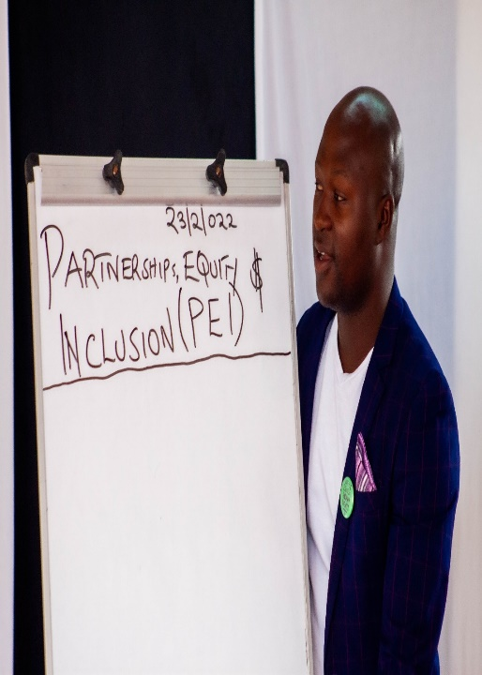
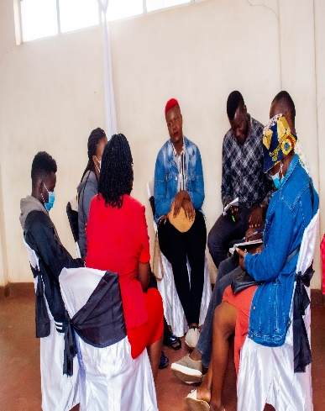
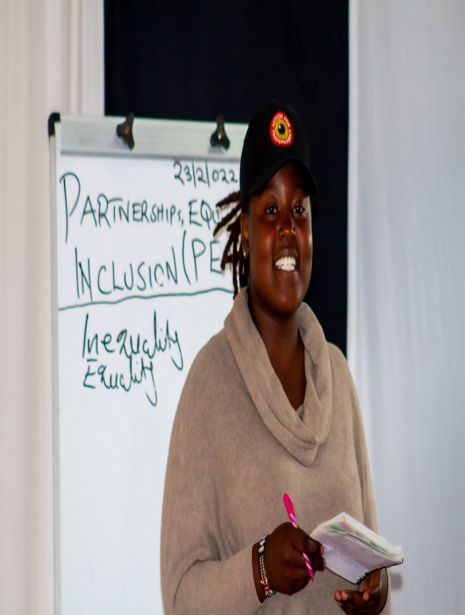

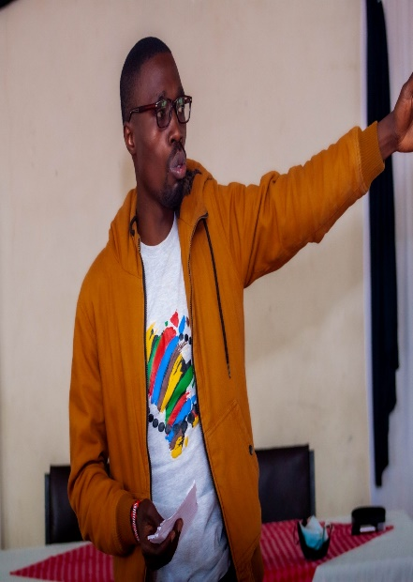

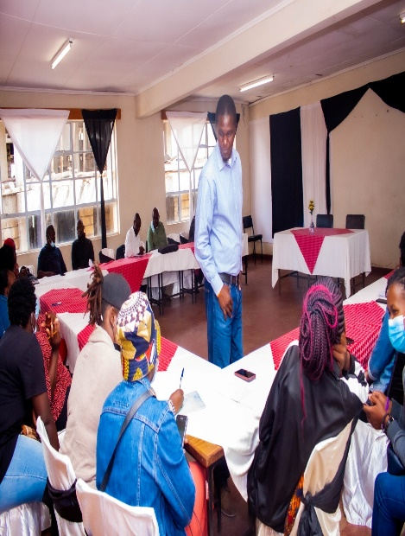
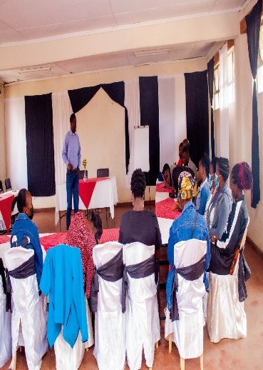

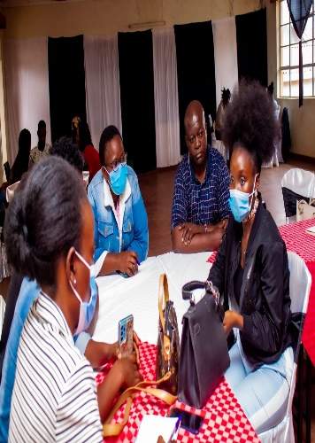
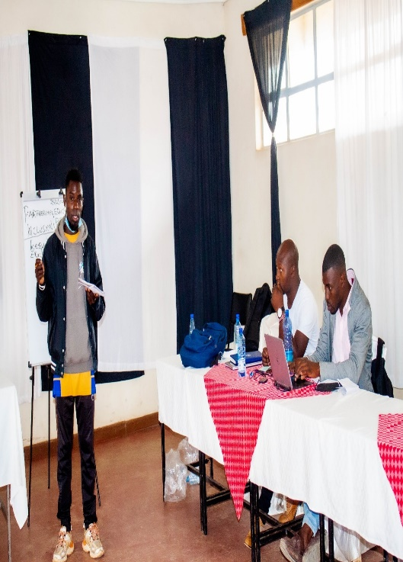
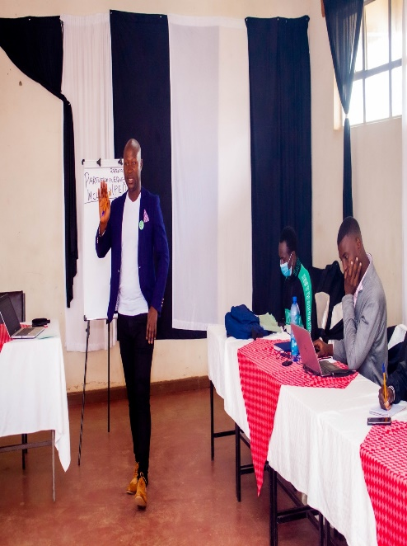
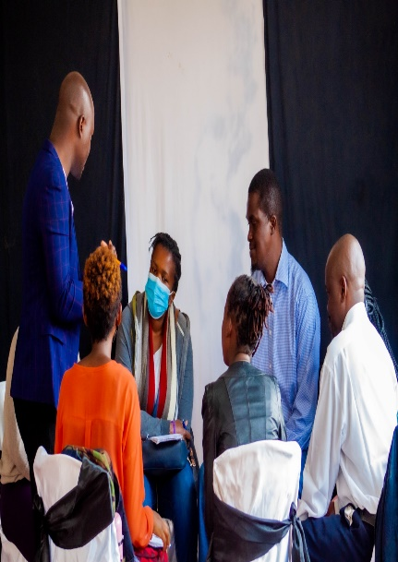
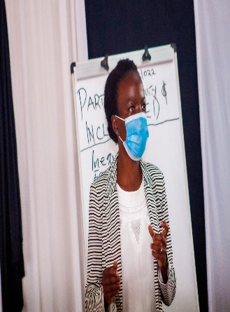
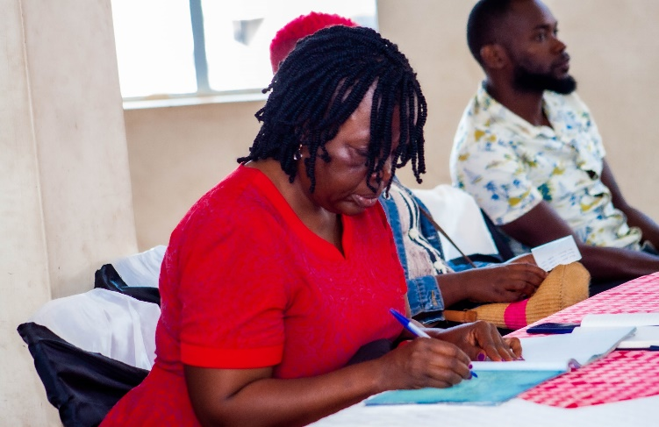

REFERENCES

Cheseto, M. (2013). Challenges in Planning for Electricity Infrastructure in Informal Settlements: Case of Kosovo Village, Mathare Valley –Nairobi. A Thesis Submitted in fulfillment of a Masters Degree at the University of Nairobi.
Corburn, J. & Riley, L. (2016). Slum Health: From the Cell to the Street. University of California Press.
Desgroppes,A.& Taupin, S. (2011). Kibera: The Biggest Slum in Africa. East African Review Vol. 44 pp. 23-33https://journals.openedition.org/eastafrica/521
GoK. (2019).2019 Kenya Housing and Population Census Vol IV: Distribution of Population by Socio-Economic Characteristics. Kenya National Bureau of Statistics.
Graham, A. (1995). Tackling poverty in Nairobi’s informal settlements: developing an institutional strategy.Environment and Urbanization. Vol. 7(2), 47-62.
IDRC. (2016).Unlocking the Poverty Penalty and Up scaling the Respect for Rights in Kenya's Informal Settlements. Author. https://www.idrc.ca/en/project/unlocking-poverty-penalty-and-upscaling-respect-rights-kenyas-informal-settlements
Kiriti, T. &Tisdell, C., (2003). Gender Inequality, Poverty and Human Development in Kenya: Main Indicators, Trends and Limitations. Social Economics, Policy and Development Working PapersNo. 35
KNBS. (2013).Exploring Kenya’s Inequality: Pulling Apart or Pooling Together: Nairobi County. KNBS&SID.
Malenya, F. L. (2020). ‘Basic Education Provision in Kenya's Urban Informal Settlements’ in Keengwe J. (Ed.) Handbook of Research on Diversity and Social Justice in Higher Education. IGI Global. 308- 332.
Nthambi, M. (2014). Solid Waste Management Options for Households in Developing Countries: Economic Assessment in Kibera Slum Kenya. Lambert Academic Publishing.
Onyango, P. and Tostensen, A. (2015).The Situation of Youth and Children in Kibera. Chr. Michelsen Institute.
Owiti, J. (2014). Political Drivers of Inequality in Kenya. Development.Vol. 57(3–4), 547–558.
Oxfam. (2009).Urban Poverty and Vulnerability in Kenya. Author.
Ren, W. G, Zhenke, Z., Kisovi M., and Das, P. (2020). Population Density and Spatial Patterns of Informal Settlements in Nairobi, Kenya. Sustainability. vol. 12 (18), 1-14.
Society for International Development. (2004).Pulling Apart: Facts and Figures on Inequality in Kenya. Author.
UN-Habitat. (2015). Habitat III Issue Paper 22: Informal Settlements. Author. https://unhabitat.org/sites/default/files/download-manager-files/Habitat-III-Issue-Paper-22_Informal-Settlements-2.0%20%282%29.pdf
World Bank. (1990).World Development Report 1990. Oxford University Press.
World Bank.(2020). Population Living in Slums. Author.https://data.worldbank.org/indicator/EN.POP.SLUM.UR.ZS?locations=ZG
Zero A., Delgado, R. C., & González, P. A. (2019). Vulnerability and everyday health risks of urban informal settlements in Sub-Saharan Africa. Global Health Journal. Vol. 4(2), 46-50.

The Kazi Mtaani Programme is an initiative designed to cushion the most vulnerable youth in the informal settlements from the effects of COVID-19 pandemic. It was implemented by the Ministry of Public Service, Gender and Youth Affairs with the objective to provide a form of social protection for workers whose prospects for daily or casual work has been disrupted by the containment policies put in place to limit the spread of COVID-19.
This refers to the practice of using polythene or other types of bags to deposit human waste and later dispose on rooftops, dumping sites, open sewers or drainage trenches.
A gamble going stale
We shall come for you
Swahili for ‘How will COVID-19 end? When will it end?’
Swahili for ‘Jobs were terminated’

