DEVELOPING PUBLIC SERVICES THAT ‘LEAVE NO ONE BEHIND’
This briefing brings together evidence from seven pilot studies exploring how public services in the Global South could be more inclusive of groups that experience inequities linked to social exclusion. Our research was conducted in healthcare, education and local government settings as key institutions in which social inequities are created and maintained. Commonly used private service providers were also included in some of the studies we conducted.
The UN Sustainable Development Goals recognise that an essential element of sustainable development involves leaving ‘no-one behind’. Failure to address inequity in society, such as unfair allocation of resources and discriminatory practices, has led to widening divisions between rich and poor, men and women and between diverse ethnic, religious and other social groups. This in turn is linked to civil unrest, conflict and humanitarian crisis as well as to losses in national productivity and economic development . Changing the culture within these services to help reduce inequity is, therefore, essential for sustainable development and social stability.

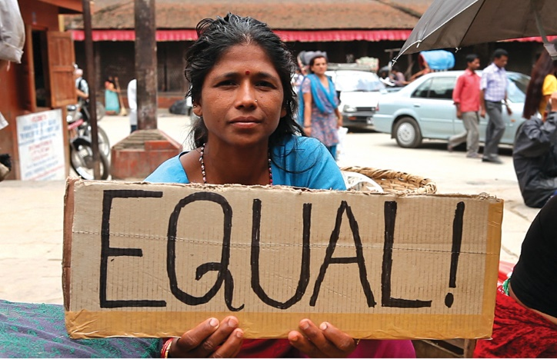
The research was carried out by teams in Bangladesh, Kazakhstan, Kenya, Myanmar, Nepal, Nigeria and Vietnam and focused on a range of social groups that experience disadvantage: women and young people, especially those from deprived and rural backgrounds, ethnic and religious minorities and migrant workers. The studies were supported by an international partnership of academic, policy and non-government organisations. More details of the Partnerships for Equity and Inclusion collaboration and full reports for all pilot studies can be found on the University of Leeds website here.

KEY RECOMMENDATIONS were identified at multistakeholder workshops across the different contexts and population groups.

Revise policies that maintain inequity:
- Pay specific attention to gender, age, ethnicity, religious identity, disability and migrant status in policy and practice for healthcare, education, water and sanitation, housing, criminal justice systems; job opportunities; and the impact of COVID-19.
- Target support at excluded groups and address systemic discrimination and the structural and physical violence that these groups experience through public services.
- Gather and use data on current service use and outcomes and on needs within excluded populations to inform policy development. Disaggregated data should be gained from complementary sources, including robust monitoring mechanisms and feedback from excluded communities and organisations that represent their interests.
- Recognise the intersectional disadvantage of those who experience multiple layers of exclusion, such as adolescent girls from minority groups, especially in rural areas or informal settlements.
- Build capacity and leadership at individual, community, institutional, policy and societal levels to achieve the systemic reforms needed.
Ensure participation in decision-making:
- Employ people from populations that experience disadvantage in service planning roles at local, regional and national levels, including at senior levels, to ensure their needs and context are understood during decision-making processes.
- Develop community partnerships with policymakers and practitioners and participatory planning to challenge current power imbalances and lack of accountability.
- Build capacity and support for excluded groups to engage in partnerships and to ensure that their aspirations are implemented in practice.
Redistribute resources:
- A systemic restructuring of public services is needed to address current injustices through, for example, service relocation, targeted provision and transparent systems that monitor and report resource distribution.
- Invest in deprived areas to increase access to good quality public services, provide employment opportunities and to enable digital inclusion.
- Provide financial assistance and incentives to mitigate inequities, particularly for young people living in informal settlements and rural areas.
Scale up equity interventions:
- Develop strong leadership to implement evidence-based interventions at local, regional and national levels. Address political, economic, and sociocultural injustices as well historic tensions and grievances.
- Gather robust and stratified data for health, education and other services, including relevant private institutions via trained staff.
- Evaluate implementation of equity interventions to generate further refinements and inform new initiatives that meet the needs of excluded groups.

THE PILOT STUDIES
The pilot studies were conducted and overseen by multisector groups, including academics, non-government organisations and policymakers. They engaged with over 385 key stakeholders using robust research methods, including participatory research, policy reviews and in-depth interviews. Studies were conducted in the following contexts and research areas:
Bangladesh: Equity in health and education services during COVID-19: challenges and the way forward
Kazakhstan: Education, gender and family relationships during COVID-19
Kenya: Impact of COVID-19 and inequalities in the informal settlement of Kibera, Nairobi
Myanmar: Expanding opportunities to deepen women’s participation in decision making processes and initiatives for peace and reconciliation
Nepal: Generation and use of gender and social stratifiers: Health Management Information Systems
Nigeria: Adolescent girls and development
Vietnam: Migrant workers and urban planning

FINDINGS: EQUITY AND INCLUSION
The policy context
Data systems for health (HMIS) in Nepal and for health, education and urban planning in Vietnam did not record certain key social group categories so could not identify inequalities in access or outcomes for these groups. The need for such data was rejected by policymakers in Vietnam and even when collected at local level in Nepal was not used in municipal planning.
“There is no use of plans formulated locally by utilizing all the available health data because that plan will remain only on the paper as municipality does not value any plans prepared by local health units.”
Health Facility Manager, Nepal
The health needs of excluded groups were similarly not considered in other contexts; for example, risk guidance on COVID-19 was inaccessible to indigenous communities in Bangladesh and were impossible to follow in overcrowded urban slums that lacked sanitation facilities in Bangladesh and Kenya.
Representation in decision-making
Collaborative decision-making with populations that experience disadvantage was identified as a key gap in service planning across the diverse studies. The lack of staff from these populations and lack of involvement in public service decision-making meant that the needs of these groups were routinely overlooked and there was no challenge to power imbalances or demand for change at local, regional or national levels. Where policies existed to involve such groups in participatory planning processes, these did not function in practice.
In Nepal, though policies on social inclusion and gender equity were well developed, these did not drive change and in none of the study contexts was there accountability for reducing the inequities that existed. Women in most study contexts experienced exclusion from decision-making that affected their lives at policy, institutional and community levels:

“the needs of the adolescent girls will be fully captured when young girls have a place in decision making.”
Adolescent girl in Amac, Nigeria
Power and resources
Exclusion from policies and institutions that affected their daily lives had economic, physical and psychological impacts on people from excluded communities. In Kenya and Myanmar exclusion and physical violence were linked:

“Police brutality is the biggest form of inequality I have seen as a young man living in Kibra, this needs to stop.”
Butrose, young person from Kibra, Kenya

Participants reported financial and other restrictions on their ability to access public services. Healthcare and education institutions were often of poor quality in rural or deprived areas in Nigeria and Kenya and too expensive for many to access. Living costs added further pressure and young Nigerian women sometimes turned to prostitution to continue their education beyond primary level.
COVID-19 exacerbated existing income and resource inequalities, particularly in deprived and rural areas. Rural and slum residents in Bangladesh and Kenya and migrant workers in Vietnam suffered financially as disruption particularly affected those in insecure employment. The non-availability or use of data on disadvantaged groups in these contexts, as well as in Nepal, meant that public resources were not allocated to meet their needs. In Kenya, prostitution could be seen by some as unavoidable.
The transition to online technology in healthcare and education during the pandemic was very difficult or impossible for many in deprived areas, due to poor planning, non access to equipment or energy supply and lower capacity to adapt, especially for women with young children. In Bangladesh, Kazakhstan and Kenya, negative impacts on health and learning increased pressure to self-finance healthcare, education and digital equipment.
Teacher training and distribution of digital equipment in Kazakhstan and ‘Kazi Mtaani’, a youth employment programme in Kenya, were examples of positive initiatives that helped mitigate inequities by targeting support at vulnerable young people during the Covid-19 pandemic. The need to maintain and increase such initiatives was promoted by multistake-holder workshops in all contexts.

For further details please contact:
Dr Ghazala Mir, Leeds Institute of Health Sciences, University of Leeds,
g.mir@leeds.ac.uk

UN Department of Economic and Social Affairs 2015 UN Sustainable Development Goals United Nations
Mir et al 2020 Partnerships for Equity and Inclusion: Evidence Synthesis University of Leeds
“World Bank. 2013. Inclusion Matters: The Foundation for Shared Prosperity. New Frontiers of Social Policy;. Washington

