MIGRANT WORKERS AND URBAN PLANNING IN VIETNAM
This briefing brings together evidence on the main barriers that hinder migrant workers from raising their voices within urban planning processes in Vietnam.

The research was carried out by Hanoi University of Public Health through mapping key stakeholders and qualitative interviews. This is one of a series of pilot studies exploring how public services could be more inclusive of disadvantaged social groups in ODA-eligible contexts. The studies are supported by an international partnership of academic, policy and non-government organisations collaborating to produce new knowledge and solutions to exclusion and disadvantage. More details of the PEI collaboration and a full report for this project can be found here

KEY RECOMMENDATIONS
At macro level for policy-makers and social organizations
- Policy-makers at national and provincial levels should consider migrant workers in all processes of urban planning and develop a monitoring system and mechanisms to collect relevant data on their needs
- The Labour Union and Women’s Union at all levels should be involved in developing interventions to support migrant workers’ voice within urban planning
At meso levels for public services
- Company managers should conduct regular needs assessments for the migrant labour force.
- Participatory research could support migrant workers to develop a voice in urban planning and facilitate policy and practice change that meets their needs
At micro level for migrant workers and their communities
- Migrant workers and local communities should be trained with the knowledge and skills to help raise their voice during urban planning processes related to healthcare and livelihood

FINDINGS
In Vietnam, availability and access to social services, including health and education, is limited for rural-to-urban migrant workers due to their temporary residence registration (hộ khẩu thường trú). Migrant populations are omitted from priority status in urban planning. There is almost no data on migrant workers’ needs and issues collected in any official reports, leaving them unsupported or unsure about how to raise their voices within urban planning

“We also do not distinguish whether they are local residents or migrant workers. We are required to manage all health data of all employees in companies. And not only migrant workers in the industrial zone, we do not collect data for migrant workers in the entire province.”
(Department of Health representative)

During COVID-19, migrant workers have been faced with significant livelihood and healthcare issues due to their insecure employment, lower work opportunities, and lower salary payments. The migrant workers, however, are not recognised as a vulnerable group by policy-makers. There have been no livelihood and healthcare policies focusing on migrant workers to support them in dealing with the COVID-19 pandemic (2020-2021) in Vietnam.

“We have no support for migrant workers in our province. Every worker is considered similarly. There is no special remuneration policy for migrant workers outside the province. All workers are the same and are treated through the same mechanisms” (IDI with representative of Labour Union).

Non-recognition
Migrant workers are not recognised as an important group to be prioritised in urban planning in Vietnam, including health planning.
Migrant workers are not recognised as a vulnerable group by policy-makers, their representative organization (the General Confederation of Labour or Labour Union), or major stakeholder groups such as the Women’s Union or employers
Both local and migrant workers are treated in the same way, despite the employment and economic disadvantages migrant workers face. No special focus is given to their needs in ubran planning or employment policy and practice.
As a result, no data or mechanisms for collecting information on migrant populations have been developed in planning processes. Migrant workers can currently only present their complaints and opinions via three main communication channels - an employer’s suggestion box, contacting the representative of Labour Unions in their companies, and expressing their opinions via social networks such as Zalo or Facebook. More robust processes for influencing employer practices and urban planning policy are therefore needed as a priority.
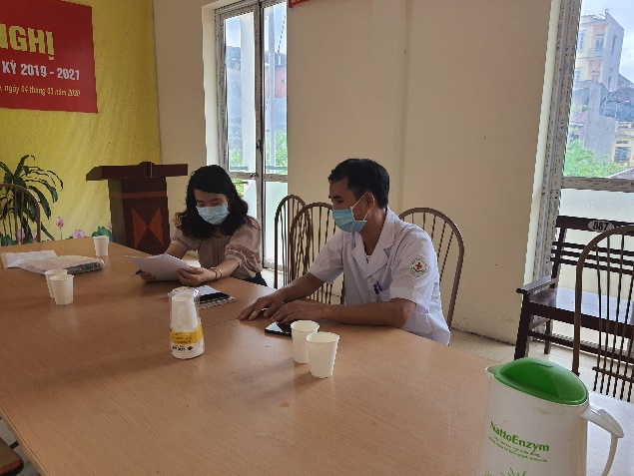
Interview with a representative of the Labour Union
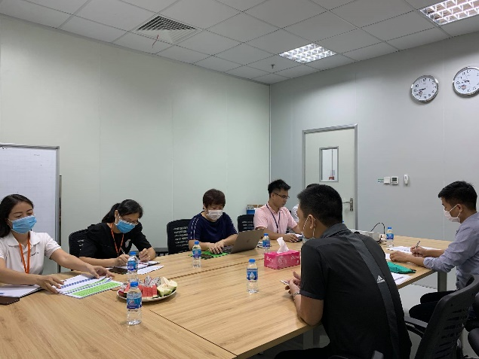
Focus group with migrant workers
Further information
More details about the project are available from the team at Hanoi University of Public Health. Please contact Professor Bui Thi Thu Ha, Chair of Board of Trustee: bth@huph.edu.vn or Dr Duong Minh Duc, Faculty of Social & Behavioural Sciences: dmd@huph.edu.vn
Website: http://www.huph.edu.vn

