WORKING PAPER NUMBER: WP21_05

The COVID-19 pandemic and volunteering behaviour in England: evidence from a volunteering platform

Chris Bojke*, Dan Howdon, Silviya Nikolova
Academic Unit of Health Economics, University of Leeds
* Corresponding author: Academic Unit of Health Economics, Leeds Institute of Health Sciences, University of Leeds, Worsley Building, Clarendon Way, Leeds, LS2 9LJ. E-mail: C.Bojke@leeds.ac.uk

This working paper should cited as: Bojke C., Howdon D., Nikolova S.. The COVID-19 pandemic and volunteering behaviour in England: evidence from a volunteering platform. Leeds: University of Leeds, Academic Unit of Health Economics; 2021. Available from: [URL]

DISCLAIMER
The series enables staff and student researchers based at or affiliated with the AUHE to make recent work and work in progress available to a wider audience. The work and ideas reported here may not always represent the final position and as such may sometimes need to be treated as work in progress. The material and views expressed in the series are solely those of the authors and should not be quoted without their permission.

Additional information

Funding
ESRC - ES/V004026/1
Conflict of interest
The authors have no conflicts of interests to declare.
Acknowledgements
The views and opinions expressed therein are those of the authors and do not reflect those of Do IT or any other individual or organisation. The authors are grateful to Adam Martin for helpful comments in internal peer review. Any outstanding errors or inaccuracies remain those of the authors.

Abstract

We use data from a volunteering platform to examine the underlying rates of new volunteers and opportunities per week, and the short- and longer- term impact that the COVID-19 pandemic has had on those rates. We use multi-level modelling to understand the variation in these responses across local areas, and attempt to use local area characteristics to explain this variation in new volunteering registrations on this platform.

We find, overall, that there are substantial differences between population-adjusted numbers of volunteers per week across Local Authorities (LAs) and Middle-Layer Super Output Areas (MSOAs) and that there is, on average, a five-fold increase in numbers of those offering to volunteer over an initial eight week period beginning in late March 2020. This increase later settles to twice the original rate (pre-March 2020) over a longer time period ending in April 2021. We also find that there is considerable variation in pandemic response across MSOAs, with some MSOAs (approximately 29%) systematically recording reductions in population-adjusted numbers of volunteers per week. A further 68% of MSOAs have an estimated increase of up to 30 new volunteers per 8,000 population and a ‘long tail’ of 3% have more substantial increases (>30) according to the data. This leads to large differences in the estimates of the median pandemic impact of 2.5 volunteers over 55 weeks to the mean impact of 7.6 new volunteers. We find that variation in these local volunteering responses to Covid-19 can be explained to a much greater extent by pre-existing characteristics of the MSOAs rather than by local pandemic circumstances. While we are unable to meaningfully assess local trends in volunteering opportunities, we also find substantial falls in this metric both in the short and long- term following the initial impact of the pandemic in England.

Key words: volunteering, COVID-19 pandemic, multilevel modelling.

JEL classification: I12, D64.

Introduction

The ongoing pandemic involving COVID-19, a viral disease caused by the SARS-CoV-2 pathogen, has led to substantial adverse health impacts and widespread societal disruption since its emergence in the final quarter of 2019 (van Dorp et al., 2020). In England, a response to this pandemic was the mobilisation of volunteers through both formal and informal structures (Department for Digital, Culture, Media & Sport, 2021). The Moving Volunteers Effectively (MoVE) project seeks to investigate ways in which volunteers were mobilised to help vulnerable people during this pandemic.

Our primary data source is data collected administratively by Do IT, a national platform which seeks to match volunteers to organisations with volunteering opportunities. We use data from this platform for the years 2019 to 2021, which we linked to publicly available administrative data, to characterise trends in volunteering behaviour in England in the period before and after the start of the COVID-19 pandemic.

Objectives
Qualitative findings from the MoVE project highlighted the importance of using existing relationships and resources in responding to community needs during the pandemic. These findings captured an overwhelming response in volunteering in response to the crisis. Qualitative exploration detected a changing pattern in community needs.
This quantitative analysis aims to explore these issues using data from the Do IT platform. Our research objectives are to establish:
- How has the COVID-19 pandemic impacted on the Do IT volunteer rate across England?
- Has the impact been consistent across Local Authority (LAs) and Middle-Layer Super Output Areas (MSOAs)?
- Insofar as these impacts have not been consistent, do any factors systematically explain differences in pandemic volunteering rates?
- Do these impacts vary over the short- and long-term?
- How has the pandemic impacted on the Do IT opportunities rate across England? Has the impact been consistent across LA and MSOAs? Has the rate been different to that of volunteers?
- Was the availability of different types of opportunities differently affected by the pandemic?

Data: The Do IT national database

We use data aggregated at Middle-Layer Super Output Areas (MSOA). MSOAs are geographically contiguous regions of between 2,000 and 6,000 households, and 5,000 to 15,000 people, defined at the time of the 2011 census (Office for National Statistics, 2011). While some administrative data we employ is collected on a daily basis, the lowest level of aggregation employed over time in this analysis is by week (defined by International Organization for Standardization week number). MSOAs are nested within local authorities – higher-level political-administrative regions of varying sizes between 2,000 and 1.1m people.

Data from the Do IT volunteering platform provides, broken down by week and MSOA, counts of: individual user sign-ups and new unique opportunities. New individual user signups are defined as individuals signing up on the Do IT platform for the first time in that week. New unique opportunities are defined as opportunities available for the first time in that week, and are grouped into one of 20 categories.

We also employ area-level administrative data on: number of COVID-19 cases, population estimates, indices of deprivation, and household income. Data on COVID-19 cases (broken down by week) is obtained from the official UK coronavirus dashboard (Public Health England, 2021). Data on numbers of deaths, population size, indices of deprivation and on household income for the most recently available year (2019) is obtained from the Office for National Statistics. Indices of multiple deprivation are a measure of relative deprivation in England, based on a set of indicators across seven dimensions of deprivation (Noble et al., 2019). The measure of household income employed is that equivalised after housing costs: a technical document detailing the method employed is available at (Office for National Statistics, 2014).

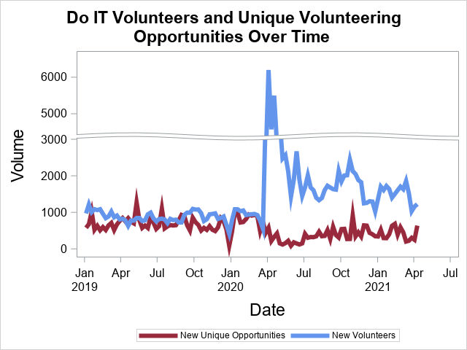
Figure 1

Figure 1 shows new individual user signups and new unique volunteering opportunities on the Do IT platform in England since the start of 2019. It appears to show a stable and overlapping trend over the pre-pandemic period for both new volunteers and new unique opportunities. However, when the pandemic and lockdown policies start to materialise in March 2020, there is a marked divergence in number of new volunteers and opportunties. For new volunteers there is an immediate but short-lived increase, peaking at approximately 6,200 new individual sign-ups in one week and, although this falls to a more stable level after a few weeks, the total remains above pre-pandemic levels. The number of opportunities declines during the same period, although this change is nowhere near as dramatic. From Figure 1 it can be seen that the number of new unique opportunities initially falls for a few weeks before recovering to a rate which appears below the pre-pandemic rate.
Figure 1 represents a national picture and may mask significant variation across local areas. In the following sections we use mixed/multi-level regression modelling to unpick local variation from the national picture at LA and MSOA level – identifying the extent to which there is systematic variation across each geographical area and identifying those areas which are at the extremes. In section 5.4 we attempt to unpick whether the systematic responses are related to local characteristics and COVID-19 related events.

Methods

Underlying Regression Model

For both new volunteers and new opportunities (y) we apply the same underlying regression framework which we outline here.
Observations of volunteers and opportunities are recorded for each of 119 weeks from the start of 2019, for 6780 MSOAs, which are nested within the 316 LAs appearing in our data. This creates a potential total of 856,919 observations (n). The multilevel nature of the data permits a 3-level mixed model regression of the form:
$$y=Xβ+Zγ+ε$$

Having properties: $γ\sim N(0,G)$,
$ε\sim N(0,σ^{2}I)$ and
$cov\left[γ,ε\right]=0$
Where:
n = the number of observations
k = number of fixed parameters to estimate
q = number of unique clusters (LAs and MSOAs)
y = the (n*1) vector of dependent variable responses either new volunteers or new unique opportunities
X = the (n*k) design matrix of fixed effects
$β$ = the (k*1) vector of fixed-effect parameters
Z = the (n*q) design matrix for the random-effects
$γ$ = the (q*1) vector of random-effects
$ε$ = the (n*1) vector of unobservable residual errors
$σ^{2}$ = the variance of the residual errors
G = the (n*n) covariance matrix for the random-effects
I = the (n*n) Identity matrix for the standard error term variances

To quantify the pandemic impact, and identify a heterogenous impact across LAs and MSOAs, we specify the following model of fixed effects: A time-invariant underlying rate of volunteering which applies over all time periods and is effectively captured by the standard intercept term ($β_{0}$), an initial pandemic response which lasts for the 8-week time period 28 March 2020 to 22 May 2020 inclusive ($β_{1}$), and a longer-term pandemic response time period from the 23 May 2020 onwards ($β_{2}$). The latter two variables are specified as dummy variables set to one if covering the relevant time period and zero otherwise. The structure of the data permits various hypothesis tests. For example, $H_{0}:β_{1}=0$ and $H_{0}:β_{2}=0$ are tests of no significant response to the COVID-19 pandemic in the short term and the long term respectively, and $H_{0}:β_{1}=β_{2}$ is a test that the short term impact is the same as the long term impact.

In addition to these fixed effects, we estimate random effect parameters for all of the fixed effect variables at MSOA and LA level. We produce Empirical Bayesian Estimates (EBEs) of these effects for comparison and, in a second step, examine the relationship between these and (a proxy for) COVID-19 infections, as well as other local area characteristics. This also permits us to understand the level of variation from the national picture at a more local level - i.e. whether this variation is greater at LA or the more local MSOA level.

The solutions for the random-coefficient parameters are the empirical Best Linear Unbiased Predictors (BLUP) given by:
$$\hat{γ}=\hat{G}Z'{\hat{V}}^{-1}(y-X\hat{β})$$

Where V is the variance of y and is given by: $V=ZGZ^{'}+Iσ^{2}$

Three models are estimated using the HPMIXED procedure in SAS 9.4 to account for the large number of clusters, and are estimated using Restricted Maximum Likelihood (REML). The models are: A constant term model only, a fixed effect only model, and a random coefficients model. The default Variance Components specification is assumed for G.

To account for differences in MSOA population size we use volunteers and opportunities per 8,000 (approximately the mean population of an MSOA) residents as our dependent variables.

Results

New Volunteer Regression
Inspection of the data shows one MSOA, ‘Strand, St James & Mayfair’ (E02000977) having an increase of 182.28 volunteers per 8,000 population per week in each of the initial 8 weeks of the pandemic. This is followed by an average of 117 volunteers per week over the remaining period. The initial underlying rate for the MSOA seems plausible but, at 1.3 new volunteers per 8,000 population per week, is the highest observed in the dataset. These figures suggest that over the whole period, the MSOA had over 5,500 new volunteers in total from an estimated population size of approximately 6,500 individuals. These data indicate the MSOA to be an extreme outlier, and may be the result of underlying data artefact or error rather than a real increase. Though the multi-level nature of the analysis minimises the impact of outliers on the estimates of the fixed effects, the inclusion of this MSOA is to vastly inflate the measure of variance at the MSOA level. For this reason we exclude this MSOA from our analysis.

A further exclusion occurs with the ‘City of London’ LA and MSOA, which represents the sole MSOA in the LA. The reason for this exclusion is not that the underlying data indicate a particular outlier, but rather that the identical nature of this area at both MSOA and LA level makes it impossible to separate out MSOA and LA variation. When these data are included the ‘City of London’ LA appears as an outlier which greatly affects the measure of overall variation between LAs. There is no impact on the estimate of the fixed effects. On the grounds that we suspect the LA variation is over-inflated due to the limited structure of this LA, we exclude it from the model.

Finally, for all MSOAs, there are three data points which are identified as errors in the underlying data - weeks 105, 111 and 112 - and are consequently excluded.

In total, the final regression models consist of 787,524 observations nested within 6,789 MSOAs, themselves nested within 316 Local Authorities. We estimate three models: a fixed-effect model containing only a constant term to establish overall variation, a fixed-effect model containing a time-invariant underlying effect ($β_{0})$, an initial 8-week incremental pandemic reaction ($β_{1}$) and a longer-term incremental pandemic reaction ($β_{2}$). A third and final random coefficients (“mixed effects”) model is estimated to allow for systematic variation from the fixed-effects for each of the MSOAs and LAs.

Table 1
 | Constant Term Only (M1) |  | Fixed Effects Only (M2) |  | Random Coefficients (M3)
 | Estimate | Std Error | Estimate | Std Error | Estimate | Std Error
Underlying Time-Invariant Rate ($β_{0}$) | 0.18670 | 0.00073 | 0.12320 | 0.00097 | 0.11550 | 0.00387
Initial pandemic Response ($β_{1}$) |  |  | 0.41570 | 0.00290 | 0.41590 | 0.01432
Longer Term pandemic Response ($β_{2}$) |  |  | 0.09195 | 0.00152 | 0.09195 | 0.00562
Error Term Variance | 0.4173 |  | 0.4062 |  | 0.2235
MSOA Underlying Rate Variance |  |  |  |  | 0.001708
LA Underlying Rate Variance |  |  |  |  | 0.004398
MSOA Initial pandemic Response Variance |  |  |  |  | 1.3399
LA Initial pandemic Response Variance |  |  |  |  | 0.000682
MSOA Longer Term pandemic Response Variance |  |  |  |  | 0.2054
LA Longer Term pandemic Response Variance |  |  |  |  | 0
AIC (smaller is better) | 1546616 |  | 1525428 |  | 1110225
BIC (smaller is better) | 1546628 |  | 1525439 |  | 1110260

In terms of model fit, as indicated by the AIC and BIC, these three models indicate that the majority of variation is explained as we move from the fixed effects model to the random coefficients model, rather than from the constant only model to the fixed effects model. This is also demonstrated by the estimate of the regression residual error term, which significantly shrinks as we move from the fixed effect model to the random coefficients model. This indicates a large degree of systematic variation explained by MSOA and LA specific variance from the fixed effects.
Both the simple fixed-effects model only and random coefficients model indicate a statistically significant impact of the pandemic on volunteer rates. The model estimates that the average MSOA has an underlying rate of 0.1155 new volunteers per week per 8,000 population.
According to the random coefficients model. the initial weekly rate in the weeks immediately preceding the initial impact of the pandemic is almost five times higher than the underlying rate, and the long term rate is approximately double the original rate. These findings are both statistically significant, of a sizable magnitude, and consistent with Figure 1. Using the underlying rate alone, we can estimate the number of new volunteers per 8,000 population for the average MSOA/LA for the 55 weeks of the pandemic had the pandemic not occurred. For that 55 week period, the average MSOA/LA would have generated a total of 6.4 new volunteers per 8,000 population. The initial pandemic impact indicates that the same average MSOA would have had an extra 3.3 volunteers over the initial 8 weeks, and a further 4.3 in total over the following 47 weeks. Thus, whilst the average MSOA/LA has had an average of 14 new volunteers per 8,000 population over the latter 55 week period, approximately 7.6 (or 55%) of those are estimated to be due to the COVID-19 pandemic.
Of further interest are the covariance estimates of model 3. These allow us to understand the degree of variation explained at each level of the model: for example, the estimates of MSOA variance and LA variance around the fixed effect for underlying rates are approximately 0.002 and 0.004 respectively. This indicates that there is relatively little variation around the fixed effects that is explained by systematic variation at either LA or MSOA level. From what limited variation there is, however, we can estimate that there is almost twice as much variation between LAs as there is between MSOAs, after allowing for the LA effect. That is, at the underlying rate of volunteering, more of the variation is explained by differences between LAs than that between MSOAs.
This statement only holds for variation at the underlying volunteer rate, as the opposite is true when we consider the variations around the reaction to the pandemic. For example, with the initial reaction to the pandemic, the MSOA variation is substantial at 1.3399, whereas the LA variation is just 0.0007. This indicates that there is not much variation between LAs, but substantial variation at MSOA level.
For long-term reactions the model indicates that there is no variation at LA level, but substantial variation at MSOA level, though smaller than that observed in the initial response.
Our conclusions from these models are that there is an overall increase in numbers of volunteers per head of population as a result of the pandemic, and that this is reflected in an initial rise to approximately five times the underlying rate. While this increased rate is not sustained, it subsequently settles down to a rate which is still double the original pre-pandemic rate of volunteering. We also conclude that there is substantial variation in response across MSOAs especially in the initial reaction. There is little to no LA-level variation in response.

LA and MSOA specific rates
The random coefficients model permits Empirical Bayesian Estimates (EBEs) of LA and MSOA specific deviations away from the overall fixed effect to allow us to make Best Linear Unbiased Predictions (BLUPs) unique to each MSOA and LA. This means that rather than assume all local areas have the same average response, we can estimate and report the systematic variation around this average. The EBEs themselves represent deviations away from the fixed effects, and so we add them to the relevant fixed effects to get area (MSOA or LA) specific parameters. Due to the large number of MSOAs and LAs, we do not report each individual EBE in this report.
For illustration, we consider MSOAs ‘Burnt Oak & Watling Park’ and ‘Brent Cross & Staples Corner’ in Local Authority ‘Barnet’ and ‘Cleadon & East Boldon’ and ‘Jarrow Town’ in LA ‘South Tyneside’ and their underlying rates of volunteers per week per 8,000 population.
The fixed effect is estimated at 0.1185, and would be the estimate for an average MSOA or LA, or the expected rate for a ‘new’ MSOA that might enter the data. However, for LAs ‘Barnet’ and ‘South Tyneside’, their EBEs for the underlying rate are 0.03289 and -0.04709 respectively, indicating that Barnet LA has a systematically higher than average underlying volunteering rate at 0.1514, and that South Tyneside has a lower than average rate at 0.071. These LA figures are applied to all MSOAs in those LAs and indicate a fair degree of variation, with MSOAs in Barnet systematically having twice the rate of new volunteers per population as those in South Tyneside.
We can also go beyond talking about average MSOAs in specific LAs by adding the MSOA EBEs to the fixed effect, and the LA EBE. As Table 2 shows the EBEs for the MSOAs are -0.00177, 0.05058, -0.01558 and 0.03095 respectively indicating that Burnt Oak and Cleadon are MSOAs that are below average for their LAs and that Brent Cross and Jarrow Town are above average for their respective LAs. In order to get the absolute picture we need to add these MSOA EBEs to the fixed effect and the respective LA EBEs. Thus the MSOAs have specific estimates of 0.14662, 0.19897, 0.05283 and 0.09936 new volunteers per 8,000 population per week respectively.

Table 2
LA | MSOA | B₀ | EBE LA | LA specific Underlying Rate | EBE MSOA | MSOA specific Underlying Rate
Barnet | Burnt Oak & Watling Park | 0.1185 | 0.03289 | 0.15139 | -0.00177 | 0.14662
Barnet | Brent Cross & Staples Corner | 0.1185 | 0.03289 | 0.15139 | 0.05058 | 0.19897
South Tyneside | Cleadon & East Boldon | 0.1185 | -0.04709 | 0.07141 | -0.01558 | 0.05283
South Tyneside | Jarrow Town | 0.1185 | -0.04709 | 0.07141 | 0.03095 | 0.09936

It can be seen that although Jarrow Town has a high rate of volunteers for its LA, and that Burnt Oak has a relatively low rate for its LA, the LA effects mean that the absolute rate of volunteers is higher in Burnt Oak than it is in Jarrow Town. This is indicative of the extent to which systematic LA variation explains variation in the data, especially relative to MSOA variation. MSOA variation, however, still plays an important role. For example, whilst the average rate in Barnet LA is approximately double the rate in South Tyneside, for MSOAs Brent Cross and Cleadon, the rate is closer to three times the underlying rate due to their MSOA level EBEs.

Underlying Volunteer Rates by LA and MSOA
To gain an understanding of the impact of LA and MSOA level variation, we plot the LA and MSOA specific estimates in a histogram to examine the distribution and explore the extremes.
Figure 2
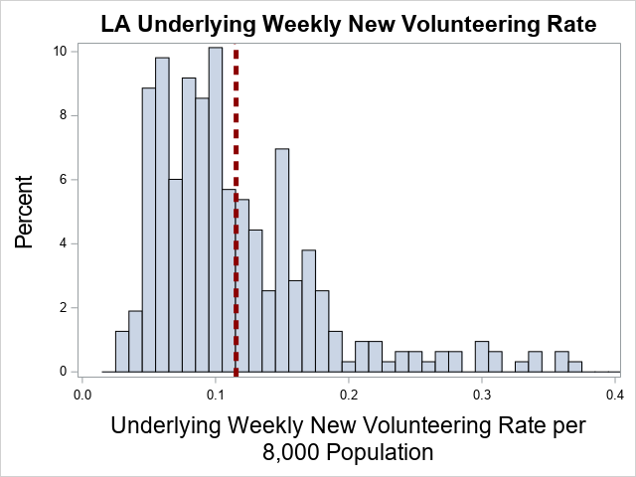

Figure 2 shows a histogram of the distribution of Local Authority level intercepts. The dotted red line shows the estimated fixed effect, indicating the mean response. As can be seen, the distribution is highly skewed with a long tail to the right indicating a few LAs with rates much higher than average, even after allowing for differing population sizes. Table 3 and Table 4 show the top and bottom 20 LAs respectively.

Table 3 : Top 20 LA underlying volunteer rates
Rank | LA Code | LAD19N | LA EBE | LA Specific Underlying Rate
1 | E09000013 | Hammersmith and Fulham | 0.2535 | 0.368976
2 | E09000020 | Kensington and Chelsea | 0.2409 | 0.356418
3 | E09000033 | Westminster | 0.2404 | 0.355926
4 | E07000041 | Exeter | 0.2225 | 0.337963
5 | E09000022 | Lambeth | 0.2202 | 0.335657
6 | E07000008 | Cambridge | 0.2166 | 0.332061
7 | E09000030 | Tower Hamlets | 0.1936 | 0.309079
8 | E07000078 | Cheltenham | 0.1914 | 0.306915
9 | E06000018 | Nottingham | 0.1839 | 0.29936
10 | E07000106 | Canterbury | 0.1837 | 0.299172
11 | E09000014 | Haringey | 0.1817 | 0.297173
12 | E07000138 | Lincoln | 0.1631 | 0.278595
13 | E09000028 | Southwark | 0.1608 | 0.276251
14 | E09000007 | Camden | 0.1511 | 0.266632
15 | E09000009 | Ealing | 0.1507 | 0.266151
16 | E09000019 | Islington | 0.1492 | 0.264685
17 | E09000032 | Wandsworth | 0.1373 | 0.252834
18 | E06000030 | Swindon | 0.1345 | 0.250048
19 | E06000015 | Derby | 0.1226 | 0.238125
20 | E09000023 | Lewisham | 0.122 | 0.237547

Table 4 : Bottom 20 LA Underlying Volunteer Rates
Rank | LA Code | LAD19N | LA EBE | LA Specific Underlying Rate
297 | E07000034 | Chesterfield | -0.0682 | 0.047303
298 | E07000189 | South Somerset | -0.06831 | 0.047194
299 | E07000071 | Colchester | -0.06843 | 0.047072
300 | E06000057 | Northumberland | -0.06917 | 0.046328
301 | E07000169 | Selby | -0.06939 | 0.046115
302 | E06000037 | West Berkshire | -0.06948 | 0.04602
303 | E07000244 | East Suffolk | -0.06984 | 0.045658
304 | E06000058 | Bournemouth, Christchurch and Poole | -0.06997 | 0.045529
305 | E06000001 | Hartlepool | -0.07014 | 0.045359
306 | E06000012 | North East Lincolnshire | -0.07036 | 0.045141
307 | E08000017 | Doncaster | -0.07105 | 0.044454
308 | E06000013 | North Lincolnshire | -0.07128 | 0.044217
309 | E08000018 | Rotherham | -0.07593 | 0.039567
310 | E07000043 | North Devon | -0.07699 | 0.038514
311 | E07000168 | Scarborough | -0.07799 | 0.037508
312 | E07000074 | Maldon | -0.07806 | 0.037437
313 | E07000076 | Tendring | -0.08063 | 0.034868
314 | E07000147 | North Norfolk | -0.08197 | 0.033529
315 | E06000046 | Isle of Wight | -0.08225 | 0.033255
316 | E06000059 | Dorset | -0.08337 | 0.032128

Local Authority level underlying rates range from Dorset (E06000059), with a rate of 0.032 new volunteers per 8,000 population per week, to Hammersmith and Fulham, with a rate of 0.369 (over ten times higher than the bottom ranked LA and three times higher than average). LAs in London account for 5 of the top 7 LAs with the highest underlying rates. Large urban LAs dominate the top 20, whereas the bottom 20 is dominated by rural LAs.

Figure 3
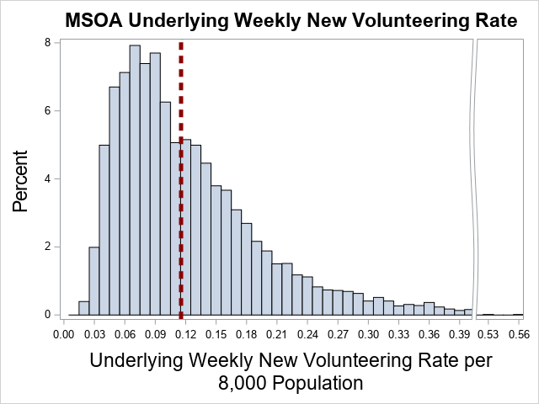

The equivalent figure for MSOAs is shown in Figure 3 and shows a similarly skewed distribution with a long right-hand tail. Although the distribution of MSOA underlying rates is wider than that of the LA-level rates, much of the variation is determined by the LA variation, as indicated by the size of the LA variance figure in the regression results. Thus 9 of the 20 MSOAs with the highest underlying rate of new volunteers per 8,000 population are clustered within London LAs and other top 20 LAs. The exceptions are the Birmingham based MSOAs ‘Central’, ‘North Central & Dartmouth Circus’ and ‘Selly Oak’.

At the opposite end of the spectrum, the MSOAs with the lowest rates of new volunteers per 8,000 population are located in Dorset, North Norfolk, Isle of Wight and Tendring LAs.

Table 5
Rank | Local Authority | MSOA Code | MSOA Name | MSOA EBE | MSOA Specific Underlying Rate
1 | Westminster | E02000979 | Central Westminster | 0.2013 | 0.55722
2 | Exeter | E02004156 | Central Exeter | 0.189 | 0.526927
3 | Birmingham | E02006899 | Central | 0.2667 | 0.490672
4 | Nottingham | E02002895 | The Park & Castle | 0.1912 | 0.490526
5 | Birmingham | E02001876 | North Central & Dartmouth Circus | 0.2637 | 0.487745
6 | Hammersmith and Fulham | E02000384 | Hammersmith Broadway | 0.1103 | 0.479312
7 | Exeter | E02004152 | St James's Park & Hoopern | 0.1347 | 0.472654
8 | Lincoln | E02005446 | Wharf & University | 0.1903 | 0.46888
9 | Nottingham | E02006904 | City Centre & Trent Bridge | 0.1687 | 0.468097
10 | Cheltenham | E02004603 | St Paul's | 0.1571 | 0.464017
11 | Kensington and Chelsea | E02000577 | Golborne & Swinbrook | 0.1035 | 0.459891
12 | Nottingham | E02002889 | Arboretum, Forest & Trent University | 0.1449 | 0.444269
13 | Birmingham | E02001922 | Selly Oak | 0.2187 | 0.442701
14 | Hammersmith and Fulham | E02000375 | Shepherd's Bush North | 0.06295 | 0.431921
15 | Canterbury | E02005022 | Canterbury St Stephen's | 0.1308 | 0.429926
16 | Hammersmith and Fulham | E02000385 | Barons Court | 0.0582 | 0.42717
17 | Hammersmith and Fulham | E02000382 | Ravenscourt Park South | 0.0557 | 0.42467
18 | Hammersmith and Fulham | E02000383 | West Kensington | 0.04814 | 0.417117
19 | Hammersmith and Fulham | E02000377 | Askew | 0.04568 | 0.414657
20 | Westminster | E02000974 | Paddington & St George's Fields | 0.05734 | 0.413267

Table 6
Rank | Local Authority | MSOA Code | MSOA Name | MSOA EBE | MSOA Specific Underlying Rate
6770 | Tendring | E02004584 | Holland-on-Sea | -0.01228 | 0.022585
6771 | Tendring | E02004573 | Harwich Town & Dovercourt | -0.0123 | 0.022567
6772 | Dorset | E02004276 | Bridport South & West Bay | -0.00959 | 0.022539
6773 | North Norfolk | E02005571 | Wells & Blakeney | -0.01107 | 0.02246
6774 | Tendring | E02004585 | Clacton Bocking's Elm | -0.01243 | 0.022436
6775 | North Norfolk | E02005570 | Sheringham | -0.01123 | 0.022301
6776 | Isle of Wight | E02003593 | Brighstone & Shalfleet | -0.01134 | 0.021918
6777 | Isle of Wight | E02003581 | Cowes Central | -0.01143 | 0.021826
6778 | North Norfolk | E02005576 | Mundesley, Trunch & Bacton | -0.01171 | 0.021818
6779 | Isle of Wight | E02003592 | Yarmouth & Freshwater | -0.0118 | 0.02145
6780 | Dorset | E02004247 | Sturminster Marshall & Crichel | -0.0108 | 0.02133
6781 | Dorset | E02004288 | Underhill & The Grove | -0.01082 | 0.021313
6782 | Dorset | E02004250 | Ferndown Town | -0.01093 | 0.021199
6783 | Dorset | E02004279 | Overmoigne, Broadmayne & Winterbourne | -0.01094 | 0.021189
6784 | Dorset | E02004287 | Wyke Regis | -0.01099 | 0.02114
6785 | Dorset | E02004282 | Preston & Lodmoor | -0.01118 | 0.02095
6786 | Dorset | E02004278 | Dorchester East | -0.01129 | 0.020835
6787 | Dorset | E02004281 | Broadwey & Littlemoor | -0.01139 | 0.020743
6788 | Dorset | E02004271 | Beaminster, Maiden Newton & Halstock | -0.01142 | 0.02071
6789 | Dorset | E02004261 | Blandford Forum Town | -0.01152 | 0.020609

Initial COVID-19 Response Rates by LA and MSOA
The initial response period covers the 8 weeks from 28 March 2020 to 22 May 2020 inclusive, and parameter estimates for this period capture the incremental increase above and beyond the LA’s and MSOA’s pre-pandemic underlying volunteer rate. Unlike underlying rates, the random coefficients model indicated that almost all systematic variation from the fixed effect initial response rate – an increase of 0.416 volunteers per 8,000 population per week – occurs at MSOA level, and very little at Local Authority level. This indicates that such variation in response appears to occur at a very local level.

Figure 4
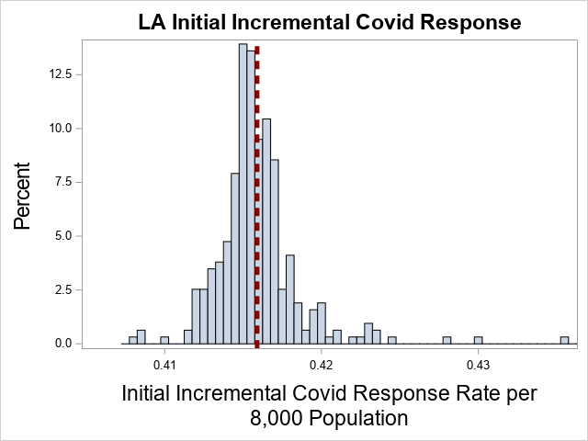

The distribution of LA specific responses to the initial pandemic period is perhaps best characterised less as a skewed distribution with a long right hand tail, but more like a Normal distribution with a very small number of outliers situated to the far right of the distribution, but not in sufficient numbers to be described as a substantial tail.

Table 7
Rank | LA Code | LAD19N | LA EBE | LA Specific Initial Response
1 | E09000032 | Wandsworth | 0.01946 | 0.435356
2 | E09000022 | Lambeth | 0.01418 | 0.430084
3 | E08000003 | Manchester | 0.01226 | 0.428157
4 | E09000028 | Southwark | 0.008593 | 0.424493
5 | E06000023 | Bristol, City of | 0.007838 | 0.423738
6 | E09000027 | Richmond upon Thames | 0.007366 | 0.423266
7 | E09000012 | Hackney | 0.007289 | 0.423189
8 | E09000014 | Haringey | 0.00718 | 0.42308
9 | E09000020 | Kensington and Chelsea | 0.007012 | 0.422912
10 | E09000009 | Ealing | 0.006769 | 0.422669
11 | E09000019 | Islington | 0.005983 | 0.421883
12 | E09000030 | Tower Hamlets | 0.005315 | 0.421215
13 | E09000013 | Hammersmith and Fulham | 0.004865 | 0.420765
14 | E07000207 | Elmbridge | 0.004434 | 0.420334
15 | E09000033 | Westminster | 0.004269 | 0.420169
16 | E09000006 | Bromley | 0.00423 | 0.42013
17 | E06000043 | Brighton and Hove | 0.004157 | 0.420057
18 | E09000023 | Lewisham | 0.004123 | 0.420023
19 | E07000085 | East Hampshire | 0.004024 | 0.419924
20 | E09000003 | Barnet | 0.003877 | 0.419777

Table 8
Rank | LA Code | LAD19N | LA EBE | LA Specific Initial Response
297 | E07000154 | Northampton | -0.00331 | 0.412593
298 | E06000012 | North East Lincolnshire | -0.00333 | 0.412567
299 | E08000016 | Barnsley | -0.00334 | 0.412561
300 | E08000024 | Sunderland | -0.00340 | 0.412502
301 | E08000035 | Leeds | -0.00352 | 0.412376
302 | E08000017 | Doncaster | -0.00361 | 0.412285
303 | E06000010 | Kingston upon Hull, City of | -0.00372 | 0.412181
304 | E06000011 | East Riding of Yorkshire | -0.00379 | 0.412107
305 | E08000018 | Rotherham | -0.00394 | 0.411963
306 | E08000004 | Oldham | -0.00397 | 0.411934
307 | E08000026 | Coventry | -0.00398 | 0.411919
308 | E06000021 | Stoke-on-Trent | -0.00400 | 0.411900
309 | E06000026 | Plymouth | -0.00401 | 0.411889
310 | E08000015 | Wirral | -0.00411 | 0.411787
311 | E08000014 | Sefton | -0.00428 | 0.411618
312 | E06000047 | County Durham | -0.00451 | 0.411391
313 | E08000019 | Sheffield | -0.00584 | 0.410056
314 | E08000034 | Kirklees | -0.00735 | 0.408551
315 | E08000032 | Bradford | -0.00736 | 0.408539
316 | E06000052 | Cornwall | -0.00776 | 0.408145

As an indication of how little variation there is in initial response at LA level, the 10 fold (or 1000%) difference between highest and lowest LAs in underlying rates compares to only a 7% difference between lowest and highest LAs in initial COVID-19 response. Eleven of the LAs that appear in the top 20 highest underlying rates also appear in the top 20 initial COVID-19 responses including all of the London based LAs. However only two of the bottom 20 underlying rate LAs appear in the bottom 20 lowest initial responses – Doncaster and Rotherham.

Overall the Pearson correlation between EBEs at LA level is 0.46, which would typically be considered to be moderately strong correlation, and suggests that those LAs with an underlying high rate of volunteers are more likely to have a relatively high initial response to COVID-19.

Figure 5
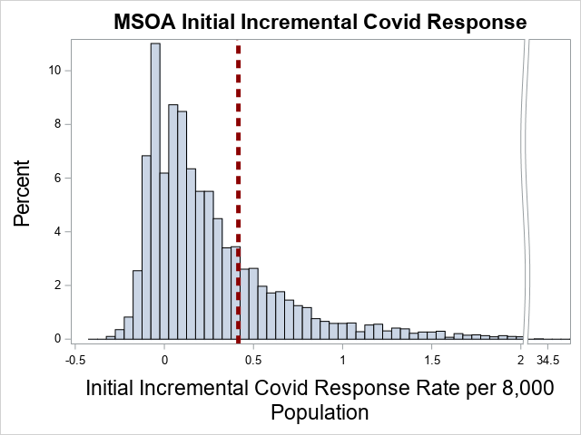

Figure 5 shows the systematic variation at MSOA level and, unlike at LA level, we can observe substantial variation. Note the difference in range in the x-axis across Figure 4 and Figure 5. The variation is such that a sizable proportion of MSOAs are estimated as having a decrease in volunteers below their natural rate (1,673 out of 6,789 MSOAs, or 25%) compared to a maximum increase of 34.4 volunteers per week over the 8 week period.

Table 9
Rank | Local Authority | MSOA Code | MSOA Name | MSOA EBE | MSOA Specific Initial Response
1 | Manchester | E02006902 | City Centre North & Collyhurst | 34.0169 | 34.44501
2 | Liverpool | E02006934 | Pier Head | 26.6698 | 27.08947
3 | Bristol, City of | E02006887 | Temple Meads | 25.0391 | 25.46284
4 | Birmingham | E02001876 | North Central & Dartmouth Circus | 22.7847 | 23.19942
5 | Nottingham | E02002895 | The Park & Castle | 20.1030 | 20.51993
6 | Leicester | E02006851 | Leicester City Centre | 15.2998 | 15.71597
7 | Leeds | E02006875 | Leeds City Centre | 13.6013 | 14.01368
8 | Swindon | E02003230 | Central South & Eastcott | 13.2700 | 13.68794
9 | Solihull | E02002099 | Central Solihull & Sharmans Cross | 12.3277 | 12.74708
10 | Norwich | E02006907 | City Centre East | 11.9168 | 12.33651
11 | Southampton | E02003571 | Central Southampton West | 11.6193 | 12.03570
12 | Brighton and Hove | E02003517 | North Laine & the Lanes | 9.8987 | 10.31876
13 | Portsmouth | E02003533 | North End West & Whale Island | 9.8765 | 10.29417
14 | Sheffield | E02006843 | Cathedral & Kelham | 9.6054 | 10.01543
15 | Harrow | E02000453 | Pinner Road | 7.9221 | 8.34179
16 | Newcastle upon Tyne | E02001731 | City Centre & Arthur's Hill | 7.7860 | 8.20090
17 | Derby | E02002808 | Cathedral Quarter & California | 7.6546 | 8.06788
18 | Stockport | E02001200 | Central Stockport, Portwood & Shaw Heath | 7.5677 | 7.98511
19 | Worcester | E02006740 | Worcester Town North | 7.2549 | 7.67170
20 | Coventry | E02001988 | Central Coventry | 7.2110 | 7.62296

Table 10
Rank | Local Authority | MSOA Code | MSOA Name | MSOA EBE | MSOA Specific Initial Response
6770 | Nottingham | E02002903 | Clifton West | -0.6605 | -0.24357
6771 | Ealing | E02000254 | Southall North | -0.6663 | -0.24367
6772 | Birmingham | E02001858 | Handsworth East | -0.6589 | -0.24412
6773 | Nottingham | E02002871 | Highbury Vale | -0.67 | -0.25309
6774 | Nottingham | E02002881 | Bilborough North | -0.6735 | -0.25655
6775 | Nottingham | E02002869 | Bulwell North | -0.6736 | -0.25669
6776 | Nottingham | E02002878 | Broxtowe & Cinderhill | -0.6757 | -0.25877
6777 | Nottingham | E02002880 | Aspley | -0.6792 | -0.26228
6778 | Nottingham | E02002883 | Thorneywood | -0.6823 | -0.26536
6779 | Cheltenham | E02004609 | Benhall & The Reddings | -0.6854 | -0.26959
6780 | Haringey | E02000404 | Scotch Estate | -0.6949 | -0.27178
6781 | Nottingham | E02002888 | St Ann's East | -0.6889 | -0.27202
6782 | Derby | E02002813 | Rose Hill & Castleward | -0.6857 | -0.27237
6783 | Nottingham | E02002887 | Beechdale | -0.6958 | -0.27891
6784 | Cheltenham | E02004604 | Arle & Hester's Way | -0.6977 | -0.28187
6785 | Exeter | E02004163 | Countess Wear & Topsham | -0.7039 | -0.28821
6786 | Nottingham | E02002890 | St Ann's West | -0.7078 | -0.29092
6787 | Cheltenham | E02004605 | Oakley | -0.711 | -0.29517
6788 | Cheltenham | E02004610 | The Park & Warden Hill | -0.7224 | -0.30656
6789 | Cheltenham | E02004607 | Pittville & Fairview | -0.7343 | -0.31846

Only two of the top 20 underlying rate MSOAs appear in the top 20 initial pandemic response MSOAs – ‘The Park & Castle’ in Nottingham and ‘North Central & Dartmouth Circle’ in Birmingham. The top 20 are dominated by MSOAs that are city centres.

None of the bottom 20 underlying rate MSOAs appear in the bottom 20 initial pandemic response MSOAs, a list that is dominated by MSOAs from Nottingham and Cheltenham. Further inspection of the MSOAs in Nottingham and Cheltenham LAs reveals that all but two MSOAs (one in each) have negative EBEs. The two positive MSOAs both have large magnitudes (e.g. The Park & Castle as shown in Table 5) which may have had a large influence on the estimation of the LA EBE. The Pearson correlation between an MSOA’s underlying rate and initial COVID-19 response is still statistically significant but lower than that observed at LA level, with a figure of 0.21, which is traditionally considered as a weak, bordering on very weak correlation.

Longer Term Response in Volunteer Rates to COVID-19 by LA and MSOA

As indicated in Table 1 regression results, the estimate of LA long term response variance is 0. We therefore conclude that there is no systematic variation at LA level for long term response, and that all systematic variation is captured at MSOA level.

As with the initial pandemic response, there is substantial variation across MSOAs in their long-term response. Though substantial, the overall long-term MSOA variation - at 0.2 - is substantially smaller than that observed in the initial pandemic response - at 1.3. Figure 6 shows that the right-hand tail of extremely positive responses is smaller than that observed for the short-term response. 2628 MSOAs (39%) have a negative impact estimated, indicating that they have fewer volunteers in the longer term than they could have expected had the pandemic not occurred.

There is a 0.90 correlation between estimates of short-term and long-term pandemic responses for MSOAs, indicating a very strong correlation. Inspection of the top 20 long-term pandemic responses show 14 MSOAs that also feature in the largest short-term responses and 5 of the lowest 20 initial responses feature in the lowest 20 of the long term responses. In the case of the lowest 20 - and therefore most negative - incremental estimates, MSOAs from Nottingham feature heavily in both.
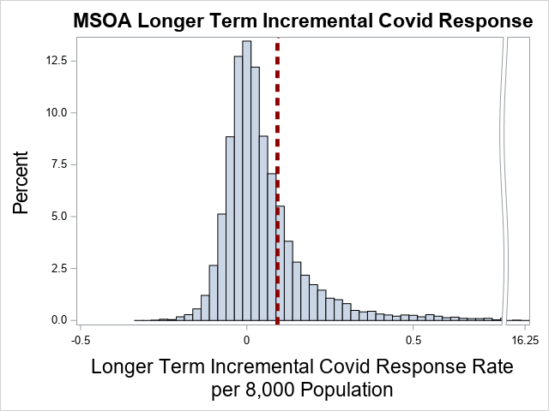
Figure 6

Table 11
Rank | LAD19N | MSOA Code | MSOAHOCLN | MSOA EBE | MSOA Specific LT Response
1 | Manchester | E02006902 | City Centre North & Collyhurst | 16.1308 | 16.22275
2 | Birmingham | E02001876 | North Central & Dartmouth Circus | 13.5766 | 13.66851
3 | Liverpool | E02006934 | Pier Head | 11.2557 | 11.34766
4 | Bristol, City of | E02006887 | Temple Meads | 10.8265 | 10.91848
5 | Nottingham | E02002895 | The Park & Castle | 6.8603 | 6.952256
6 | Stafford | E02006197 | Central Stafford | 6.0825 | 6.174425
7 | Leicester | E02006851 | Leicester City Centre | 5.4483 | 5.540228
8 | Leeds | E02006875 | Leeds City Centre | 5.0714 | 5.163361
9 | Swindon | E02003230 | Central South & Eastcott | 4.4336 | 4.525539
10 | Southampton | E02003571 | Central Southampton West | 3.9202 | 4.012111
11 | Derby | E02002808 | Cathedral Quarter & California | 3.5444 | 3.636351
12 | Stockport | E02001200 | Central Stockport, Portwood & Shaw Heath | 3.5172 | 3.609152
13 | Norwich | E02006907 | City Centre East | 3.4712 | 3.563168
14 | Milton Keynes | E02003472 | Central Milton Keynes & Newlands | 3.3425 | 3.434457
15 | Portsmouth | E02003533 | North End West & Whale Island | 3.1194 | 3.211391
16 | Preston | E02005269 | Preston Town Centre | 3.0535 | 3.145406
17 | Stoke-on-Trent | E02002969 | Boothen & Penkhull | 3.0402 | 3.132165
18 | Cambridge | E02003725 | Central & West Cambridge | 3.0301 | 3.122099
19 | Solihull | E02002099 | Central Solihull & Sharmans Cross | 3.0214 | 3.113358
20 | Brighton and Hove | E02003517 | North Laine & the Lanes | 2.9747 | 3.066618

Table 12
Rank | LAD19N | MSOA Code | MSOAHOCLN | MSOA EBE | MSOA Specific LT Response
6770 | Exeter | E02004149 | Pennsylvania & University | -0.2806 | -0.18862
6771 | Kirklees | E02002295 | Deighton & Brackenhall | -0.2828 | -0.19086
6772 | Nottingham | E02002897 | Wollaton Vale | -0.2834 | -0.1914
6773 | Tower Hamlets | E02000885 | Shadwell North | -0.2842 | -0.19224
6774 | Bradford | E02002206 | Wrose & Bolton Woods | -0.2863 | -0.19434
6775 | Exeter | E02004155 | Heavitree East & Whipton South | -0.2869 | -0.19498
6776 | Nottingham | E02006905 | Meadows | -0.2886 | -0.19662
6777 | Exeter | E02004163 | Countess Wear & Topsham | -0.2888 | -0.19682
6778 | Nottingham | E02002888 | St Ann's East | -0.2935 | -0.20154
6779 | Nottingham | E02002876 | Old Basford | -0.2951 | -0.20312
6780 | Nottingham | E02002882 | Mapperley Park | -0.2981 | -0.20617
6781 | Nottingham | E02006834 | Top Valley East | -0.3025 | -0.21058
6782 | Exeter | E02004151 | Pinhoe & Whipton North | -0.3078 | -0.21581
6783 | Nottingham | E02002891 | Bakersfield | -0.3106 | -0.2187
6784 | Nottingham | E02002883 | Thorneywood | -0.316 | -0.22401
6785 | Nottingham | E02002869 | Bulwell North | -0.33 | -0.23803
6786 | Nottingham | E02002880 | Aspley | -0.3397 | -0.24778
6787 | Exeter | E02004161 | Wonford & St Loye's | -0.346 | -0.25405
6788 | Nottingham | E02002881 | Bilborough North | -0.3538 | -0.26189
6789 | Nottingham | E02002877 | Sherwood Vale | -0.3628 | -0.27084

Modelled Incremental Impact of COVID-19 on new volunteer numbers
In this section, we take our regression results to estimate the additional number of volunteers per 8,000 population due to COVID-19 over the 55 week period starting 28 March 2020. Our method of doing this is to use the estimated regression parameters to estimate the counterfactual expectations of MSOA specific new volunteers had the pandemic not occurred. In this case, this is done by applying our estimate of the fixed effect underlying rate (${\hat{β}}_{0}$) and the MSOA and LA specific random effects. We then compare this value to the modelled outcomes for the relevant COVID-19 periods.

Figure 7
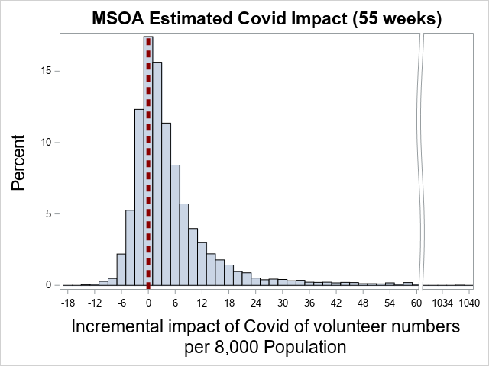
Figure 7 shows the distribution of the incremental impact of the pandemic on total new volunteer numbers over 55 weeks post March 2020, i.e. effectively the difference between what we have observed and what we would have expected had MSOAs continued at their pre-pandemic rates of new volunteers. The reference line is drawn at 0 to help identify the proportion of the MSOA population that we estimate had fewer volunteers as a result of the pandemic. The distribution has a very long right hand tail, with the mean difference being 7.65 (95% CI 6.95 – 8.35) extra new volunteers, but features a much lower median value of 2.51. Over 95% of the estimated distribution lies in the range between -18 and 30. 1,978 (29%) MSOAs have a negative impact estimated. Of the expected increase of 7.65 new volunteers, almost 44% of that increase occurs in the first 8 weeks.
Table 13 shows the top 20 biggest estimated gains from the pandemic. So, for example, if we sum the actual reported figures for MSOA ‘City Centre North & Collyhurst’ and impute the missing weeks 105, 110 and 111 with that MSOA average we see that they report 1,090.6 new volunteers per 8,000 population over the whole period. Our regression model predicts 1,066.1 over that period, a close match to that actually observed. If we model expectations for that MSOA using just their underlying rate we estimate that that MSOA would have had just 19.6 new volunteers per 8,000 population over that 55 week period. The incremental difference is therefore 1,038 new volunteers per 8,000 population, a substantial increase and one which seems barely plausible, but one which matches the sustained reporting for that MSOA over a long time period.

Table 13 : Top 20 Estimated Incremental Impact in Volunteer Numbers due to the pandemic
Rank | Local Authority | MSOA Code | MSOA | Observed new volunteers | Modelled new volunteers | Modelled as if no pandemic | MSOA Estimated impact of pandemic
1 | Manchester | E02006902 | City Centre North & Collyhurst | 1090.6 | 1066.1 | 19.6 | 1038.0
2 | Birmingham | E02001876 | North Central & Dartmouth Circus | 878.9 | 859.2 | 26.8 | 828.0
3 | Liverpool | E02006934 | Pier Head | 789.8 | 772.2 | 14.8 | 750.1
4 | Bristol, City of | E02006887 | Temple Meads | 757.6 | 740.7 | 17.1 | 716.9
5 | Nottingham | E02002895 | The Park & Castle | 535.6 | 524.2 | 27.0 | 490.9
6 | Leicester | E02006851 | Leicester City Centre | 413.3 | 404.3 | 13.5 | 386.1
7 | Leeds | E02006875 | Leeds City Centre | 380.1 | 371.9 | 13.0 | 354.8
8 | Swindon | E02003230 | Central South & Eastcott | 354.1 | 346.6 | 20.2 | 322.2
9 | Stafford | E02006197 | Central Stafford | 328.1 | 320.7 | 11.0 | 311.3
10 | Southampton | E02003571 | Central Southampton West | 303.8 | 297.2 | 8.7 | 284.9
11 | Norwich | E02006907 | City Centre East | 282.9 | 276.8 | 6.6 | 266.2
12 | Solihull | E02002099 | Central Solihull & Sharmans Cross | 270.2 | 264.5 | 11.8 | 248.3
13 | Derby | E02002808 | Cathedral Quarter & California | 262.7 | 257.2 | 19.8 | 235.5
14 | Stockport | E02001200 | Central Stockport, Portwood & Shaw Heath | 256.3 | 251.0 | 15.4 | 233.5
15 | Portsmouth | E02003533 | North End West & Whale Island | 246.8 | 241.4 | 4.9 | 233.3
16 | Brighton and Hove | E02003517 | North Laine & the Lanes | 250.1 | 245.0 | 15.0 | 226.7
17 | Milton Keynes | E02003472 | Central Milton Keynes & Newlands | 236.3 | 231.2 | 8.8 | 220.6
18 | Cambridge | E02003725 | Central & West Cambridge | 231.1 | 226.4 | 16.9 | 207.4
19 | Preston | E02005269 | Preston Town Centre | 223.4 | 218.7 | 10.0 | 206.7
20 | Newcastle upon Tyne | E02001731 | City Centre & Arthur's Hill | 220.3 | 215.7 | 10.6 | 202.6

Table 14 : Middle 20 Estimated Incremental Impact on Volunteer Numbers due to the pandemic
Rank | Local Authority | MSOA Code | MSOA | Observed new volunteers | Modelled new volunteers | Modelled as if no COVID-19 | MSOA Estimated impact of COVID-19
3385 | Wychavon | E02006753 | Fernhill Heath & Ombersley | 6.59 | 6.71 | 4.15 | 2.53
3386 | Nuneaton and Bedworth | E02006490 | Bedworth Heath | 5.55 | 5.67 | 2.98 | 2.53
3387 | Northampton | E02005674 | Cliftonville & Rushmere | 13.52 | 13.63 | 11.10 | 2.53
3388 | Bromley | E02000159 | Keston | 9.69 | 9.82 | 7.00 | 2.53
3389 | Central Bedfordshire | E02003641 | Linslade West | 7.46 | 7.58 | 5.04 | 2.52
3390 | Bolton | E02001011 | Westhoughton East | 9.35 | 9.47 | 6.92 | 2.52
3391 | Mendip | E02006051 | Draycott, Westbury & Wookey | 5.45 | 5.57 | 2.90 | 2.52
3392 | Milton Keynes | E02003482 | Bow Brickhill & Woburn Sands | 7.92 | 8.04 | 5.52 | 2.52
3393 | Brent | E02000097 | Kingsbury South | 12.23 | 12.35 | 9.83 | 2.51
3394 | North Kesteven | E02006866 | North Hykeham South | 10.08 | 10.20 | 7.50 | 2.51
3395 | Kettering | E02005641 | Rothwell | 11.73 | 11.85 | 9.12 | 2.51
3396 | Blackpool | E02002650 | Common Edge | 10.52 | 10.64 | 8.03 | 2.51
3397 | Cornwall | E02003906 | Perranporth & Goonhavern | 10.89 | 11.02 | 8.12 | 2.51
3398 | Eastbourne | E02004361 | Ratton | 7.30 | 7.42 | 4.92 | 2.51
3399 | Cheshire East | E02003817 | Congleton West Heath | 4.83 | 4.95 | 2.34 | 2.51
3400 | Reading | E02003398 | Palmer Park | 8.01 | 8.13 | 5.59 | 2.51
3401 | East Hampshire | E02004704 | Whitehill & Selborne | 5.80 | 5.93 | 3.29 | 2.51
3402 | Newham | E02000742 | Lonsdale Avenue | 13.69 | 13.81 | 11.20 | 2.50
3403 | Doncaster | E02001539 | Moorends | 4.12 | 4.24 | 1.61 | 2.50
3404 | Crawley | E02006576 | Pound Hill | 7.28 | 7.40 | 4.78 | 2.49

Table 14 shows the estimated impact on the median MSOAs. As can be seen, the impact is far more modest than that observed at the extreme end of the scale. On average the middle 20 MSOAs have approximately 2.5 more new volunteers per 8,000 population over 55 weeks as a result of the pandemic, representing a 56% increase.

Table 15 : Bottom 20 Estimated Incremental Impact on Volunteer Numbers due to COVID-19
Rank | Local Authority | MSOA Code | MSOA | Observed new volunteers | Modelled new volunteers | Modelled as if no COVID-19 | MSOA Estimated impact of COVID-19
6770 | Nottingham | E02002904 | Clifton South | 2.8 | 3.2 | 12.8 | -9.6
6771 | Lincoln | E02005443 | Glebe Park | 2.4 | 2.8 | 12.4 | -9.6
6772 | Nottingham | E02006834 | Top Valley East | 3.3 | 3.7 | 13.3 | -9.7
6773 | Nottingham | E02002902 | Clifton North | 5.4 | 5.8 | 15.5 | -9.7
6774 | Bradford | E02002206 | Wrose & Bolton Woods | 1.0 | 1.4 | 11.1 | -9.7
6775 | Nottingham | E02002875 | Basford Park Lane | 6.0 | 6.4 | 16.3 | -9.9
6776 | Nottingham | E02002876 | Old Basford | 6.2 | 6.6 | 16.5 | -9.9
6777 | Northampton | E02005650 | Boughton | 0.0 | 0.4 | 10.3 | -9.9
6778 | Nottingham | E02002887 | Beechdale | 5.2 | 5.6 | 16.1 | -10.5
6779 | Exeter | E02004151 | Pinhoe & Whipton North | 5.0 | 5.5 | 15.9 | -10.5
6780 | Kirklees | E02002295 | Deighton & Brackenhall | 1.2 | 1.6 | 12.3 | -10.7
6781 | Nottingham | E02002877 | Sherwood Vale | 6.6 | 7.1 | 18.0 | -11.1
6782 | Exeter | E02004163 | Countess Wear & Topsham | 4.6 | 5.1 | 16.7 | -11.6
6783 | Nottingham | E02002888 | St Ann's East | 3.6 | 4.1 | 15.8 | -11.6
6784 | Nottingham | E02002891 | Bakersfield | 1.0 | 1.5 | 13.7 | -12.2
6785 | Nottingham | E02002883 | Thorneywood | 2.2 | 2.7 | 15.4 | -12.7
6786 | Exeter | E02004161 | Wonford & St Loye's | 2.1 | 2.6 | 15.7 | -13.1
6787 | Nottingham | E02002869 | Bulwell North | 1.1 | 1.6 | 14.9 | -13.2
6788 | Nottingham | E02002880 | Aspley | 0.9 | 1.5 | 15.2 | -13.7
6789 | Nottingham | E02002881 | Bilborough North | 0.0 | 0.5 | 14.9 | -14.4

Table 15 shows the lowest 20 estimated pandemic-based increments and show negative values, indicating MSOAs which we predict exhibited fewer volunteer numbers due to COVID-19. For example, we observe no new volunteers over the 55 week pandemic period for Bilborough North in Nottingham. Our model predicted that we would have expected to see 0.5 volunteers. Under pre-pandemic times, this MSOA would have averaged 14.9 volunteers over a 55 week period. Figure 8 shows a graphical depiction of this volunteering impact by government office region of England.

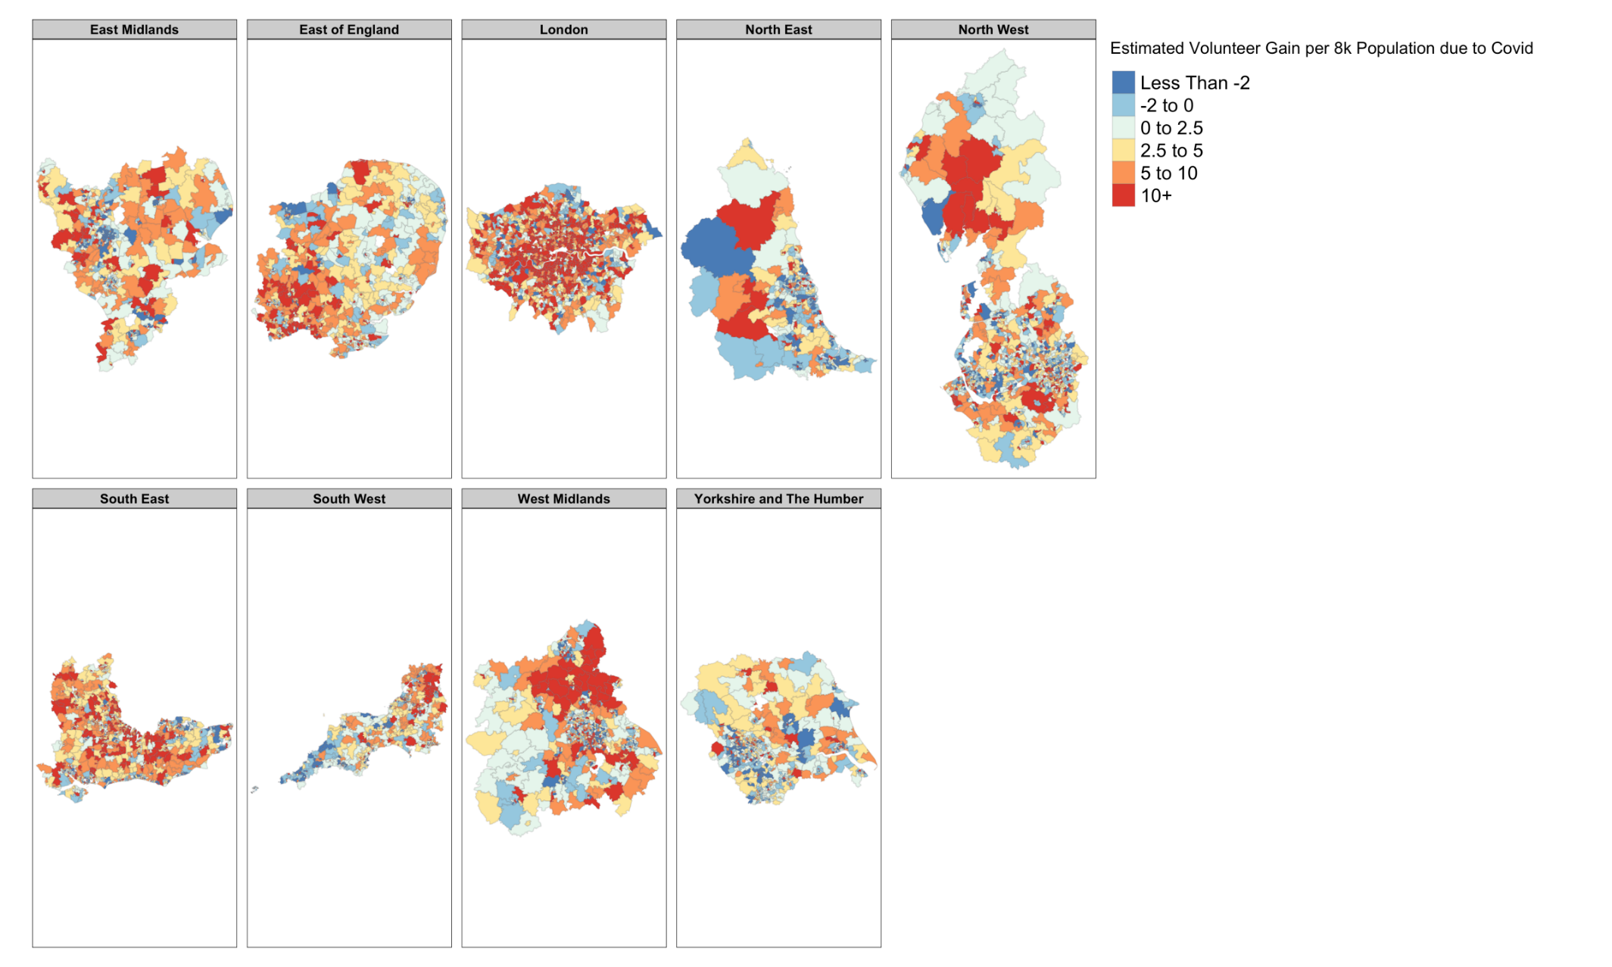
Figure 8

COVID-19 Impact on Volunteering Regression
In a final step, we use the MSOA EBEs as the dependent variable in a regression including additional variables not included in the earlier model: for deaths in Waves 1 (March to August) and 2 (September onwards), the degree of urbanicity of the MSOA, deciles of average household income for each MSOA, as well as deciles of a battery of components of the indices of multiple deprivation deemed to be relevant a priori.

While the relationship between infection and death varies substantially by age, deaths are assumed to be a proxy for infection at a population level. It is also important to note that there is a lag between infection and death, with the mean time from symptom onset to death estimated at between 17.8 and 20.2 days in three separate studies (Wood, 2020). This means that deaths in, for instance, March 2020 (the month of the first death certified as caused by COVID-19 in England) are likely to represent infections predominantly both in that month and in the previous month.

Results are presented in Table 16 and graphically in Figure 9.

Deaths per 8,000 population | Coeff. |  | (Std. err.)
Wave 1 | -0.0523 |  | (0.0786)
Wave 2 | -0.0630 |  | (0.0628)
Previous year | 0.00348 |  | (0.0186)
Urbanicity
Rural town and fringe | 4.137 | ** | (1.853)
Rural town and fringe (sparse) | 3.559 |  | (6.612)
Rural village and dispersed | 0 |  | (.)
Rural village and dispersed in a | -2.219 |  | (4.611)
Urban city and town | 6.832 | *** | (1.605)
Urban city and town (sparse) | 4.416 |  | (8.184)
Urban major conurbation | 3.910 | ** | (1.747)
Urban minor conurbation | 4.476 | * | (2.470)
IMD components
Employment
1 (least deprived) | 12.63 | *** | (2.212)
2 | 6.110 | *** | (1.925)
3 | 5.228 | *** | (1.748)
4 | 2.950 | * | (1.621)
5 (omitted) | 0 |  | (.)
6 | -0.227 |  | (1.603)
7 | -3.316 | * | (1.731)
8 | -4.211 | ** | (1.962)
9 | -6.722 | *** | (2.240)
10 (most deprived) | -10.41 | *** | (2.755)
Education
1 (least deprived) | -1.705 |  | (1.989)
2 | -3.133 | * | (1.762)
3 | -2.354 |  | (1.651)
4 | -1.220 |  | (1.593)
5 (omitted) | 0 |  | (.)
6 | -0.476 |  | (1.590)
7 | -3.771 | ** | (1.668)
8 | -4.200 | ** | (1.800)
9 | -1.850 |  | (2.019)
10 (most deprived) | -7.579 | *** | (2.394)
Living environment
1 (least deprived) | 0.518 |  | (2.230)
2 | 1.626 |  | (1.922)
3 | 1.712 |  | (1.749)
4 | 0.892 |  | (1.624)
5 (omitted) | 0 |  | (.)
6 | -1.334 |  | (1.630)
7 | -3.423 | * | (1.779)
8 | -3.331 | * | (1.945)
9 | -1.092 |  | (2.204)
10 (most deprived) | -6.193 | ** | (2.666)
Income deprivation affecting older people
1 (least deprived) | -11.44 | *** | (2.104)
2 | -8.113 | *** | (1.915)
3 | -6.286 | *** | (1.752)
4 | -3.692 | ** | (1.625)
5 (omitted) | 0 |  | (.)
6 | 3.116 | * | (1.608)
7 | 5.276 | *** | (1.752)
8 | 9.646 | *** | (1.889)
9 | 16.48 | *** | (2.084)
10 (most deprived) | 20.30 | *** | (2.428)
Indoor environment
1 (least deprived) | -2.714 |  | (2.186)
2 | -1.483 |  | (1.873)
3 | -0.627 |  | (1.709)
4 | 0.625 |  | (1.606)
5 (omitted) | 0 |  | (.)
6 | 2.519 |  | (1.598)
7 | 4.640 | *** | (1.672)
8 | 7.616 | *** | (1.828)
9 | 9.095 | *** | (2.074)
10 (most deprived) | 14.74 | *** | (2.673)
Household income
1 (lowest income) | -5.513 | ** | (2.592)
2 | -2.949 |  | (2.081)
3 | -0.368 |  | (1.766)
4 | -2.228 |  | (1.609)
5 (omitted) | 0 |  | (.)
6 | -0.204 |  | (1.583)
7 | 1.646 |  | (1.688)
8 | 2.849 |  | (1.764)
9 | 3.679 | * | (1.906)
10 (highest income) | 6.255 | *** | (2.116)
Constant | 0.635 |  | (3.181)
Observations | 6789
* p<0.10 ** p<0.05 *** p<0.01

Table 16

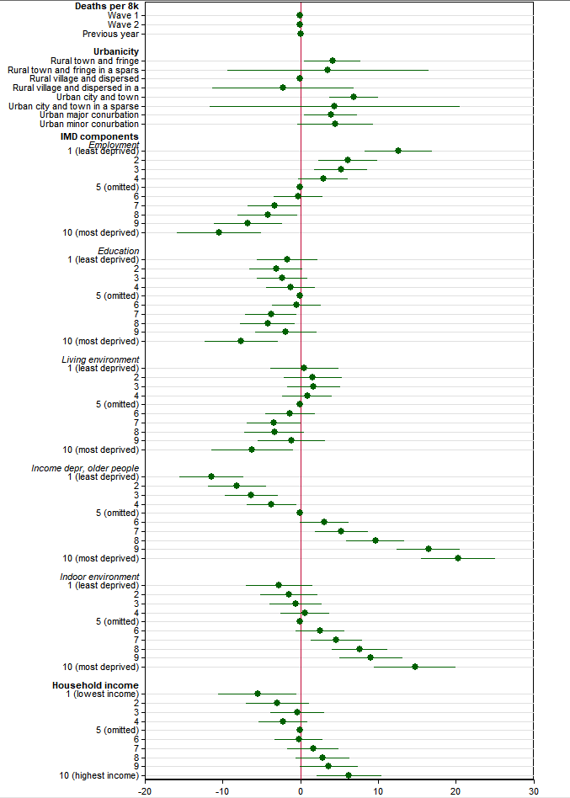
Figure 9: coefficient plot, variation in volunteers per 8,000 MSOA residents (x-axis)
These results suggest a far stronger role for pre-existing neighbourhood characteristics than for the characteristics of the pandemic locally. Deaths in the relevant MSOA in each wave of the pandemic are not associated with additional volunteer signups on the Do IT platform. Conversely, the degree of urbanicity of the MSOA and dimensions of relative deprivation are associated with volunteering behaviour at this local level.

In general, greater urbanicity is associated with more volunteering at the MSOA level. Compared to rural villages, MSOAs classed by the ONS as areas of “urban cities and towns”, “urban major(/minor) conurbations”, and “rural towns” are found to exhibit significantly greater volunteering behaviour over the pandemic period. Urban cities and towns – the area type exhibiting the greatest degree of divergence – are found to on average to have almost 7 more volunteers per 8,000 population than rural villages.

Relationships with measures of local deprivation exist in both directions – with some dimensions suggesting greater deprivation is associated with more volunteering, and some suggesting the converse. Greater deprivation in terms of employment is associated with less volunteering behaviour, whereas greater income deprivation affecting older people and greater deprivation in terms of the locality’s indoor environment are associated with more volunteering behaviour. Relationships with education and the local living environment are more ambiguous, but suggest greater deprivation being associated with less volunteering behaviour. The greatest amount of variation by these deprivation measures is explained by income deprivation affecting older people and employment. Compared to the 5th decile of MSOAs, for the former, the least (most) deprived decile of MSOAs exhibit on average around 11 less (20 more) volunteers per 8,000 residents; for the latter, the least (most) deprived decile of MSOAs exhibit on average around 12 more (10 fewer) volunteers per 8,000 people. For household income, higher income is associated with more volunteering behaviour, with – again compared to the 5th decile of MSOA household income - the lowest (highest) paid decile of MSOAs exhibiting around 5.5 fewer (6.2 more) volunteers per 8,000 population.

New Opportunities Regression

We also use similar methods to estimate, at a national level, the impact of the pandemic on new opportunities on the Do IT platform. We do not, however, explore the nature of MSOA level variation. This is because the nature of opportunities being made available is different to that of individuals making themselves available for volunteering: specifically, we do not necessarily anticipate that the MSOA in which an opportunity is made available will draw its volunteers primarily from that MSOA itself. We focus on results from our fixed effects model, which presents the underlying time-invariant rate and, separately, an initial and longer-term covid response.

Table 17 presents results from these models.

 | Constant Term Only (M1) |  | Fixed Effects Only (M2)
 | Estimate | Std Error | Estimate | Std Error
Underlying Time-Invariant Rate ($β_{0}$) | 0.075 | 0.001 | 0.0942 | 0.001
Initial Covid Response ($β_{1}$) |  |  | -0.0524 | 0.002
Longer Term Covid Response ($β_{2}$) |  |  | -0.039 | 0.001
Table 17

While the constant term only model suggests a time-invariant rate of 0.075 opportunities per week per 8,000 population, the addition of pandemic response variables increases this rate to 0.0942 per 8,000 population, and initial and longer-term pandemic responses of -0.0524 and -0.039 per 8,000 population. This suggests a fall in opportunities in the initial pandemic period of over 50%, and a longer-term impact that, while lower, still amounts to over 40%.

We additionally break down these opportunities by type of opportunity as entered on the Do IT platform, and investigate the types of opportunity on which the greatest impact of the pandemic is evidenced.

Table 17 presents, sorted by initial response estimate size, estimates of the underlying rate of volunteering, and the initial and longer-term pandemic response. We also present the estimate as a percentage of the underlying rate, highlighting types where this fall is estimated at over 60% (in the initial response) and over 40% (in the longer term response) of the underlying rate. Two of the largest three initial absolute falls are exhibited in interpersonal opportunities and health and social care, perhaps reflecting the impact of pandemic restrictions. In every group, the overall rate falls by at least 39% in the initial pandemic period, and by at least 13.8% overall.

 | Initial response |  |  | Longer term response |  |  | Underlying rate
 | Estimate | Std error | Estimate as % of underlying | Estimate | Std error | Estimate as % of underlying | Estimate | Std error
Interpersonal | -0.032588 | 0.001574 | -56.1% | -0.021425 | 0.000806 | -36.9% | 0.05807 | 0.00052
Leadership | -0.031356 | 0.001468 | -61.4% | -0.018647 | 0.000752 | -36.5% | 0.05105 | 0.00049
Health & social care | -0.020936 | 0.001074 | -61.5% | -0.015928 | 0.000550 | -46.8% | 0.03405 | 0.00036
People & communities | -0.020392 | 0.001183 | -52.2% | -0.015850 | 0.000606 | -40.6% | 0.03903 | 0.00039
Professions | -0.015769 | 0.000865 | -74.8% | -0.006519 | 0.000443 | -30.9% | 0.02107 | 0.00029
Supporting others | -0.015450 | 0.001004 | -48.1% | -0.013759 | 0.000514 | -42.8% | 0.03214 | 0.00033
Practical | -0.014081 | 0.000995 | -59.5% | -0.004904 | 0.000510 | -20.7% | 0.02366 | 0.00033
Promotion & fundraising | -0.012766 | 0.000746 | -72.8% | -0.006204 | 0.000382 | -35.4% | 0.01754 | 0.00025
Technology | -0.011383 | 0.000581 | -77.5% | -0.007899 | 0.000297 | -53.8% | 0.01469 | 0.00019
Office | -0.009136 | 0.000618 | -68.1% | -0.005113 | 0.000316 | -38.1% | 0.01342 | 0.00021
Environmental | -0.008181 | 0.000691 | -64.8% | -0.005999 | 0.000354 | -47.5% | 0.01263 | 0.00023
Creative | -0.006656 | 0.000560 | -61.7% | -0.002139 | 0.000287 | -19.8% | 0.01078 | 0.00019
Culture & heritage | -0.006505 | 0.000644 | -53.8% | -0.005433 | 0.000330 | -44.9% | 0.01209 | 0.00021
Professional | -0.006200 | 0.000484 | -70.9% | -0.002249 | 0.000248 | -25.7% | 0.00875 | 0.00016
Teaching & training | -0.005819 | 0.000701 | -42.8% | -0.001877 | 0.000359 | -13.8% | 0.0136 | 0.00023
Crisis & poverty | -0.005306 | 0.000580 | -53.6% | -0.002237 | 0.000297 | -22.6% | 0.00991 | 0.00019
Education & learning | -0.005104 | 0.000704 | -39.9% | -0.002531 | 0.000361 | -19.8% | 0.0128 | 0.00023
Academic | -0.004550 | 0.000587 | -40.9% | -0.002583 | 0.000301 | -23.2% | 0.01113 | 0.0002
Sport & recreation | -0.003555 | 0.000449 | -52.8% | -0.003150 | 0.000230 | -46.8% | 0.00674 | 0.00015
Crime & justice | -0.002604 | 0.000353 | -52.2% | -0.001925 | 0.000181 | -38.6% | 0.00499 | 0.00012
Table 17

Conclusion

This study assesses volunteering behaviour on the Do IT volunteering platform in England during the COVID-19 pandemic which saw its first impact in England in early 2020. While it must be noted that these findings relate only to one volunteering platform and should not be seen as representing the totality of volunteering behaviour in England since the onset of the COVID-19 pandemic, our results can point tentatively towards some broad conclusions. Our findings indicate an initial increase in such volunteering during the first eight weeks of the pandemic, equivalent to around five times the underlying rate previously. In the longer-term this increase in volunteering persisted and, although at a lower rate, still amounts to around double the underlying rate. When geographically disaggregated, we demonstrate substantial variation around this, with this variation overwhelmingly at the MSOA rather than local authority level.
This variation at MSOA level appears to be explained in part by local underlying factors, such as degree of urbanicity, local indices of deprivation, and average household income. These results are not invariant to the socioeconomic factor in question: while lower household income, for instance, is associated with lower volunteering behaviour, an increasing degree of income deprivation affecting older people is correlated with higher volunteering behaviour. We find that increased urbanicity is broadly associated with increased volunteering behaviour. Perhaps surprisingly, we find only a weak relationship between MSOA deaths – which we use as a proxy for local infection rates – at any stage of the pandemic and volunteering behaviour.
We also investigate the impact of the pandemic on available volunteering opportunities made available through the Do IT platform. This suggests a substantial fall – in excess of 50% - of volunteering opportunities in the initial period of the pandemic’s impact in England, and a longer-term fall of over 40% compared to the pre-pandemic period.

Bibliography

Brown, J. (2021). Coronavirus: A history of English lockdown laws. House of Commons Library Briefing Paper, 9068, 24.
Department for Digital, Culture, Media & Sport. (2021). A look at volunteering during the response to COVID-19. GOV.UK. https://www.gov.uk/government/publications/a-look-at-volunteering-during-the-response-to-covid-19/a-look-at-volunteering-during-the-response-to-covid-19
Noble, S., McLennan, D., Noble, M., Plunkett, E., Gutacker, N., Silk, M., & Wright, G. (2019). The English indices of deprivation 2019.
Office for National Statistics. (2011). Census geography. Census Geography. https://www.ons.gov.uk/methodology/geography/ukgeographies/censusgeography
Office for National Statistics. (2014). Small Area Income Estimates: Model-based estimates of the mean household weekly income for middle layer super output areas 2013/14 technical report. 82.
Public Health England. (2021). Official UK Coronavirus Dashboard. Official UK Coronavirus Dashboard. https://coronavirus.data.gov.uk/details/download
van Dorp, L., Acman, M., Richard, D., Shaw, L. P., Ford, C. E., Ormond, L., Owen, C. J., Pang, J., Tan, C. C. S., Boshier, F. A. T., Ortiz, A. T., & Balloux, F. (2020). Emergence of genomic diversity and recurrent mutations in SARS-CoV-2. Infection, Genetics and Evolution, 83, 104351. https://doi.org/10.1016/j.meegid.2020.104351
Wood, S. N. (2020). Did COVID-19 infections decline before UK lockdown? ArXiv:2005.02090 [q-Bio, Stat]. http://arxiv.org/abs/2005.02090

This excludes weeks 105, 111 and 112 which were identified as errors in the Do IT database
This is approximately concurrent with the period covering the first phase of the harshest lockdown measures in England, which came into legal force on 26 March, and were initially relaxed from 13 May (Brown, 2021).
Includes fixed effect.
Includes relevant LA EBE value as well as fixed effect

