EQUITY IN HEALTH & EDUCATION SERVICES IN BANGLADESH: CHALLENGES AND WAY FORWARD

Addressing the Disparities in Service Delivery during COVID-19 Pandemic and Recommendations for Equitable Mitigation Strategies
This briefing brings together evidence on how to address inequity in essential services such as health and education in a resource-constrained setting like Bangladesh, both during a crisis and in general. A qualitative study was conducted in which the experiences of both service receivers and service providers were explored through the lens of equity, involving 40 patients cum parents from five different socioeconomic and geographic regions across Bangladesh, as well as 30 healthcare staff and teachers from all tiers of service facilities. The study revealed a deep schism in Bangladeshi society that surfaced prominently during a global pandemic.
4 Disadvantaged
Communities
40 Service Receivers
30 Service Providers
5 Socioeconomic Groups
All Tiers of Health & Education Facilities
Experience of Health and Education Services in Bangladesh: Under the lens of Equity
The research was carried out by Centre for Injury Prevention and Research Bangladesh (CIPRB) and is one of a series of pilot studies exploring how public services could be more inclusive of disadvantaged social groups in ODA-eligible contexts. The studies are supported by an international partnership of academic, policy and non-government organisations collaborating to produce new knowledge and solutions to exclusion and disadvantage. More details of the PEI collaboration and a full report for this project can be found here.
BANGLADESH’S COMMITMENT TOWARDS EQUITY  Bangladesh, as a signatory to the Sustainable Development Goals (SDG), Universal Health Coverage, and major international declarations on inclusive education, has enacted policies to promote equity and inclusion in the country's health and education services^{1,2}. As part of the commitment, ‘The National Health Policy 2011’ declared to make health services equitably affordable and accessible to all³. On a similar notion, ‘The National Education Policy 2010’ emphasizes inclusion and equal opportunity for all children⁴. However, after a decade of these policies, a holistic equity-focused strategy has yet to be implemented at service level, necessitating an assessment of current practices^{5,6}. | THREE KEY STRATEGIES FOR EQUITABLE SERVICES AT NATIONAL LEVEL: STAKEHOLDERS’ RECOMMENDATIONS  The experiences of inequity in health and education services found through the study was presented in a workshop involving policymakers, planners, representatives from NGO working for marginalized communities, and key professional stakeholders. They recommended following three key strategies to achieve equity at national level:  ■ Evidence Generation on Existing Inequity  More equity-focused research is needed, along with integration of equity as outcome evaluation criteria for programs and interventions, to surface the unequal distribution of services among disadvantaged communities. Evidence of existing inequity will help identify gaps in current policies, allowing for subsequent policy formulation and reform with a focus on equitable services.  ■ Representation of Disadvantaged Communities during Policy and Planning  Inclusion of representatives from disadvantaged communities should be emphasized while developing national policies and programs, including interventions from international and non-governmental organizations, to ensure that these strategies are more aligned with the priorities and needs of vulnerable communities and that equitable participation is established.  ■ Targeted Approach with Multi-Sectoral Involvement  To ensure adoption and equitable distribution of benefit, solution strategies should take into account the social and environmental circumstances of different communities, and alternate strategies for disadvantaged communities should be developed if necessary.  Integration of multiple government sectors is also imperative for building targeted approaches, as basic services are interlinked with each other and promotion of all aspects is necessary for a sustainable development.  Diagram: Equitable mitigation strategies in services proposed by key stakeholders at workshop  STRATEGIES TO MITIGATE DISPARITIES REVEALED THROUGH STUDY: SUGGESTIONS FROM WORKSHOP  ■ Strategies for Health Equity  - Health-financing with expansion of financial protection for disadvantaged communities. Recommendations for pooling of funds to create a national health insurance scheme.  - Strengthening of Primary Health Care (PHC), particularly in urban area with capacity building of PHC staff to increase access of essential services at community level.  ■ Strategies for Equity in Education  - Development of infrastructure with logistic supply at government educational institutions. Emphasizing on capacity building of government school teachers.  - Integration of inclusive pre-school education and psychosocial counselling at all tiers of education facilities.  ■ Strategies for Equitable Interventions during Crisis  - Expansion of digital coverage, particularly to disadvantaged and remote areas.  - Targeted risk communication strategies for vulnerable communities during epidemics and humanitarian crisis.  - Development of context-specific preventive strategies for disadvantaged communities.  - Introduction of social safety net for vulnerable communities.
EXPERIENCES OF INEQUITY IN SERVICES: KEY STUDY FINDINGS

■ Health Services

- The digital divide in Bangladesh come in effect during the pandemic when people from rural and coastal areas, indigenous communities, and urban slums had no access to telemedicine.

- Access to primary and essential healthcare were also restricted for these disadvantaged communities during the pandemic.

- These disadvantaged groups have always faced high out-of-pocket expenditure while seeking healthcare.

- When compared to health workers in the private-sector, government healthcare workers, particularly those from primary care centres, face difficulties due to a lack of logistics, human resources, and workplace security.

■ Education Services

- The pandemic results in complete cessation of the education for children of urban slum and indigenous communities due to a lack of initiative from these communities’ institutions and lack of access to digital learning facility.

- The families of rural and coastal areas experienced challenges in accessing digital learning facility due to a lack of adequate internet facilities and smart devices.

- The existing school drop-out rate increased sharply among children of rural, coastal, and urban slum dwellers, with social consequences such as early marriages of schoolgirls as a result of the education gap caused by the pandemic.

- In comparison to the staff of private English-medium schools, government school teachers and those from private Bengali-medium institutions have limited opportunities for capacity development, particularly in pre-education and psychosocial counselling. In addition, the former institutions lack adequate logistical support for digital learning.

■ Pandemic Management

- Indigenous communities couldn’t adhere to the risk communication for COVID-19 due to cultural and language barrier.

- Urban slum dwellers lack the scope and affordability to practice preventive behaviours for COVID-19.

■ Economic Burden

- Most being day labourers, urban slum dwellers faced substantial economic burden during the pandemic with high percentage of loss of employment.

- Rural Bangladesh's low socioeconomic group suffered economically as a result of the disruption in agriculture and small-to-medium business during the pandemic.
“I was scheduled to attend my antenatal visit, but the health centre was not providing antenatal check-ups at that time. We are not solvent enough to visit a private clinic.
No, we can’t consult doctors online here”
- [Experience of a rural female during the pandemic]
“There were some instructions from government on online classes, but these are hard to follow. Many of our students can’t’ afford smart mobile or internet. A number of girls were married off. It’s frustrating!”
- [A government school teacher's experience in a village.]

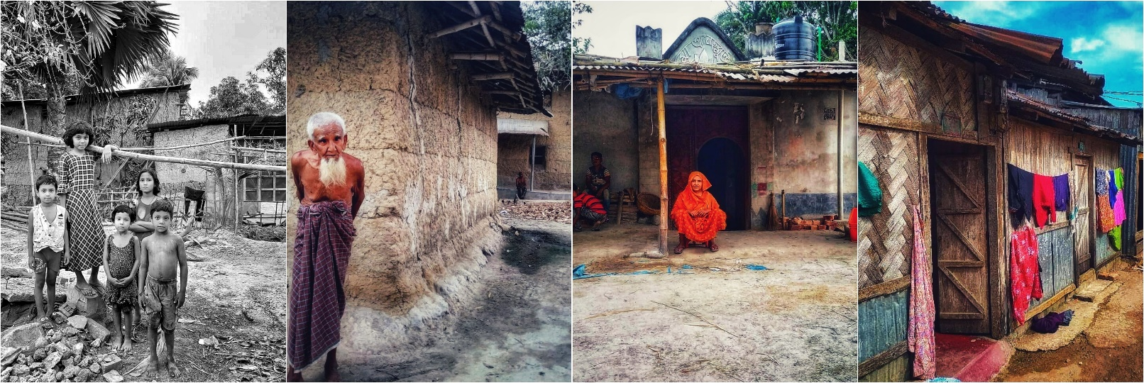

Reference:
1. UNDP. Sustainable Development Goals in Bangladesh. UNDP. Published 2021. Accessed April 18, 2021. https://www.bd.undp.org/content/bangladesh/en/home/sustainable-development-goals.html
2. Azim F, Hasan T. Exploring the Challenges of Achieving Equity through Inclusion in the Bangladeshi Education Context. Int J English Educ. 2014;(4):429. Accessed April 18, 2021. www.ijee.org
3. Ministry of Health and Family Welfare. Policy - National Health Policy. Global database on the Implementation of Nutrition Action (GINA). Published 2008. Accessed April 18, 2021. https://extranet.who.int/nutrition/gina/en/node/8273
4. Billah M. Education Policy: A Critical Review. Bangladesh Education Article. Published 2010. Accessed April 18, 2021. https://bdeduarticle.com/education-policy-a-critical-review/
5. Joarder T, Chaudhury TZ, Mannan I. Universal Health Coverage in Bangladesh: Activities, Challenges, and Suggestions. Adv Public Heal. 2019;2019:1-12. doi:10.1155/2019/4954095
6. Malak MS, Begum HA, Habib MA, Banu MS, Roshid MM. Inclusive education in Bangladesh: Are the guiding principles aligned with successful practices? In: Equality in Education: Fairness and Inclusion. Sense Publishers; 2014:107-124. doi:10.1007/978-94-6209-692-9_9

Correspondence:
Dr Farah Naz Rahman
Email: farah.naz@ciprb.org
Centre for Injury Prevention and Research, Bangladesh (CIPRB)
House-B162, Road-23, New DOHS, Mohakhali, Dhaka-1212
Phone: +8802-58814988
www.ciprb.org

