Education, gender and family relationships in the time of COVID-19: Kazakhstani teachers’, parents’ and students’ perspectives
This briefing brings together evidence on how to address equitable access to quality education and mitigate the negative impact of the pandemic on the broader wellbeing of school students, parents and teachers in Kazakhstan. This research was carried out by the Graduate School of Education, Nazarbayev University and is one of a series of pilot studies exploring how public services could be more inclusive of disadvantaged social groups in ODA-eligible contexts. The studies are supported by an international partnership of academic, policy and non-government organisations collaborating to produce new knowledge and solutions to exclusion and disadvantage. More details of the PEI collaboration and a full report for this project can be found here.
POLICY CONTEXT
While the COVID-19 pandemic is profoundly reshaping education delivery worldwide, its short and long term impacts are not equal for all schools, parents, teachers and students. At one point, 188 countries had imposed countrywide school closures, affecting more than 1.5 billion children and youth (UNESCO, 2020a). Because of existing gender norms, women are disproportionately impacted by school closures (UNESCO, 2020b). Likewise, the pandemic has disrupted education in Kazakhstan. All schools were closed abruptly on March 12th 2020. After a 3-week preparation, schools began operating entirely via a distance/online mode from April 6th until the 2019-2020 academic year. Since the beginning of the 2020-2021 academic year, schools are working using some combination of on-site and distance/online mode. While the Ministry of Education and Science (MoES) the Republic of Kazakhstan quickly introduced measures for distance/online education to ensure students’ education continues, the transition to this mode of education delivery came in a context of existing inequities based on school types (mainstream schools vs Nazarbayev Intellectual Schools (NIS) and other elite schools), location (rural vs urban), ability, the medium of instruction (Russian vs Kazakh) and regional income disparities. Kazakhstani women spent considerably more time than men in unpaid household and care work even before the pandemic. A significant proportion of women (40%) have seen an increase in the time spent on care/domestic labour during the pandemic (UN Women and UNFPA, 2020).

KEY RECOMMENDATIONS
- Support digital equity and redistribute educational funding and resources to disadvantaged schools and marginalised learners as part of building back a better education system. | - Integrate an intentional gender lens in policy measures to mitigate the impact of COVID-19 on women. Single mothers, mothers with disabled children and rural women need greater support. |  | - Offer training programmes for parents on effective remote learning at home to strengthen family wellbeing and support effective distance/online education.
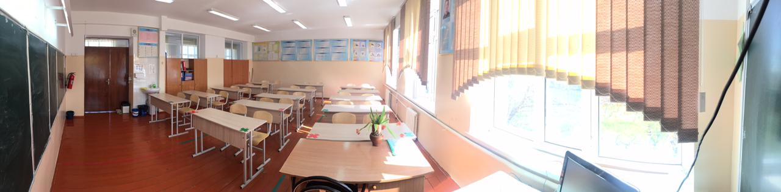
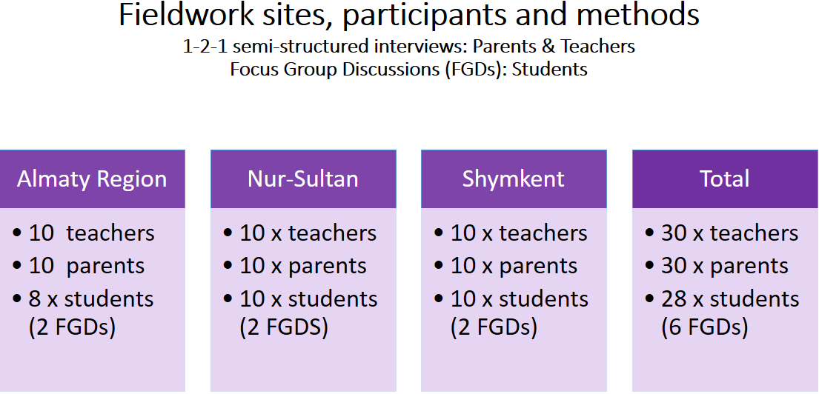 |  | THE STUDY:  Findings draw on the views of 88 stakeholders.  The majority of parents and teachers had three or more children.  Parents Teachers  1 child 23% 23%  2 children 23% 30%  3 and more children 54% 37%  FINDINGS  Access to quality education and participants’ wellbeing were negatively impacted. These impacts were unevenly distributed.  Quality of education and equity  1. Widening educational inequities between school types and across locations:  - NIS teachers and students found the transition smoother because of meticulous planning, prompt teacher capacity development, quick distribution of digital devices, and extensive IT support to students and teachers.  - Mainstream schools, particularly in rural areas, completed the school year learning how to do distance/online education on the go.  - Mainstream teachers, particularly older ones, found the transition and learning to teach using digital technology extremely challenging.  - All parents found the shift to distance/online education hard. Still, the difficulties were profound for low-income families, parents with limited educational resources and digital connectivity, working parents, single mothers, parents with many children, parents in rural areas and parents with children in primary schools.  2. Mitigating inequities: The long summer break enabled educational authorities to subscribe to e-platforms, support teachers through professional development and distribute digital devices to teachers and students from low-income families and families with many children. The Regional Methodology Offices developed a bank of video lessons, although teachers questioned the quality of the lessons.
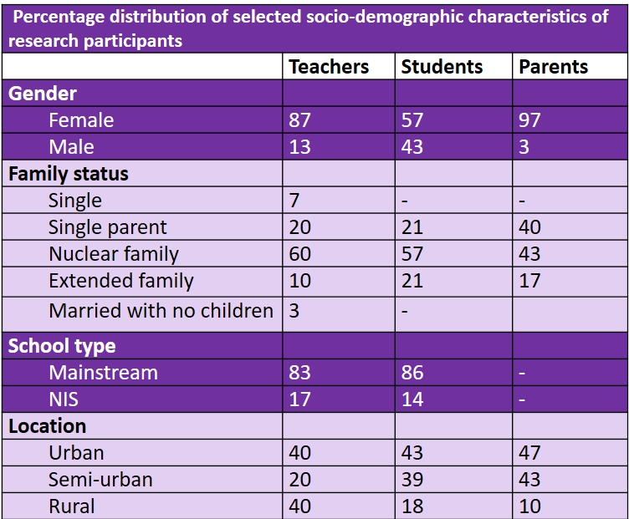

FINDINGS: Wellbeing and equity  1. The absence of the school commute positively impacted stakeholders’ wellbeing. It reduced stress, gave more time to spend with family and resulted in monetary savings.  2. Work-life balance has been negatively impacted for all stakeholders:  - Students are overwhelmed by the amount of school work, and some adolescent girls now have to contribute to household chores.  - Parents have to juggle work, homeschooling and managing multiple chat school-related groups.  - Teachers have to handle numerous chat groups with students, parents, peers and school administration. They have to call parents when children fail to turn up for lessons.  - Female teachers have to homeschool their own children, do domestic chores and manage a heavy workload.  3. Psycho-social and mental wellbeing:  - The fear of catching COVID-19 and seeing neighbours and relatives dying impacted stakeholders’ psychological and mental wellbeing.  - Participants believed governmental communication about COVID-19 statistics could have been more effective and transparent.  - Social isolation was felt strongly by those who stringently followed government regulations regarding quarantine measures.  4. Relationships: Distance/online education has negatively impacted family relationships, relationships between parents and teachers and relationships between school leaders and teachers.  5. Financial wellbeing:  - Teachers’ income has not been directly affected by the pandemic. They have been paid on time and have received a pay rise. | Quality of Education and equity (continued)  3. Perceptions of distance/online education varied:  - Urban mainstream teachers’ perceptions of the quality of distance/online education have improved over time.  - Parental perceptions of the quality of distance/ online education remain mainly negative.  - Unstable internet connection and the short duration of lessons (20 minutes) prevented teachers from using interactive virtual lessons and making it harder to adequately cover the curriculum.  - There was a misalignment between the work plan on the mainstream schools preferred digital platform and teachers’ actual lesson plans.  - Supporting primary school children remained difficult both for parents and teachers.  - Students transitioning from primary to secondary school had to navigate the challenges of distance/online education in a new school environment with little knowledge of available support structures.  - Teaching and learning specific subjects, namely physics, chemistry, biology, mathematics and physical education, was more challenging.  4. Student learning and engagement:  - No reliable data exists on student learning. Parents complete assessment tasks for children, and students collude and plagiarise.  - Some stakeholders believed that learning and engagement have decreased for low achievers, shy and introverted learners.  - With few exceptions, students across the board reported a loss of concentration and motivation to learn.
- The direct economic impact on parents varies according to the sector of the economy.
- Both teachers and parents incur costs of Wi-Fi bills, and some have bought digital devices on credit.
- Because of the actual or perceived low quality of education in the distance mode, some parents feel compelled or are encouraged by teachers to buy paid tuition, forcing some stay home mothers to seek paid work.

KEY RECOMMENDATIONS: SCHOOL LEADERS  1. Develop a plan for supporting the psycho-social needs of students and teachers.  2. Give teachers the autonomy to choose digital platforms that work best for them and their students.  3. Align the school work plan in e-platforms to teachers’ actual teaching plans.  4. Continue supporting teachers’ professional development in e-learning.  5. Promote teacher collaboration for sharing ideas and planning together.  6. Support parents with disabled children by extending them help from professionals.  7. Maintain clear communication with parents about curricular and extracurricular issues.  KEY RECOMMENDATIONS: TEACHERS  1. Help students by giving clear instructions and guidance on managing time and staying focused. Use multiple ways of checking learning progress. Provide students emotional support.  2. Use peer learning to reduce reliance on parents and help combat students’ social isolation.  3. Use low-stakes assessment to identify those who need remedial teaching. When using high-stakes assessment, give clear instructions about the task and the assessment criteria. Give adequate time for completing assignments. Provide timely feedback to students and parents.  4. Keep students’ workload manageable by liaising with other teachers.  CITATION SUGGESTION:  Durrani, Naureen, Helmer, Janet, Polat, Filiz and Qanay, Gulmira. (2021) Education, gender and family relationships in the time of COVID-19: Kazakhstani teachers’, parents’ and students’ perspectives. Partnerships for Equity and Inclusion (PEI) Policy brief #5. Graduate School of Education, Nazarbayev University. | KEY RECOMMENDATIONS: POLICY MAKERS  1. Ensure return to school by upscaling the COVID-19 vaccination rollout.  2. Integrate a gender lens in policy measures to mitigate the impact of COVID-19 on women.  3. Invest in expanding access to a stable Internet connection, particularly in rural areas. Expand access to digital devices for both teachers and students.  4. Build back a better education system by redistributing funding and resources to disadvantaged schools and marginalised learners.  5. Give more weightage to formative assessment and de-emphasise the role of high-stakes assessment.  6. Investments in educational technology could support the development of assessment approaches resistant to cheating, collusion and plagiarism. Teachers’ capacity in constructing assessment tasks suitable for e-platforms needs to be developed.  7. The quality of video lessons collected by regional methodological offices needs to be assessed to save teachers’ time and effort.  8. Reconsider the lesson duration in consultation with teachers and parents.  9. Offer parents training programmes on effective remote learning at home to give parents more confidence in assisting with online/distance learning.  10.Embed Digital literacy in pre-service training programmes  11. Maintain regular, transparent and effective government communication in the context of the pandemic to build trust and alleviate stakeholders’ stress.  REFERENCES  UNESCO (2020a) Policy brief: The impact of covid-19 on children. https://unsdg.un.org/resources/policy-brief-impact-covid-19-children  UNESCO (2020b) Policy brief: The impact of COVID 19 on women. https://www.un.org/sexualviolenceinconflict/wp-content/uploads/2020/06/report/policy-brief-the-impact-of-covid-19-on-women/policy-brief-the-impact-of-covid-19-on-women-en-1.pdf  UN Women and UNFPA (2020). Rapid gender assessment (RGA). https://kazakhstan.unfpa.org/en/publications/rapid-gender-assessment-covid-19-situation-republic-kazakhstan

