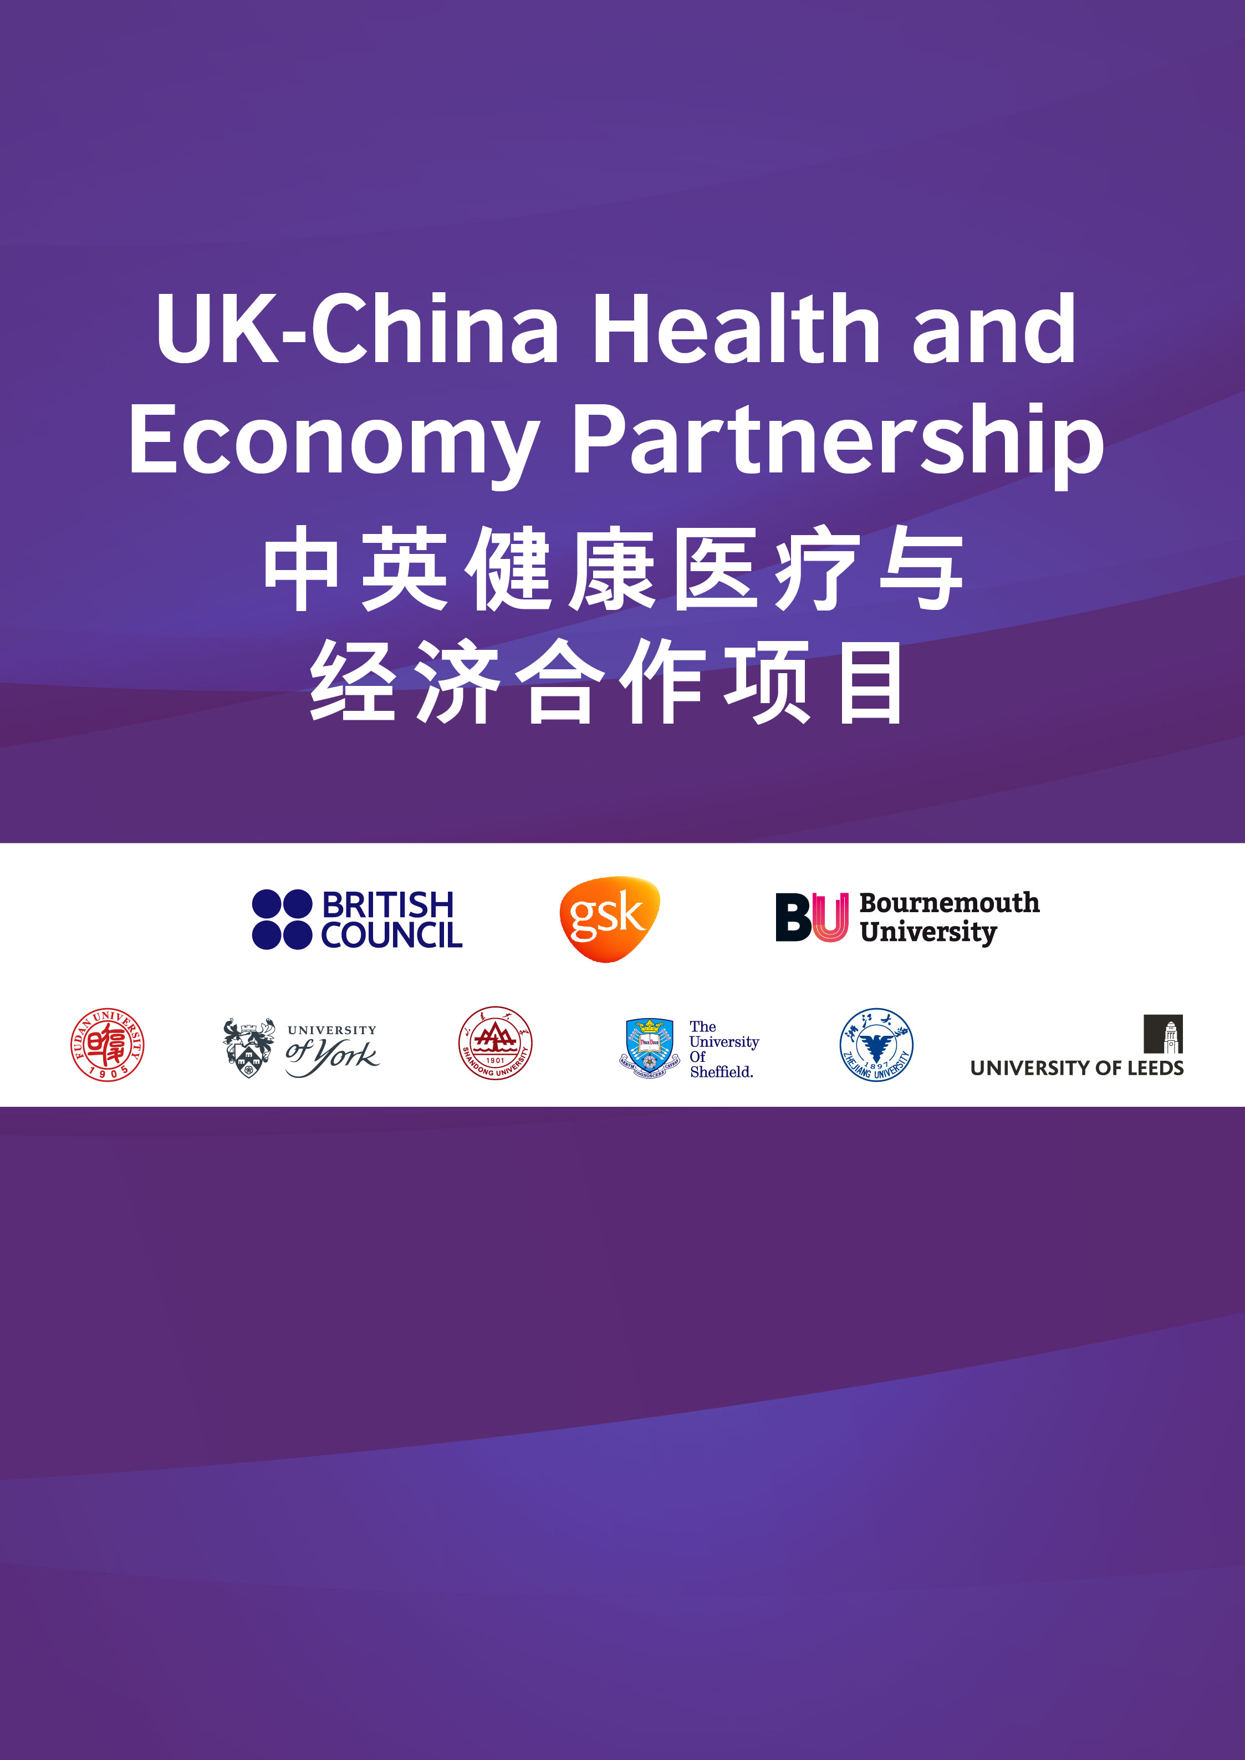

Health Economics of Diagnostic

Tests and Screening Programmes Masterclass

23rd – 25th March 2021
The masterclass will take place in person at Zhejiang University
and online throughout China and the UK.
Attendance is by invitation only and all materials will be available online.

UK-CHEP short summary
The UK-China Health and Economy Partnership is a novel knowledge transfer partnership that will promote long-term collaboration between Bournemouth University, University of York, University of Sheffield and University of Leeds in the UK and Fudan University, Shandong University and Zhejiang University in China.
The partnership aims to create long-term, sustainable collaboration in health economics, which will give UK and Chinese academics the means to work together on world-class educational and research outcomes that would otherwise not be possible working in isolation.
This partnership was originally launched in Jinan, Shandong province in November 2017 by Bournemouth University. GlaxoSmithKline and the British Council have extended the partnership for a further two years, from January 2019.
Masterclass Summary
The masterclass will explore the key health economic arguments surrounding the implementation of diagnostic tools and screening programmes, demonstrating how concepts of sensitivity and specificity and prevalence fit within the internationally recognised economic evaluation framework used for more traditional treatments.
Presentations will be given by leading experts in health economics and diagnostic and screening evaluation methodologies and the sessions will be chaired by Partnership Leads, Professors Hengjin Dong (Zhejiang University) and Chris Bojke (University of Leeds).
The presenters are:
- Professor Chris Bojke, University of Leeds
- Professor Hengjin Dong, Zhejiang University
- Professor Shuyan Gu, Nanjing University
- Dr Yuanyuan Li, Zhejiang University
- Dr Alison Smith, University of Leeds
- Dr Weijia Wu, Zhejiang University
- Dr Zixuan Zhao, Zhejiang University
- Dr Bethany Shinkins, University of Leeds
- Dr Xueshan Sun Zhejiang University
- Professor Darrin Baines, Bournemouth University
Speaker Biographies
Professor Chris Bojke
Professor Bojke is the University of Leeds UK lead for the UK-CHEP. He is a professor in economic evaluation and health technology assessment methods with a speciality using Real World Data. Chris currently leads the Academic Unit of Health Economics at Leeds and is interim deputy chair of the NICE Public Health Advisory Committee B.
Dr Bethany Shinkins
Dr Shinkins is an Associate Professor of economic evaluation and health technology assessment and leads the Test Evaluation Group (TEG) at the University of Leeds. Bethany is also the Deputy Director of the NIHR Leeds In Vitro Diagnostics Co-operative, leading the methodology platform and working closely with industry and academic partners to improve the quality of evidence generation for in vitro diagnostic tests.
Dr Alison Smith
Dr Smith is a Lecturer in Health Economics and a member of the TEG at the University of Leeds. Alison recently finished her PhD, in which she explored the role of test measurement uncertainty (bias and imprecision) on the clinical and cost-effectiveness of testing strategies. She sits on the NIHR Leeds In Vitro Diagnostics Co-operative, and is an expert member of the European Federation of Clinical Chemistry and Laboratory Medicine (EFLM) Test Evaluation Working Group.
Speaker Biographies
Professor Darrin Baines
Professor Baines is a health economist who specialises in health policy and the evaluation of health systems. He has published widely in international journal and is currently the coordinating lead of the UK-China Health and Economy Partnership. Professor Baines is also the academic lead of a British Council funded Newton project currently transferring health economics expertise to pharmacists in Egypt. His website is: darrinbaines.net
Professor Hengjin Dong
Professor Dong is the Zhejiang University China lead for the UK-CHEP. He is a professor in health technology assessment and health economics. Professor Dong is also the director of Centre for Health Policy Studies in ZJU and member of the editorial board of PharmacoEconomics, Section Editor of BMC Health Services Research.
Professor Shuyan Gu
Professor Gu specialises in health economics, health technology assessment, health behaviour and quality of life assessment. She has published ten articles as first author in international journal such as BMC Medicine, Diabetes Obesity & Metabolism, Pharmacoeconomics, Quality of Life Research, etc., and is currently working in School of Government, Nanjing University. Her website is: https://public.nju.edu.cn/szdw/jsml/111/20190830/i16924.html

Speaker Biographies
Dr Yuanyuan Li
Dr Li is a postdoctoral researcher in Department of Big Data Science and Health in Zhejiang University. Li obtained the doctor's degree in Zhejiang University supervised by professor Dong in 2019.She has expertise in economic evaluation for esophageal cancer screening.
Dr Weijia Wu
Dr Wu is currently a PhD student studying health economics at Zhejiang University in Hangzhou. Wu obtained the bachelor's degree and master's degree from Hebei University and Fudan University, respectively. So far, Wu have published articles in Pharmacol Res (IF=5.9) and Ther Adv Med Oncol (IF=6.8).
Dr Zixuan Zhao
Dr Zhao is a PhD student supervised by professor Dong in Zhejiang University. She obtained the bachelor's degree of business management in Hohai University in 2017.She was a co-applicant on three successful bids for economic evaluation program on lung cancer treatment and screening (2019-21).
Dr Xueshan Sun
Dr Sun is a PhD. student in School of public health, Zhejiang University. She is currently studying economic modelling and health policy evaluation. Her major studying field is now the economic evaluation of osteoarthritis in China.

Masterclass Timetable

23 March 2021 - Day 1

China time | UK time | Title | Presenter
15:20 | 08:20 | Welcome | Prof Darrin Baines, Bournemouth University;  Prof Hengjin Dong, Zhejiang University
15:30 | 08:30 | Introduction to the Economic Evaluation of Tests | Prof Chris Bojke， University of Leeds
16:30 | 09:30 | Choice across 10 pharmacologic combination strategies for type 2 diabetes: a cost-effectiveness analysis | Prof Shuyan Gu, Nanjing University
17:10 | 10:10 | Coffee break
17:20 | 10:20 | Economic evaluation of Esophageal cancer screening in China | Dr. Yuanyuan Li, Zhejiang University
17:50 | 10:50 | Discussion | Lead by Prof Hengjin Dong, Zhejiang University
18:00 | 11:00 | Summary | Prof Chris Bojke， University of Leeds
18:20 | 11:20 | Dinner

24 March 2021 - Day 2

China time | UK time | Title | Presenter
15:30 | 08:30 | Welcome | Prof Hengjin Dong, Zhejiang University
15:40 | 08:40 | Decision analytic models for tests | Dr. Alison Smith，  University of Leeds
16:40 | 09:40 | Decision modeling for economic evaluation for CAR-T cell therapy products | Dr. Weijia Wu, Zhejiang University
17:10 | 10:10 | Coffee break
17:20 | 10:20 | Public preferences on lung cancer screening in rural China | Dr. Zixuan Zhao, Zhejiang University
17:50 | 10:50 | Discussion | Lead by Dr. Alison Smith, University of Leeds
18:00 | 11:00 | Summary | Prof Hengjin Dong, Zhejiang University
18:20 | 11:20 | Dinner

25 March 2021 – Day 3

China time | UK time | Title | Presenter
15:30 | 08:30 | Welcome | Prof Hengjin Dong, Zhejiang University
15:40 | 08:40 | Thinking beyond accuracy | Dr. Bethany Shinkins，  University of Leeds
17:10 | 10:10 | Coffee break
17:20 | 10:20 | Cost effectiveness of drugs managing osteoarthritis in China/ Health utility of Chinese outpatient with osteoarthritis | Dr. Xueshan Sun, Zhejiang University
17:50 | 10:50 | Discussion | Lead by Bethany Shinkins, University of Leeds
18:00 | 11:00 | Summary | Prof Chris Bojke， University of Leeds  Prof Hengjin Dong,  Zhejiang University
18:20 | 11:20 | Dinner

