

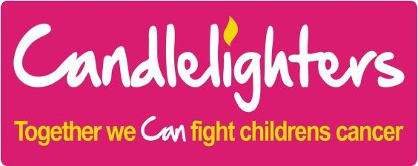

The Register is held at the University of Leeds  
The Principal Investigator is Dr Richard Feltbower

UNIVERSITY OF LEEDS



What if I don’t want my details on the Register?

You have the right to control over the information we hold about you governed by two major UK laws—GDPR and Common Law section 251. We therefore do offer the right to opt out. More information about this can be found in the downloads section of our website.

What has the Register already shown?

Our research has shown that:

* Survivors of childhood and young adult cancer re­main at increased risk of cardiovascular late effects compared with the general population.
* The number of children and young people being diag­nosed with cancer in Yorkshire is increasing, in par­ticular the number of children and young people with leukaemia, bone tumours, germ cell tumours and car­cinomas.
* Survival from cancer in young people is getting better over time.
* South Asian children and young people with neuro­blastoma, bone tumours and sarcomas have higher survival rates than non-south Asian individuals.
* South Asians with leukaemia and lymphoma have lower survival rates compared to non-south Asians.

How can I get further information?

If you are interested in any further information regarding the Register please contact:

Dr Richard Feltbower  
Email: [r.g.feltbower@leeds.ac.uk](mailto:r.g.feltbower@leeds.ac.uk) Tel: 0113 343 4841

Professor Adam Glaser   
Email: [a.glaser@nhs.net](mailto:a.glaser@nhs.net) Tel: 0113 343 0367

How do we ensure confidentiality?

All data are kept under conditions of strict security, as re­quired by law in the Data Protection Act. No personal in­formation is ever released to unauthorised individuals, groups or companies. A Scientific Advisory Group moni­tors the security and release of data.

No individual on the Register is ever approached directly or identified in any published material. All our research is car­ried out with the approval of the appropriate NHS research ethics committees through the Health Research Authority.

Are personal data used in any other way?

The research team may use your details to retrieve addi­tional NHS data. For example on the number of hospital admissions you had following treatment for your cancer, the number of times you saw your GP prior to diagnosis and details of the cancer treatment you received. This en­ables us to look at the long term effects of cancer treat­ment and improve the treatment patients receive. We do this by sharing very limited details with NHS digital such as date of birth and NHS number.

We may also share limited details to obtain information held in secure government databases. For example infor­mation relating to education and any benefits received. This will allow us to look at the impact of cancer on educa­tion and employment and help plan services accordingly. All new data obtained is stored according to our strict se­cure data protocol.

Do I need to give consent?

No, under the General Data Protection Regulation we are allowed to process personal data, for purposes that are in the public interest without consent.

What is the Yorkshire Register?

The Yorkshire Register is a collection of information on children and young people who are diagnosed with cancer.

It allows us to know how many children and young people are being diagnosed with cancer in this area. This infor­mation is shared with the National Health Service (NHS) National Cancer Registration and Analysis Service.

Why do we need cancer registration?

Cancer Registration is the only way the NHS can identify how many new cancers there are, the type of cancer, who has been diagnosed and where.

It lets the NHS see how successful it is in treating people who develop cancer. NHS staff need to know this to make sure the right services and people are available.

Cancer Registration information is also important for can­cer research, in helping us to understand more about the causes of cancer and the best way of treating it.

What is the purpose of the Yorkshire register?

The Yorkshire Register exists to carry out research ad­dressing questions pertinent to the Yorkshire population.

Our current work covers the following topics:

* Looking at patterns of cancers across the region
* Identifying possible causes of the disease
* Investigating the type of care given to patients

What information do we hold?

Information is held on approximately 10,500 individuals. For each person we hold information on their diagnosis, place of residence and age at the time of diagnosis, type of treatment received and their current health status. Every individual on the Register is followed-up through no­tifications from Public Health England on any subsequent cancers, and causes of death.