https://medicinehealth.leeds.ac.uk/downloads/download/92/yorkshire_specialist_cancer_register_downloads

Opting out will not affect you or the treatment you re­ceive in anyway. You are able to opt out at any time.

If you wish to opt out or would like discuss this further please contact Professor Adam Glaser whose details are on the back of the leaflet

What has the Yorkshire Register shown?

Our research has shown that:

* The number of children and young people diag­nosed with cancer in Yorkshire is increasing.
* Survival from cancer in young people is getting better over time.
* South Asians with neuroblastoma, bone tumours and sarcomas have higher survival rates than non-­south Asian individuals.
* South Asians with leukaemia and lymphoma have lower survival rates vs. non-south Asians.

How is the Yorkshire Register funded?

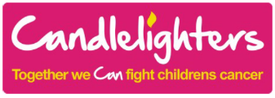The Candlelighters' Trust, a charity based at the Leeds Gen­eral Infirmary, has funded the Register since 1984. Since 2017 we have also received funding from the Laura Crane Youth Cancer Trust.

FURTHER INFORMATION

For further information, please contact:

Dr Richard Feltbower,

University of Leeds

School of Medicine

Worsley Building

Clarendon Way

Leeds, LS2 9JT

TEL: 0113 3434841

Email: [r.g.feltbower@leeds.ac.uk](mailto:r.g.feltbower@leeds.ac.uk)

If you would like to speak to a hospital doctor, please contact:

Professor Adam Glaser,

Consultant Paediatric Oncologist

D Floor, Martin Wing

Leeds General Infirmary

Great George Street

Leeds, LS1 3EX

TEL: 0113 3430367

Email: [a.glaser@nhs.net](mailto:a.glaser@nhs.net)

Full details of the Register can be found on the following website:

[https://medicinehealth.leeds.ac.uk/leeds-institute-cardiovascular-  
metabolic-medicine/doc/yorkshire-specialist-register-cancer-  
children-young-people/page/1](https://medicinehealth.leeds.ac.uk/leeds-institute-cardiovascular-metabolic-medicine/doc/yorkshire-specialist-register-cancer-children-young-people/page/1)

More details on cancer registration in England

<http://www.ukiacr.org/about/membership/public>-health-england

**THE YORKSHIRE SPECIALIST  
REGISTER OF CANCER IN  
CHILDREN AND YOUNG  
PEOPLE**

Information Leaflet for Patients

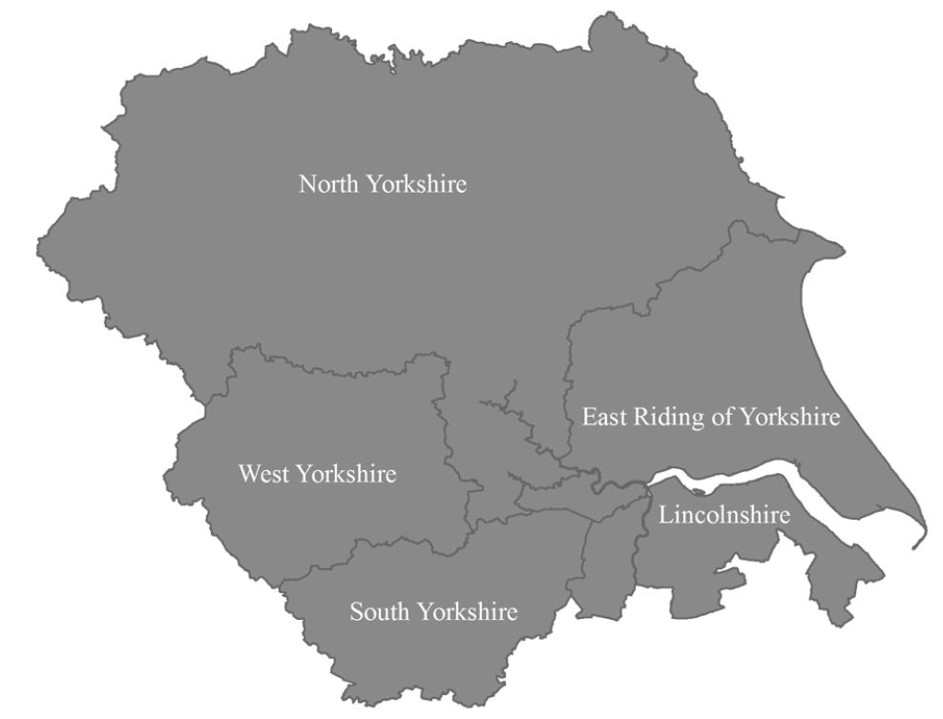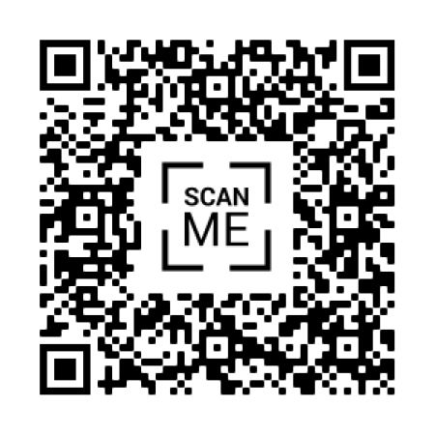

<https://www.ncras.nhs.uk/>

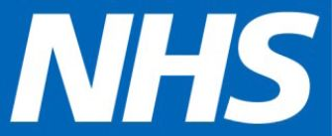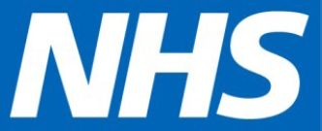

UNIVERSITY OF LEEDS

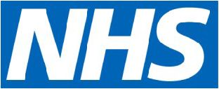

What is the Yorkshire Register?

The Yorkshire Register is a collection of information on children and young people who are diagnosed with cancer and certain benign conditions.

It allows us to know how many children and young people are being diagnosed with cancer in this area. This information is shared with the National Health Service (NHS) and the National Cancer Registration and Analysis Service.

What is the National Cancer Registration and Analysis Service?

Cancer registration allows the NHS to know how many people are being diagnosed with cancer. Whenever a person is diagnosed with cancer, the registration system records their relevant details on a computer database.

Cancer registration has been running for over 50 years in England. Most countries in the world have a cancer registration system.

Why do we need cancer registration?

Cancer Registration is the only way the NHS can identify how many new cancers there are, the type of cancer, who has been diagnosed and where.

It lets the NHS see how successful it is in treating people who develop cancer. NHS staff need to know this to make sure the right services and people are available, in the right place.

Cancer Registration information is also important for cancer research, in helping us to understand more about the causes of cancer and the best way of treating it.

What is the purpose of the Yorkshire Register?

The Yorkshire register exists to provide answers to specific questions pertinent to the Yorkshire popula­tion, e.g. how survival differs by ethnicity which is im­portant as the Yorkshire region has a unique and di­verse ethnic profile.

What information is held on the Register?

The Yorkshire Register is held at the University of Leeds and has details of over 10,000 children and young people. The University will collect information about you for this research study from medical rec­ords. This information will include your name, NHS number, address and health information, which is re­garded as a special category of information. We will use this information to carry out research into the pat­terns and causes of cancer in young people diagnosed in Yorkshire.

Will anyone be told I have cancer?

The Yorkshire Register and the National Cancer Regis­tration and Analysis Service are very careful about every person's details. There are strict rules about passing these details on to other people, agreed by the Health Research Authority Confidentiality Advisory Group. The information that registries give out or pub­lish does not identify anyone individually, nor enable anyone to be identified. The Yorkshire Register has a data management group to make sure the details are safe and are used properly.

Will my personal data be used in any other way?

Your information may be used by the registry research team to help us to retrieve additional NHS data relat­ing directly to their diagnosis, such as, when you first saw your GP about your cancer symptoms, and subse­quent hospital admissions and GP consultations. We do this by sharing a very limited dataset with NHS Dig­ital, e.g. date of birth and NHS number. This will help us to understand more about the way young people present to their GP and to monitor the health and well-the most successful treatments are. We may also share limited details to obtain information held in secure government databases. For example infor­mation relating to how individuals perform at school or higher education from the National Pupil Database and Higher Education Statistics Authori­ty; and whether they have received any Employ­ment and Support Allowance in later life. This will allow us to look at the impact of cancer on educa­tion and social outcomes, and help plan services accordingly. All new data obtained is stored ac­cording to our strict secure data protocol.

Who is the study sponsor?

The University of Leeds is the sponsor for this study. We act as the data controller which means that we are responsible for looking after your in­formation and using it properly. The University of Leeds will keep identifiable information about you as long as the Register is funded.

What about your personal rights?

Your right to have control over the information we hold about you is governed by two major UK laws—GDPR and Common Law section 251.

What if I don't want the Yorkshire Register to know about my condition?

In order to work properly, the Register needs to know about everyone with cancer. Sharing your information with us helps us to find out how best to treat cancer now and in the future.

However, as part of the regulations mentioned above we do offer a right to opt out. More infor­mation about this can be found in the downloads section of our website.