Further Information
If you want to know more about our register please visit our website. Here you will find details of people you can contact if you wish to or how to be removed from the register.
https://medicinehealth.leeds.ac.uk/leeds-institute-cardiovascular-metabolic-medicine/doc/yorkshire-specialist-register-cancer-children-young-people/page/1

More details about cancer registration in England can
be found here:
http://www.ukiacr.org/about/membership/public-health-england

The Yorkshire Specialist Register of Cancer In Children and Young People

What is the Yorkshire Register?
A collection of information about children and young people with cancer. Our register is only for people who live in Yorkshire but there is also one that covers all of England.

Why do we need Cancer Registers?
They let us know how many new cancers there are and where the people that have them live. This helps us make sure these people get the right care.

They also help us to carry out research so that we can find out more about cancers and how to treat them.

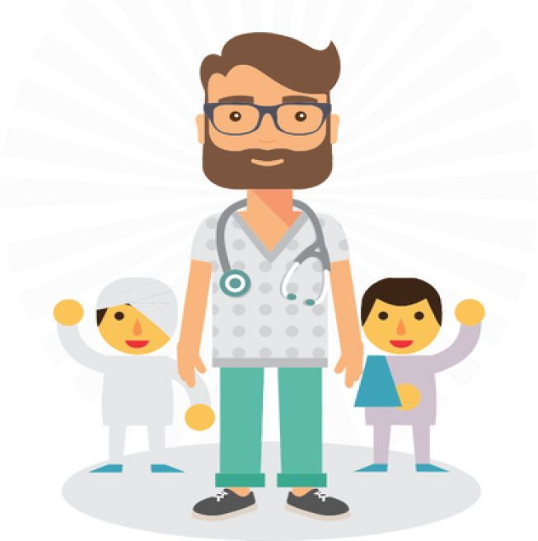
What information do you hold about me?

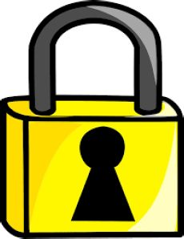
Your name, address, the date that you were born, your special hospital number and details about your cancer.

What do you do with my information?

Sometimes we might use your details to get more information about you or your cancer or the treatment to have had. This is to help us understand more about cancers. We are very careful when we are doing this. There are very strict rules to make sure we keep your information safe.

What if I'm not sure I want to be on the register?
If you aren't sure speak to your parent or guardian and look at our website on the back of this leaflet. Your doctor or one of our team will be happy to speak to you about it

