Title: Interview for an Italian web news channel: Dr Roberta Longo answers questions on Covid-19 and health economics in the Italian and UK health systems.

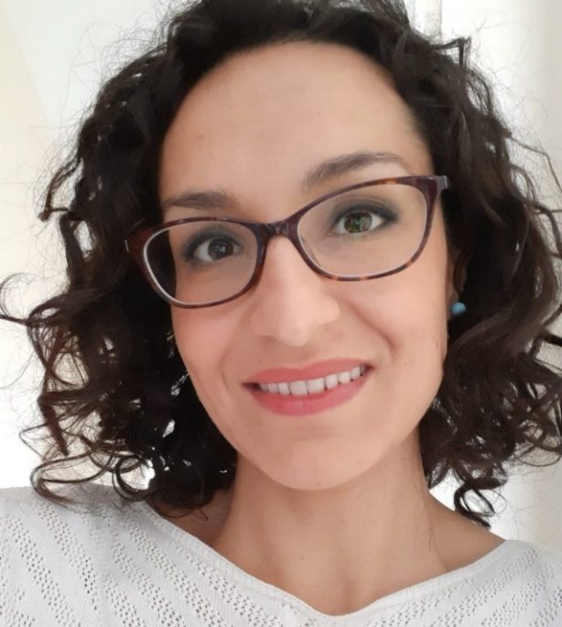

Can you help us understand the role of health economists in the healthcare system? What is the contribution they can make?

Economics is the study of how society and its individuals choose to allocate scarce resources to meet potentially unlimited needs. Scarcity is the fundamental economic problem. The resources with which to produce goods and services are scarce while needs and wants are potentially unlimited; we are therefore faced with the need to make choices. Healthcare abides by these characteristics. If we think about it, doctors, nurses, medicines, diagnostic tests and so on are all limited resources. On the other hand, we have the needs of an entire population, which can be defined as unlimited. Health economics specifically studies the choices made in health care under conditions of scarcity. The goal is to maximize the benefits obtained from the resources used through cost-effectiveness or cost-utility analyses. Many of the research projects I work on are clinical trials in which new drug treatments or a new surgical technique are tested. In the UK, trials are never done only on the effectiveness but also on the cost-effectiveness of the new treatment; our work as health economists focuses on this last aspect.

How does the health system work in the UK? Are there many differences with the Italian system?

The UK health system is public and is financed through general taxation. Unlike Italy, the provision of the service is totally free, except for the cost of the prescription. Another fundamental difference is at an organizational level: in Italy health is organized at a regional level while in the UK it is centralized - even if every nation in the Kingdom (England, Wales, Scotland and Northern Ireland) has its own National Health System (NHS).

Why did you go to Leeds? Are there many Italians there?

I arrived in Leeds in 2008, after obtaining a Masters in Health Economics from the nearby University of York and a PhD in Economics from the Sapienza University of Rome. The University of Leeds is very renowned, it is among the top 100 universities in the world (QS World University Rankings, 2019) and among the top 10 in the UK (The Guardian University Guide 2019). I started as a research fellow and was promoted lecturer in Health Economics in 2014. I would like to progress in my academic career even if it's not easy with two young children. Leeds is a vibrant and modern city in West Yorkshire, a financial but also cultural center, which I invite everyone to visit. At present it is estimated that around 2000 Italians live in Leeds; I know a few hundred!

What is your idea of ​​this pandemic? Did we act late? Have we underestimated the start of SARS-CoV-2 in China?

It is now evident that not only Italy underestimated the risk of the situation in China, but also many other governments, including the United Kingdom, also underestimated the virulence and mortality of the new virus when Italy was at the centre of the crisis, thus becoming unprepared to respond. This contributed to the initial uncontrolled spread of COVID-19 in Europe and the USA. From a health economics point of view, all this has meant converting resources to cope with the emergency in ICUs. A health economist not only looks at the direct cost of the emergency (for example the cost of machinery, medicines, hospital beds and obviously the cost in terms of lives lost due to the COVID) but also at the opportunity cost. We all have heard of cancellations of non-urgent operations or postponed specialist visits. Behind cancellations and postponements there are patients who have not been able to receive treatment, because the resources were used for the emergency, and who will likely have negative repercussions. These are examples of the opportunity cost of COVID-19. A very important cost in a health economics analysis.
In your opinion, have all the cuts to health care spending in the last twenty years made Italy more vulnerable and with fewer beds? Were spending cuts inevitable in such a delicate sector?

Italy, like many other countries, cut healthcare spending after the financial crisis of 2008 – although in recent years healthcare spending has started to rise again in line with GDP. Having said that, at the start of the emergency, Italy was in a much better positions than many other European countries in terms of ICU beds; here too I include the United Kingdom, which on average has half of it compared to Italy. The USA is the country with the highest number of ICU beds per 100,000 inhabitants in the world. Yet we have seen the catastrophic effects on the most well-placed countries from this point of view. To date, evidence has shown us that countries that have acted promptly in terms of restrictive measures, used diagnostic tests and large-scale contact tracing, have had the least number of infections and deaths.

Does the private system in Leeds manage to communicate well with the public? We, in Puglia, have not been able to eliminate waiting lists through private providers: perhaps, with an extra incentive, we would have made it ...

Another fundamental difference between Italy and the United Kingdom is that the public and private healthcare are traditionally distinct entities; even if in recent years there is more connection. There is not a proper elimination of waiting lists by sending patients to private providers, but the patient can exercise a certain degree of choice. In England since 2013 there are commissioning groups, which are groups with real budgets and the task of commissioning healthcare services from providers to meet the health needs of local people. For example, take hip replacement surgery, the commissioning process involves contracting this type of surgery with existing service providers and can include competitive tendering opportunities where private providers can also participate. At this point the patient has the right to choose where to be operated.

Is it right to manage the health care system like a business company, while knowing that such a service can only be at a loss to provide effective assistance for all?

This is precisely the point of the cost-effectiveness analysis. It is not possible to provide all available treatments, but only those that, through comparative analyses, are shown to be cost-effective in terms of quantity and quality of life. Health care is an economic good, for the reasons listed above, and this is why we have to think in economic terms. This does not mean wanting to make a profit but aiming for efficiency.

In Italy not all general practitioners use online prescription, there is a strong delay in the use of technologies and telemedicine (except in the cardiology and oncology sector). How's it going in Leeds?

It is widely believed that information technology will improve diagnosis, treatment and healthcare in general. In reality, the scientific evidence on the effectiveness of a range of IT applications is mixed and not conclusive. Having said that, in England there are clinics that make the electronic prescriptions and others do not - it is not uniformly widespread. With an app, however, it is possible to book a GP appointment, for example. Also the history of a person through the health system is all filed in electronic data.

Is it true that hospitals should be torn down and rebuilt every 20 years?

A hospital is a capital good and by definition destined to last in the long term; certainly more than 20 years with the right maintenance and the necessary investment.

Can you explain how the Italian health system (and not only), despite being aware of a rampant epidemic, found itself without adequate PPE for the emergency? Hospitals and care homes have turned into hotspots for the outbreak. Do you have the same problems in England?

As I said before, the fact of having underestimated the dangerousness of the virus has meant Italy was unprepared to face the emergency also from the point of view of the supply of PPE to doctors, nurses and all the professionals in close contact with patients. I can tell you that it is not, or was not, an Italian issue only; it's a big problem in England and also in the United States.

No one in England speaks of "herd immunity" anymore? How's the fight against covid-19 going in Leeds? Are you also locked in the house?

No, nobody talks about it anymore and it has even been denied that it was the government's strategy. Like Italy, UK is following the strategy of flattening the curve. About two weeks after the closure of Italy, the lockdown also occurred in the UK. Very similar restrictions with some differences, for example here you can still go to the park and generally go out for a walk once a day. Almost nobody wears a mask.

Do you miss the "therapeutic" sea of ​​southern Salento? Will he be able to return for the summer? Will covid-19 give us respite?

I miss the sea but I miss our families and friends more. My two children miss their grandparents, uncles and cousins ​​a lot. I can't even think about the possibility of not being able to return this summer ... I'm optimistic!

Link to the original interview (in Italian): https://www.corrieresalentino.it/2020/04/salentini-in-lotta-contro-il-covid-che-brillano-a-leeds-roberta-longo-e-stato-sottovalutato-da-tutti-il-virus/

