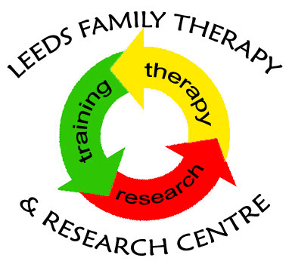

OPEN EVENING
Systemic Practice Training Courses Applications 2020

Leeds Family Therapy & Research Center (LFTRC) is offering an open evening to prospective applicants and current students to the following courses:
- Foundation Course in Systemic Practice
- Intermediate Course in Systemic Practice
- Postgraduate Certificate in Systemic Practice

This is a drop-in session to answer your questions about:
- course commitments
- course philosophy
- systemic approach
- application process
and an opportunity to also meet staff and other prospective applicants

Time: 5.00pm - 7:00pm, Wednesday 26th February 2020
Venue: Room 8.43 X, Worsley Building on the University campus

If you wish to attend please email to book your places and for detailed direction: familytherapy@leeds.ac.uk

For details of training courses and application, please visit www.leeds.ac.uk/familytherapy

