
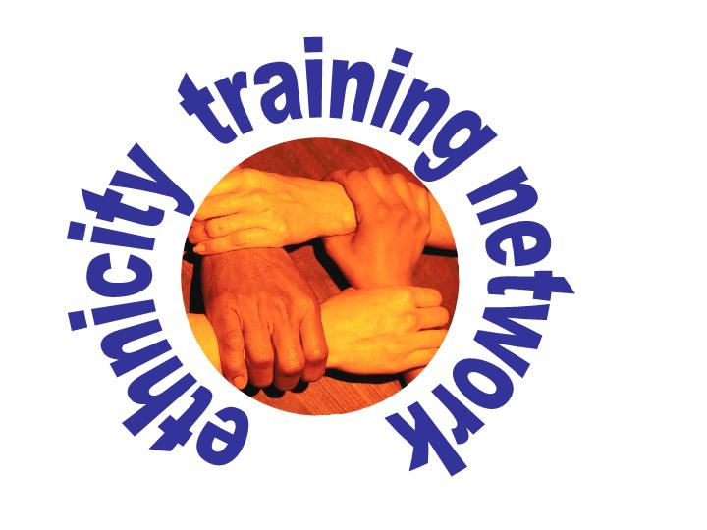
Ethnicity Training Network
Training Request Form
Thank you for your interest in the Ethnicity Training Network. To apply for training, please fill in this form and return it us by post or e-mail. This does not commit you to anything and we will not pass on any of your details without your permission.
- Name : |  |  | - Gender:
- Organisation:

- Job Title:
- Address:
  - Post Code: | 
Telephone: |  | E-mail:
- Please tick the area of England in which you are based:
Yorkshire and the Humber North East North West
East Midlands West Midlands Eastern South East South West London Other (say which)
- Are you applying for yourself or on behalf of your organisation?
- What kind of training do you need and what do you want to achieve from this?
- Where would you like the training to take place?
- What training, (if any), have you or your colleagues already received in relation to ethnicity and health?
10. How many people do you expect to attend the training?
- Where did you hear about the Ethnicity Training Network?
Signature: Date:
Please return this form to: The Ethnicity Training Network,
Leeds Institute of Health Sciences, 101 Clarendon Road,
University of Leeds, Leeds, LS2 9PL
Tel: 0113-343-4832 E-mail: g.mir@leeds.ac.uk

