NIHR ACF/ACL Travel Bursary
You are entitled to £1000 per year to attend conferences and further training courses (the financial year is from 1st April-31st March).
- Prior to attending a conference/meeting you should complete a form for NIHR Study leave reimbursement (copy on last page of this guidance or can be obtained from Karen Lawson, K.Lawson@leeds.ac. uk tel: 0113 2064622).
- Please give full details of the conference/course (date, location, title of course) and expenditure which will be incurred.
- Have the form signed by your supervisor or programme leader.
- Send the form to Karen Lawson for approval by Academic Training Programme Director Prof Phil Quirke. Scanned forms can be emailed to K.Lawson@leeds.ac.uk or sent by post:
Karen Lawson, Room 005, Cancer and Genetics Building, University of Leeds, St James’s University Hospital, Leeds. LS9 7TF
- You will be notified when your application has been approved.
- To claim back expenditure associated with your conference/meeting attendance:

If you are an Academic Clinical Lecturer in the University of Leeds please use the e-expenses claim process
- Go to https:\\selfservice.leeds.ac.uk and enter the same ‘User ID’ and ‘Password’ you use to log onto the University network.
- Before you begin your claim online, please ensure you know the budget code and who your approver is (check with Karen Lawson).
- Once you have completed your claim online you need to print two copies of the PDF and send to Karen Lawson at the address above with the original receipts (not credit card statements).
- If you need any help completing your claim within the e-expenses system please click on
‘Expenses Documentation and Training Material’

If you are an Academic Clinical Fellow or external to the University please use a paper-based expenses form
- Use a white UKTS for UK travel, yellow OSTS for overseas travel (examples on next page). These forms can be obtained from your University host department or by contacting Karen Lawson.
- Do not download forms from the internet or photocopy uncompleted forms as the original triplicate form is needed for the claim. Each claim form has a unique number.
- Complete the claims form with full details of travel, sign in the box on left hand side of form and leave the ‘cost object’ and ‘authorised signature’ boxes on right hand side blank.
- Post the form, with full receipts (not credit card statements) to support each part of the claim, to Karen Lawson at the postal address above.

FOR BOTH ELECTRONIC AND PAPER-BASED CLAIMS:
- Claims must be submitted within 6 weeks of expenditure (and within 3 weeks of 31st July).
- Include your contact details in case there is a query with your claim.
- For any queries regarding completion of forms and claiming expenditure other than travel please contact K.Lawson@leeds.ac.uk 0113 2064622
- Guidelines for expenses claims are detailed within the University financial regulations at: http://www.leeds.ac.uk/finance/policies/expenses/travel/expense_rates.htm .

Examples of paper-based University travel expenses claims forms (these are examples only, please use original triplicate forms when making your claim)
UK Travel Overseas Travel
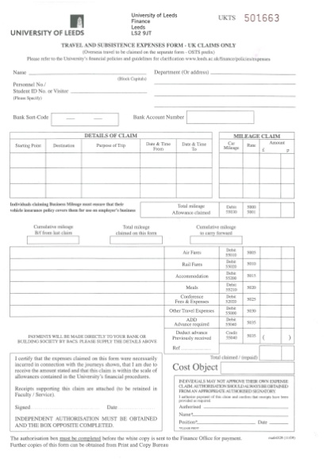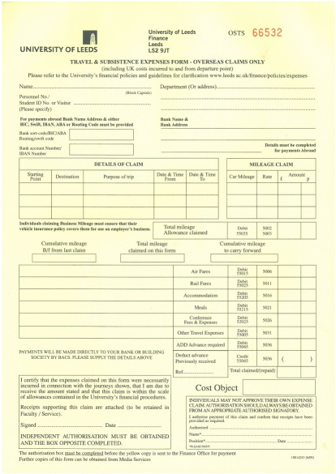

Approval Form for NIHR Study Leave Reimbursement
To be returned (prior to booking travel or conference arrangements) to:
Karen Lawson, Room 005, Cancer and Genetics Building, University of Leeds,
St James’s University Hospital, Leeds. LS9 7TF or email k.lawson@leeds.ac.uk
Name.......................................................................................................................................................
Post and year..........................................................................................................................................
Please give a full breakdown of the anticipated expenditure for this claim:-
Conference/meeting details (date, location, title of conference, duration, what the costs include e.g. accommodation, conference dinner and benefit likely to be derived):
For accommodation please state how many nights the accommodation is required for and the cost of one night’s accommodation.
For travel include ALL costs – train/taxi/air fare/car mileage.

Are you presenting? Yes/No
What are you presenting (poster/oral presentation; what is the title)?

Amount previously claimed from April 1st £........................
Amount for this claim £.......................
Residual allocation remaining from annual £1000 £........................
Please note that the University has limits to claims for accommodation etc – check the expenses guidelines before booking anything. http://www.leeds.ac.uk/finance/policies/expenses/travel/expense_rates.htm
Approval by supervisor/Programme leader
Signature:
Name: Date:
Approval by Academic Training Programme Director
Signature:
Name: Prof Phil Quirke /Dr Jo Bentley Date:

